Assignment II (Set B) — Robust Reinforcement Learning under Sticky Actuators

Group 109 — Q_learning_SARSA

Group Contribution Declaration
# | Name | BITS ID | Contribution
1 | Stuti Srivastava | 2025AG05747 | 100 %
2 | Chirag Bhatnagar | 2025AG05066 | 100 %
3 | Neelam Devi | 2025AG05908 | 100 %
4 | Aditya Saraswat | 2025AG05058 | 100 %

Course: AIML ZG512 Deep Reinforcement Learning · Group: 109 (Set B, groups 101–200) · Master random seed: 109 (our group number)
The notebook was executed top-to-bottom in the BITS virtual lab; timestamped screenshots of that run are in the Appendix. Key cells print a [lab-stamp] line (date, time, host, user) so every output can be matched to a screenshot.
Section | Assignment task | Marks
0 | Setup: installs, imports, constants, hyper-parameters | –
1 | (a) Sticky-actuator wrapper + six verification checks | 2
2 | Shared machinery for (b) and (c): discretiser, validation set, ε schedule, agent, training loop | –
3 | (b) Q-learning and (c) SARSA, each trained on the original and the modified environment | 3 + 3
4 | (d) Five required plots with interpretation + greedy test table | 3
5 | Extra experiments: cross-evaluation, 3-seed robustness, memory-augmented agent | –
6 | (e) Discussion | 2

0. Setup

0.1 Install the libraries (first code cell, safe to re-run)
In [3]:
# Install every third-party library used in this notebook; pip skips packages that are
# already present and only upgrades a package that is older than the minimum version.
%pip install -q "gymnasium>=0.29" "numpy>=1.21" "matplotlib>=3.5" "pandas>=1.3"
Note: you may need to restart the kernel to use updated packages.

0.2 Imports and the run-stamp helper
In [5]:
import os # paths for the outputs/ folder (CSV logs, figures)
import math # erfc() for the normal-approximation p-value in part (a)
import time # wall-clock timing of each training run
import socket # host name printed in the lab-stamp (identifies the virtual lab machine)
import getpass # user name printed in the lab-stamp
import platform # Python version printed in the lab-stamp
import datetime as dt # timestamps on every progress line

# typed containers for config/results; replace() copies a config
from dataclasses import dataclass, replace

import numpy as np # numerics, random generators and the Q-tables
import pandas as pd # tables for verification and evaluation results
import matplotlib # version string only
import matplotlib.pyplot as plt # all figures

# 3-colour map for the greedy-policy heatmaps
from matplotlib.colors import ListedColormap

# legend swatches + hatched "unvisited" background
from matplotlib.patches import Patch, Rectangle
import gymnasium as gym # MountainCar-v0 and the gym.Wrapper base class
from IPython.display import display # pretty tables inside Jupyter

OUT_DIR = "outputs" # every CSV log and saved figure goes here
os.makedirs(OUT_DIR, exist_ok=True) # create the folder if it does not exist yet

pd.set_option("display.width", 220) # wide tables are printed on one line
pd.set_option("display.max_columns", 30) # never truncate the evaluation tables

def now() -> str:
"""Return the current local time as 'YYYY-MM-DD HH:MM:SS' (used in every log
line)."""
return dt.datetime.now().strftime("%Y-%m-%d %H:%M:%S") # formatted wall-clock time

def clock() -> str:
"""Return only the time of day 'HH:MM:SS' (short prefix for progress lines)."""
return dt.datetime.now().strftime("%H:%M:%S") # formatted time of day

def current_user() -> str:
"""Login name of the person running the notebook ('unknown' if the OS hides it)."""
try:
return getpass.getuser() # works on Windows, Linux and most containers
except Exception: # some containers have no user entry
return "unknown"

def lab_stamp(label: str) -> None:
"""Print one evidence line: timestamp, machine, user and a label naming the cell
that produced it."""
# one-line stamp
print(
f"[lab-stamp] {now()} | host={socket.gethostname()} | user={current_user()} "
f"| {label}"
)

lab_stamp("setup") # stamp the start of the run
print(
f"python {platform.python_version()} | gymnasium {gym.__version__} | numpy "
f"{np.__version__} | "
# library versions for reproducibility
f"pandas {pd.__version__} | matplotlib {matplotlib.__version__}"
)
NOTEBOOK_T0 = time.perf_counter() # used to report the total run time at the end
[lab-stamp] 2026-11-04 22:43:58 | host=ip-10-3-20-152.ap-south-1.compute.internal | user=s2025ag05066 | setup
python 3.12.7 | gymnasium 1.4.0 | numpy 1.26.4 | pandas 2.2.3 | matplotlib 3.10.1

0.3 Figure style
One visual grammar for all figures: colour = algorithm (Q-learning blue, SARSA orange) and line style = environment (dashed = original, solid = sticky/modified). Quantities with different units (e.g. original vs modified rewards) are never forced onto one shared y-axis; they get separate panels.
In [7]:
plt.rcParams.update(
{ # light, recessive chart chrome so the data stands out
"figure.dpi": 100,
"savefig.dpi": 150,
"savefig.bbox": "tight",
"figure.facecolor": "#fcfcfb",
"axes.facecolor": "#fcfcfb",
"axes.edgecolor": "#c3c2b7",
"axes.labelcolor": "#52514e",
"axes.titlecolor": "#0b0b0b",
"axes.titlesize": 11,
"axes.titleweight": "bold",
"axes.labelsize": 10,
"axes.spines.top": False,
"axes.spines.right": False,
"axes.grid": True,
"grid.color": "#e1e0d9",
"grid.linewidth": 0.6,
"xtick.color": "#898781",
"ytick.color": "#898781",
"text.color": "#0b0b0b",
"font.family": "sans-serif",
"font.size": 9.5,
"legend.frameon": False,
"legend.fontsize": 9,
"lines.linewidth": 1.8,
}
)
# colour encodes the algorithm
ALGO_COLOR = {"q_learning": "#2a78d6", "sarsa": "#eb6834"}
# display names of the algorithms
ALGO_LABEL = {"q_learning": "Q-learning", "sarsa": "SARSA"}
ENV_STYLE = {"original": "--", "modified": "-"} # line style encodes the environment
# display names of the environments
ENV_LABEL = {"original": "original", "modified": "sticky"}
INK, INK_2, INK_MUTED = "#0b0b0b", "#52514e", "#898781" # text / reference-line colours

def save_fig(fig, name: str) -> None:
"""Save a figure to outputs/<name>.png (for the report) and then show it inline."""
fig.savefig(os.path.join(OUT_DIR, f"{name}.png")) # high-resolution copy on disk
plt.show() # render inside the notebook

0.4 Constants from the question and our experimental configuration
Hyper-parameters (identical for all four agents, as required):
Setting | Value | Why
Discretisation | 36 position × 28 velocity uniform bins | Bin widths are 0.05 and 0.005, so a position edge falls exactly on the flag (x = 0.5) and a velocity edge falls exactly on the gentle-arrival threshold (v = 0.03). The agent can therefore tell a gentle approach from a fast one. A 25 × 25 grid cannot do this cleanly: it puts every velocity from 0.0252 to 0.0308 into one bin, mixing gentle and too-fast arrivals. 1 008 states × 3 actions stay small enough to be visited many times in 10 000 episodes (finer grids = "narrow features" that need more samples, Lecture 11).
α (learning rate) | 0.10 | Standard tabular step size; stable under the noisy sticky transitions.
γ (discount) | 0.99 | MountainCar needs 100–200 steps to reach the flag; γ = 0.99 keeps the +25 bonus visible from ~100 steps away (0.99¹⁰⁰ ≈ 0.37).
ε schedule | exponential decay 1.0 → 0.05, floor reached at episode 5 000, then held at 0.05 | Broad exploration first; the 0.05 floor keeps SARSA's on-policy values genuinely different from Q-learning's greedy values.
Episodes | 10 000 per agent (≥ 6 000 required) | Learning curves are still improving at 6 000 (pilot runs).
Q-table initialisation | zeros, shape (36, 28, 3) | As specified. Because every step costs ≥ 1, zero is optimistic and drives systematic exploration.
Seed | 109 for every run | Same seed → same initial states and same random streams for all four agents.

In [9]:
ENV_ID = "MountainCar-v0" # base environment from Gymnasium
PUSH_LEFT, NO_PUSH, PUSH_RIGHT = 0, 1, 2 # action ids of MountainCar-v0
# readable names
ACTION_NAMES = {PUSH_LEFT: "push left", NO_PUSH: "no push", PUSH_RIGHT: "push right"}
STICK_PROB = 0.30 # probability that an attempted action change is ignored (Step 2)
PUSH_PENALTY = 0.3 # energy penalty for every *selected* push (Step 4)
GENTLE_BONUS = 25.0 # gentle-arrival bonus B (Step 5)
GOAL_POSITION = 0.5 # flag position
GENTLE_SPEED = 0.03 # maximum arrival velocity that earns the bonus
MAX_EPISODE_STEPS = 200 # Gymnasium's TimeLimit for MountainCar-v0
SEED = 109 # master seed = our group number

@dataclass(frozen=True)
class ExperimentConfig:
"""All hyper-parameters shared by Q-learning and SARSA (frozen so no run can change
them by accident)."""

n_pos_bins: int = 36 # position bins over [-1.2, 0.6]
n_vel_bins: int = 28 # velocity bins over [-0.07, 0.07]
alpha: float = 0.10 # learning rate
gamma: float = 0.99 # discount factor
eps_start: float = 1.0 # ε at episode 0
eps_end: float = 0.05 # ε floor
# fraction of training after which ε reaches the floor
eps_decay_fraction: float = 0.5
n_episodes: int = 10_000 # training episodes per agent
log_every: int = 100 # print one progress line every N episodes

CFG = ExperimentConfig() # the single configuration used everywhere
TEST_SEEDS = list(range(50_000, 50_100)) # 100 fixed seeds for the greedy test episodes
# print the configuration as a table
display(pd.DataFrame([vars(CFG)]).T.rename(columns={0: "value"}))
 | value
n_pos_bins | 36.00
n_vel_bins | 28.00
alpha | 0.10
gamma | 0.99
eps_start | 1.00
eps_end | 0.05
eps_decay_fraction | 0.50
n_episodes | 10000.00
log_every | 100.00

1. Part (a) — Modified environment and verification

1.1 The wrapper
StickyActuatorMountainCar follows Steps 1–6 of the question in that order. Three design decisions:
1. Separate random generator for the actuator. The stuck/not-stuck draw does not use the base environment's np_random. Sharing it would shift the base env's random stream and change the initial states. With a separate generator, seed 109 gives the original and the modified environment exactly the same start positions, so the comparison is fair. The generator is re-seeded whenever reset(seed=…) is called.
2. A random number is drawn only when a ≠ a_prev, exactly as in the worked example (step 2 shows "–").
3. Audit log for verification only. With audit=True the wrapper appends one record per step to self.audit_log (selected action, random number, executed action, reward parts). The log is a Python attribute that no agent ever reads; the info dictionary returned to the agent stays untouched (Step 6). Training always runs with audit=False.
In [11]:
class StickyActuatorMountainCar(gym.Wrapper):
"""MountainCar-v0 with a sticky actuator, an energy penalty and a gentle-arrival
bonus (question Steps 1-6).

Everything else (observation space, action space, physics, termination and
truncation) is inherited unchanged from the wrapped environment.
"""

def __init__(
self,
env,
stick_prob=STICK_PROB,
push_penalty=PUSH_PENALTY,
bonus=GENTLE_BONUS,
goal_position=GOAL_POSITION,
gentle_speed=GENTLE_SPEED,
rng=None,
audit=False,
):
"""Store the modification parameters; `rng` may be injected for unit tests,
`audit` enables the log."""
super().__init__(env) # gym.Wrapper keeps spaces/spec of the base env
self.stick_prob = float(stick_prob) # P(replace an attempted change by a_prev)
self.push_penalty = float(push_penalty) # energy cost of a selected push
self.bonus = float(bonus) # gentle-arrival bonus B
# flag position used in the bonus test
self.goal_position = float(goal_position)
# speed threshold used in the bonus test
self.gentle_speed = float(gentle_speed)
# True when a test supplies its own generator
self._rng_injected = rng is not None
# actuator random generator
self._rng = rng if rng is not None else np.random.default_rng()
self.a_prev = NO_PUSH # action actually executed on the previous step
self.audit = bool(audit) # whether step() records an audit entry
self.audit_log = [] # verification records (never shown to the agent)

def reset(self, *, seed=None, options=None):
"""Reset the base env, set a_prev = 1 (do not accelerate) and re-seed the
actuator generator if seeded."""
# base reset (initial position is random)
obs, info = self.env.reset(seed=seed, options=options)
self.a_prev = NO_PUSH # question: a_prev = 1 on every reset
# a seeded reset makes the actuator reproducible
if seed is not None and not self._rng_injected:
# independent stream derived from the same seed
self._rng = np.random.default_rng([seed, 2026])
return obs, info # observation and info are passed through

def _gentle_arrival_bonus(self, obs, terminated, truncated) -> float:
"""Step 5: return B if ALL four gentle-arrival conditions hold, otherwise 0."""
# car position at/after the flag
reached_flag = bool(obs[0] >= self.goal_position)
slow_enough = bool(obs[1] <= self.gentle_speed) # arrival velocity at most 0.03
# all conditions simultaneously
if terminated and not truncated and reached_flag and slow_enough:
return self.bonus # gentle arrival
return 0.0 # any failed condition -> no bonus

def step(self, action):
"""Apply Steps 1-6 of the question in order and return (obs, R, terminated,
truncated, info)."""
a = int(action) # Step 1: the agent's selected action (kept)
a_prev_before = self.a_prev # remembered only for the audit record
r_draw = np.nan # no random number unless the action changes
if a == self.a_prev: # Step 2: repeating the executed action...
a_exec = a # ...is never modified
else: # attempted change of action
r_draw = float(self._rng.random()) # r ~ U[0, 1)
# stuck -> keep previous executed action
a_exec = self.a_prev if r_draw < self.stick_prob else a
# Step 3: execute in the base env
obs, r_base, terminated, truncated, info = self.env.step(a_exec)
self.a_prev = a_exec # update a_prev with the *executed* action
# Step 4: penalty uses the *selected* action
penalty = self.push_penalty if a != NO_PUSH else 0.0
bonus = self._gentle_arrival_bonus(obs, terminated, truncated) # Step 5
reward = float(r_base) - penalty + bonus # R = R_base - 0.3*1[a != 1] + B
if self.audit: # verification-only bookkeeping
# one audit record per step
self.audit_log.append(
dict(
a_prev=a_prev_before,
a=a,
r=r_draw,
a_exec=a_exec,
r_base=float(r_base),
penalty=penalty,
bonus=bonus,
R=reward,
pos=float(obs[0]),
vel=float(obs[1]),
terminated=bool(terminated),
truncated=bool(truncated),
)
)
# Step 6: info is the base env's, unchanged
return obs, reward, terminated, truncated, info

def make_env(kind: str, audit: bool = False, stick_prob: float = STICK_PROB):
"""Create the 'original' MountainCar-v0 (with its 200-step TimeLimit) or the
'modified' sticky version."""
base = gym.make(ENV_ID) # includes TimeLimit(200) and OrderEnforcing
if kind == "original": # unmodified environment
return base # unmodified environment
if kind == "modified": # our wrapper sits on top of the TimeLimit
# sticky actuator + reward changes
return StickyActuatorMountainCar(base, stick_prob=stick_prob, audit=audit)
raise ValueError(f"unknown environment kind: {kind}") # guard against typos

print(make_env("modified")) # show the wrapper stack
<StickyActuatorMountainCar<TimeLimit<OrderEnforcing<PassiveEnvChecker<MountainCarEnv<MountainCar-v0>>>>>>

1.2 Verification V1 — the worked example from the question, reproduced exactly
A scripted random generator returns the question's random numbers (0.62, 0.27, 0.81, 0.18), and the agent selects the question's actions (0, 0, 2, 2, 1). The wrapper must produce the executed actions in the table and must not draw a random number at step 2.
In [13]:
class ScriptedRNG:
"""Stand-in random generator that returns a fixed list of numbers and counts how
many were requested."""

def __init__(self, values):
"""Store the numbers to hand out, in order."""
self.values = list(values) # the scripted random numbers
self.calls = 0 # how many numbers the wrapper has asked for

def random(self) -> float:
"""Return the next scripted number (same interface as numpy's
Generator.random)."""
value = self.values[self.calls] # next number in the script
self.calls += 1 # count the draw
return value # return the scripted number

scripted = ScriptedRNG([0.62, 0.27, 0.81, 0.18]) # r values from the question's table
# wrapper with scripted draws
env_ex = StickyActuatorMountainCar(gym.make(ENV_ID), rng=scripted, audit=True)
env_ex.reset(seed=SEED) # fresh episode -> a_prev = 1
for a in [0, 0, 2, 2, 1]: # the agent actions from the question
env_ex.step(a) # run one step
# recorded steps
ex = pd.DataFrame(env_ex.audit_log)[["a_prev", "a", "r", "a_exec", "penalty", "R"]]
ex.insert(0, "step", range(1, 6)) # step numbers 1..5
ex["expected a_exec"] = [0, 0, 0, 2, 2] # executed actions from the question
ex["expected a_prev"] = [1, 0, 0, 0, 2] # a_prev column from the question
# row check
ex["match"] = (ex["a_exec"] == ex["expected a_exec"]) & (
ex["a_prev"] == ex["expected a_prev"]
)
# print "–" where no number was drawn
ex["r"] = ex["r"].map(lambda v: "–" if np.isnan(v) else f"{v:.2f}")
display(ex) # show the reproduced example with checks
# all rows match and exactly 4 draws
V1_PASS = bool(ex["match"].all() and scripted.calls == 4)
# verdict of check V1
print(
f"random numbers requested: {scripted.calls} (expected 4) -> V1 "
f"{'PASS' if V1_PASS else 'FAIL'}"
)
 | step | a_prev | a | r | a_exec | penalty | R | expected a_exec | expected a_prev | match
0 | 1 | 1 | 0 | 0.62 | 0 | 0.3 | -1.3 | 0 | 1 | True
1 | 2 | 0 | 0 | – | 0 | 0.3 | -1.3 | 0 | 0 | True
2 | 3 | 0 | 2 | 0.27 | 0 | 0.3 | -1.3 | 0 | 0 | True
3 | 4 | 0 | 2 | 0.81 | 2 | 0.3 | -1.3 | 2 | 0 | True
4 | 5 | 2 | 1 | 0.18 | 2 | 0.0 | -1.0 | 2 | 2 | True

random numbers requested: 4 (expected 4) -> V1 PASS

1.3 Verification V2 — the interface is unchanged
In [15]:
# one of each environment
base_env, mod_env = make_env("original"), make_env("modified")
obs_b, info_b = base_env.reset(seed=SEED) # same seed for both resets
obs_m, info_m = mod_env.reset(seed=SEED) # same seed for the modified env
info_keys_b, info_keys_m = set(info_b), set(info_m) # info keys seen during a short run
rng_v2 = np.random.default_rng([SEED, 21]) # random actions for the short run
for _ in range(300): # 300 random steps in both envs
act = int(rng_v2.integers(3)) # same action sent to both
# send the same action to both envs
for env_, keys in ((base_env, info_keys_b), (mod_env, info_keys_m)):
_, _, te, tr, inf = env_.step(act) # step and collect the info keys
keys |= set(inf) # collect any info keys returned
if te or tr: # restart a finished episode
env_.reset() # start a new episode
v2 = pd.DataFrame(
[
(
"observation space",
str(base_env.observation_space),
str(mod_env.observation_space),
),
("action space", str(base_env.action_space), str(mod_env.action_space)),
(
"max episode steps",
base_env.spec.max_episode_steps,
mod_env.spec.max_episode_steps,
),
(
"initial observation (seed 109)",
np.round(obs_b, 6).tolist(),
np.round(obs_m, 6).tolist(),
),
("info keys seen in 300 steps", sorted(info_keys_b), sorted(info_keys_m)),
],
columns=["property", "original", "modified"],
) # side-by-side comparison
# row-wise equality
v2["identical"] = [str(x) == str(y) for x, y in zip(v2["original"], v2["modified"])]
display(v2) # show the side-by-side comparison
V2_PASS = bool(v2["identical"].all()) # everything must be identical
print(f"V2 {'PASS' if V2_PASS else 'FAIL'}") # verdict of check V2
 | property | original | modified | identical
0 | observation space | Box([-1.2 -0.07], [0.6 0.07], (2,), float32) | Box([-1.2 -0.07], [0.6 0.07], (2,), float32) | True
1 | action space | Discrete(3) | Discrete(3) | True
2 | max episode steps | 200 | 200 | True
3 | initial observation (seed 109) | [-0.49125200510025024, 0.0] | [-0.49125200510025024, 0.0] | True
4 | info keys seen in 300 steps | [] | [] | True

V2 PASS

1.4 Verification V3 — about 30 % of attempted changes are replaced; repeats are never replaced
We run 300 episodes (60 000 steps) of a uniformly random policy on the modified environment and read the audit log. Each episode uses its own seed (1000 + episode) so it can be replayed exactly in V5.
In [17]:
def run_policy_with_audit(policy, n_episodes: int, seed_base: int, rng_seed: int):
"""Run `policy(obs, rng)` on the audited modified env; return one DataFrame row per
step (with episode ids)."""
env = make_env("modified", audit=True) # audited wrapper (verification only)
# random generator for the policy itself
rng = np.random.default_rng([SEED, rng_seed])
rows = [] # collected audit records
for ep in range(n_episodes): # one episode per seed
# per-episode seed -> exactly replayable
obs, _ = env.reset(seed=seed_base + ep)
env.audit_log.clear() # start a fresh log for this episode
while True: # act until the episode ends
# act with the given policy
obs, _, terminated, truncated, _ = env.step(policy(obs, rng))
if terminated or truncated: # episode finished
break # leave the step loop
# tag every record with episode, seed and time index
for t, rec in enumerate(env.audit_log):
# tag record with episode, seed and step index
rec.update(episode=ep, seed=seed_base + ep, t=t)
rows.extend(env.audit_log) # keep this episode's records
return pd.DataFrame(rows) # one row per audited step

def random_policy(obs, rng) -> int:
"""Uniformly random action (ignores the observation)."""
return int(rng.integers(3)) # 0, 1 or 2 with equal probability

def wilson_interval(k: int, n: int, z: float = 1.96):
"""95 % Wilson score interval for a binomial proportion k/n."""
p = k / n # observed proportion
centre = (p + z * z / (2 * n)) / (1 + z * z / n) # Wilson centre
# half-width
half = z * math.sqrt(p * (1 - p) / n + z * z / (4 * n * n)) / (1 + z * z / n)
return centre - half, centre + half # lower and upper bound

lab_stamp("part (a) - random-policy audit") # stamp the start of the audit
# 60 000 audited steps
audit = run_policy_with_audit(
random_policy, n_episodes=300, seed_base=1000, rng_seed=31
)
# steps where the agent tried to switch
audit["attempted_change"] = audit["a"] != audit["a_prev"]
# steps where the actuator ignored the agent
audit["replaced"] = audit["a_exec"] != audit["a"]
changes = audit[audit["attempted_change"]] # subset: attempted changes
repeats = audit[~audit["attempted_change"]] # subset: repeated actions
# replacements among attempted changes
k, n = int(changes["replaced"].sum()), len(changes)
p_hat = k / n # observed replacement rate
lo, hi = wilson_interval(k, n) # 95 % confidence interval
# z-statistic against H0: p = 0.30
z = (p_hat - STICK_PROB) / math.sqrt(STICK_PROB * (1 - STICK_PROB) / n)
p_value = math.erfc(abs(z) / math.sqrt(2)) # two-sided p-value
# size of the audit
print(f"steps audited: {len(audit):,} in {audit['episode'].nunique()} episodes")
# replacement statistics with CI and z-test
print(
f"attempted changes (a != a_prev): {n:,} | replaced by a_prev: {k:,} | rate = "
f"{p_hat:.4f} "
f"| 95% CI [{lo:.4f}, {hi:.4f}] | z = {z:+.2f}, p = {p_value:.2f}"
)
# repeats must never be replaced
print(
f"repeated actions (a == a_prev): {len(repeats):,} | replaced: "
f"{int(repeats['replaced'].sum())} "
f"| random numbers drawn on repeats: {int(repeats['r'].notna().sum())}"
)
# all three conditions of V3
V3_PASS = bool(
lo <= STICK_PROB <= hi
and repeats["replaced"].sum() == 0
and repeats["r"].notna().sum() == 0
)
# verdict of check V3
print(
f"V3 {'PASS' if V3_PASS else 'FAIL'} (0.30 inside the CI, zero replacements and "
"zero draws on repeats)"
)

# replacement rate for every (a_prev -> a) transition; the diagonal holds the repeats
trans = audit.groupby(["a_prev", "a"])["replaced"].agg(["mean", "size"]).reset_index()
# "rate (n)"
trans["cell"] = trans.apply(
lambda r: f"{r['mean']:.3f} (n={int(r['size']):,})", axis=1
)
trans_table = trans.pivot(index="a_prev", columns="a", values="cell") # 3 x 3 table
# readable row labels
trans_table.index = [f"a_prev={i} ({ACTION_NAMES[i]})" for i in trans_table.index]
# readable column labels
trans_table.columns = [f"a={j} ({ACTION_NAMES[j]})" for j in trans_table.columns]
# heading for the 3 x 3 table
print("\nReplacement rate by transition (diagonal = repeats, must be 0):")
display(trans_table) # show the 3 x 3 table
[lab-stamp] 2026-11-04 22:43:58 | host=ip-10-3-20-152.ap-south-1.compute.internal | user=s2025ag05066 | part (a) - random-policy audit
steps audited: 60,000 in 300 episodes
attempted changes (a != a_prev): 39,914 | replaced by a_prev: 12,037 | rate = 0.3016 | 95% CI [0.2971, 0.3061] | z = +0.69, p = 0.49
repeated actions (a == a_prev): 20,086 | replaced: 0 | random numbers drawn on repeats: 0
V3 PASS (0.30 inside the CI, zero replacements and zero draws on repeats)

Replacement rate by transition (diagonal = repeats, must be 0):
 | a=0 (push left) | a=1 (no push) | a=2 (push right)
a_prev=0 (push left) | 0.000 (n=6,601) | 0.307 (n=6,518) | 0.300 (n=6,664)
a_prev=1 (no push) | 0.300 (n=6,794) | 0.000 (n=6,763) | 0.310 (n=6,802)
a_prev=2 (push right) | 0.299 (n=6,462) | 0.292 (n=6,674) | 0.000 (n=6,722)

In [18]:
# Figure A1: running replacement rate converging to 0.30 as attempted changes accumulate
cum_k = changes["replaced"].cumsum().to_numpy() # cumulative replacements
cum_n = np.arange(1, n + 1) # cumulative attempted changes
cum_p = cum_k / cum_n # running rate
# CI every 10
band = np.array(
[wilson_interval(int(kk), int(nn)) for kk, nn in zip(cum_k[9::10], cum_n[9::10])]
)
fig, ax = plt.subplots(figsize=(8, 3.4)) # one wide panel
# shaded confidence band
ax.fill_between(
cum_n[9::10],
band[:, 0],
band[:, 1],
color=ALGO_COLOR["q_learning"],
alpha=0.15,
lw=0,
label="95 % Wilson interval",
)
# running replacement rate
ax.plot(
cum_n,
cum_p,
color=ALGO_COLOR["q_learning"],
lw=1.4,
label="running replacement rate",
)
ax.axhline(STICK_PROB, color=INK_2, ls=":", lw=1.2) # target probability
# label the reference line
ax.annotate(
"specified 0.30",
(cum_n[-1], STICK_PROB),
xytext=(-4, 6),
textcoords="offset points",
ha="right",
color=INK_2,
fontsize=9,
)
# log x-axis shows early and late behaviour
ax.set(
xscale="log",
ylim=(0, 0.6),
xlabel="attempted action changes (log scale)",
ylabel="fraction replaced by a_prev",
title="A1. Sticky actuator: replacement rate under a random policy",
)
ax.legend(loc="upper right") # legend in the empty corner
save_fig(fig, "A1_replacement_rate") # save and show
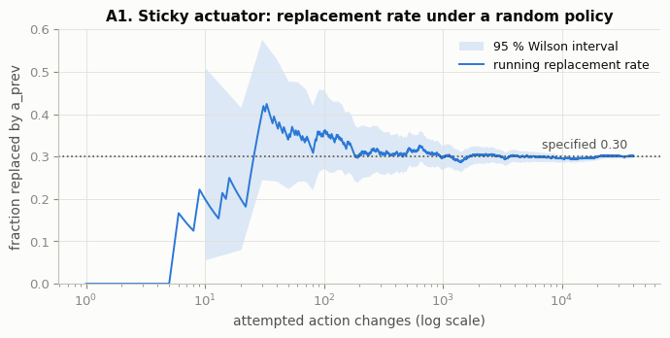
Reading A1 and the transition table. The running rate is noisy over the first few hundred switches, settles near 0.30 after ≈ 1 000 attempted changes, and ends at 0.302 with a 95 % interval [0.297, 0.306] that contains 0.30 (z = +0.69, p = 0.49: no evidence of any deviation). The 3 × 3 table shows ≈ 0.30 for every kind of switch (left → right, none → left, …) and exactly 0 on the diagonal, where the agent repeats its executed action.

1.5 Verification V4 — the energy penalty follows the selected action
Each step is placed in one of the four cases from the question's note. The penalty the agent actually received is recovered from the returned reward as R_base + B − R, where B is recomputed independently from the observation and flags.
In [21]:
def independent_bonus(df: pd.DataFrame) -> np.ndarray:
"""Recompute B from the logged observation and flags, without using the wrapper's
own bonus value."""
# all four bonus conditions
ok = (
df["terminated"]
& ~df["truncated"]
& (df["pos"] >= GOAL_POSITION)
& (df["vel"] <= GENTLE_SPEED)
)
return np.where(ok, GENTLE_BONUS, 0.0) # 25 where all conditions hold, else 0

audit["B_check"] = independent_bonus(audit) # independently recomputed bonus
# what the agent was charged
audit["penalty_received"] = audit["r_base"] + audit["B_check"] - audit["R"]
audit["case"] = np.select( # the four cases from the question's note
[
(audit["a"] != NO_PUSH) & ~audit["replaced"],
(audit["a"] != NO_PUSH) & audit["replaced"],
(audit["a"] == NO_PUSH) & audit["replaced"],
(audit["a"] == NO_PUSH) & ~audit["replaced"],
],
[
"selected push, executed as selected",
"selected push, actuator stuck on another action",
"selected 'no push', stuck actuator keeps pushing",
"selected 'no push', executed 'no push'",
],
default="unclassified",
) # never used: the four cases cover every step
# penalty statistics per case
v4 = audit.groupby("case", sort=False)["penalty_received"].agg(
steps="size", min_penalty="min", max_penalty="max"
)
# rule from the question
v4["expected"] = [0.3 if c.startswith("selected push") else 0.0 for c in v4.index]
# observed penalty equals the rule in every step
v4["match"] = np.isclose(v4["min_penalty"], v4["expected"]) & np.isclose(
v4["max_penalty"], v4["expected"]
)
display(v4.round(6)) # show the four cases
# largest deviation from the reward formula
max_err = float(
np.abs(
audit["R"]
- (audit["r_base"] - PUSH_PENALTY * (audit["a"] != NO_PUSH) + audit["B_check"])
).max()
)
# all conditions of V4
V4_PASS = bool(
v4["match"].all() and max_err < 1e-12 and (audit["r_base"] == -1.0).all()
)
# verdict of check V4
print(
f"max |R - (R_base - 0.3*1[a!=1] + B)| over {len(audit):,} steps = {max_err:.1e} "
f"-> V4 {'PASS' if V4_PASS else 'FAIL'}"
)
 | steps | min_penalty | max_penalty | expected | match
case
selected 'no push', executed 'no push' | 16003 | 0.0 | 0.0 | 0.0 | True
selected push, executed as selected | 31960 | 0.3 | 0.3 | 0.3 | True
selected 'no push', stuck actuator keeps pushing | 3952 | 0.0 | 0.0 | 0.0 | True
selected push, actuator stuck on another action | 8085 | 0.3 | 0.3 | 0.3 | True

max |R - (R_base - 0.3*1[a!=1] + B)| over 60,000 steps = 0.0e+00 -> V4 PASS

1.6 Verification V5 — physics, termination and truncation are unchanged
For 25 audited episodes we replay the executed actions in a fresh, unwrapped MountainCar-v0 with the same reset seed. If the wrapper changed nothing except the action substitution, every observation and every terminated/truncated flag must match exactly.
In [23]:
mismatches, compared = 0, 0 # counters over all replayed steps
for ep, ep_log in list(audit.groupby("episode"))[:25]: # first 25 audited episodes
env_r = gym.make(ENV_ID) # fresh unwrapped environment
# same initial state as the audited run
env_r.reset(seed=int(ep_log["seed"].iloc[0]))
for rec in ep_log.itertuples(): # replay executed actions one by one
o, _, te, tr, _ = env_r.step(int(rec.a_exec)) # replay the executed action
# compare position, velocity and flags exactly
same = (
(float(o[0]) == rec.pos)
and (float(o[1]) == rec.vel)
and te == rec.terminated
and tr == rec.truncated
)
mismatches += int(not same) # count any difference
compared += 1 # count compared steps
V5_PASS = mismatches == 0 # V5 passes only with zero mismatches
# verdict of check V5
print(
f"replayed {compared:,} steps from 25 episodes: {mismatches} mismatches -> V5 "
f"{'PASS' if V5_PASS else 'FAIL'}"
)
replayed 5,000 steps from 25 episodes: 0 mismatches -> V5 PASS

1.7 Verification V6 — the +25 bonus is paid only for a gentle arrival
A random policy almost never reaches the flag, so we use hand-coded policies. Pure "push with the velocity" (the question's suggestion) is not enough here: in the original physics it always reaches the flag at about 0.033–0.050, so on its own it could never earn the bonus. (In the table below it does earn it in 10 of 60 episodes, but only because the sticky actuator sometimes delays its pushes and bleeds off speed.) We therefore add pump-then-coast variants: push with the velocity until position x_c, then stop pushing and let gravity slow the car. Varying x_c gives a mix of gentle arrivals, fast arrivals and time-outs.
Then seven boundary unit tests use a scripted fake base environment to hit the exact edge cases: v = 0.03 (inclusive), v = 0.0301, and reaching the flag on step 200 (terminated and truncated).
In [25]:
def pump_policy(obs, rng) -> int:
"""Hand-coded policy from webinar 1: push in the direction of the velocity."""
return PUSH_RIGHT if obs[1] >= 0 else PUSH_LEFT # push in the direction of motion

def make_pump_and_coast(x_coast: float):
"""Return a policy that pumps energy, then coasts (no push) once moving right beyond
position x_coast."""

def policy(obs, rng) -> int:
"""Push with the velocity, except coast on the final rightward approach."""
if obs[1] < 0: # moving left: keep pumping left
return PUSH_LEFT # keep pumping left while moving left
# moving right: coast after x_coast
return NO_PUSH if obs[0] > x_coast else PUSH_RIGHT

return policy # the configured policy

lab_stamp("part (a) - bonus audit") # stamp the start of the bonus audit
policies = {"pump (push with velocity)": pump_policy} # baseline heuristic
# six coasting thresholds
policies.update(
{
f"pump, coast after x>{xc:+.1f}": make_pump_and_coast(xc)
for xc in (-0.2, -0.1, 0.0, 0.1, 0.2, 0.3)
}
)
bonus_rows = [] # one row per policy
terminal_steps = [] # last step of every episode (for the pooled check)
for i, (name, pol) in enumerate(policies.items()): # run every hand-coded policy
# 60 audited episodes per policy
log = run_policy_with_audit(
pol, n_episodes=60, seed_base=20_000 + 100 * i, rng_seed=40 + i
)
last = log.groupby("episode").tail(1).copy() # final step of each episode
last["policy"] = name # remember which policy produced it
terminal_steps.append(last) # collect terminal steps
# gentle arrivals (bonus expected)
gentle = last["terminated"] & ~last["truncated"] & (last["vel"] <= GENTLE_SPEED)
# fast arrivals (no bonus expected)
fast = last["terminated"] & (last["vel"] > GENTLE_SPEED)
# summary row for this policy
bonus_rows.append(
dict(
policy=name,
episodes=len(last),
gentle_arrivals=int(gentle.sum()),
fast_arrivals=int(fast.sum()),
timeouts=int((~last["terminated"]).sum()),
bonus_paid=int((last["bonus"] == GENTLE_BONUS).sum()),
bonus_on_fast_or_timeout=int((last["bonus"][~gentle] != 0).sum()),
)
)
display(pd.DataFrame(bonus_rows)) # show the per-policy summary
term = pd.concat(terminal_steps) # pooled terminal steps of all 420 episodes
# random-policy audit: on all 60 000 steps the bonus must equal the independent rule
random_bonus_ok = bool((audit["bonus"] == audit["B_check"]).all())
paid = term[term["bonus"] == GENTLE_BONUS] # episodes that earned the bonus
# arrivals without the bonus
unpaid_arrivals = term[(term["bonus"] == 0) & term["terminated"]]
# boundary sharpness of the bonus rule
print(
f"pooled: {len(term)} episodes | bonus paid {len(paid)} times | "
f"max arrival speed among paid = {paid['vel'].max():.4f} (must be <= 0.03) | "
f"min arrival speed among unpaid arrivals = {unpaid_arrivals['vel'].min():.4f} "
"(must be > 0.03)"
)
# wrapper vs independent rule
pooled_ok = bool((term["bonus"].to_numpy() == independent_bonus(term)).all())

# --- boundary unit tests with a scripted fake base environment
# -------------------------------------------
class ScriptedBaseEnv(gym.Env):
"""Fake MountainCar whose next step returns a scripted (position, velocity,
terminated, truncated)."""

def __init__(self, pos, vel, terminated, truncated):
"""Store the outcome that step() will return; spaces copy MountainCar-v0."""
# same bounds as MountainCar-v0
self.observation_space = gym.spaces.Box(
np.array([-1.2, -0.07], np.float32), np.array([0.6, 0.07], np.float32)
)
self.action_space = gym.spaces.Discrete(3) # three actions
# scripted step result
self.outcome = (
np.array([pos, vel], np.float32),
-1.0,
terminated,
truncated,
{},
)

def reset(self, *, seed=None, options=None):
"""Return an arbitrary valley-floor state."""
super().reset(seed=seed) # seed the gym.Env base class
return np.array([-0.5, 0.0], np.float32), {} # valley-floor start state

def step(self, action):
"""Return the scripted outcome regardless of the action."""
return self.outcome # scripted (obs, reward, terminated, truncated, info)

cases = [ # (description, pos, vel, terminated, truncated, expected B)
("gentle arrival, v = 0.020", 0.52, 0.020, True, False, 25.0),
("boundary, v = 0.030 exactly (inclusive)", 0.52, 0.030, True, False, 25.0),
("just too fast, v = 0.0301", 0.52, 0.0301, True, False, 0.0),
("fast arrival, v = 0.045", 0.55, 0.045, True, False, 0.0),
(
"flag reached ON step 200 (terminated and truncated)",
0.51,
0.010,
True,
True,
0.0,
),
("time-out below the flag", 0.40, 0.010, False, True, 0.0),
("ordinary mid-episode step", 0.30, 0.010, False, False, 0.0),
]
unit_rows = [] # results of the boundary tests
for desc, pos, vel, te, tr, expected in cases: # one fake env per edge case
# wrap the fake env
w = StickyActuatorMountainCar(ScriptedBaseEnv(pos, vel, te, tr))
w.reset(seed=0) # fresh episode (a_prev = 1)
_, R, _, _, _ = w.step(NO_PUSH) # 'no push' -> no penalty, no random draw
# R + 1 recovers B (R_base = -1, no penalty)
unit_rows.append(
dict(
case=desc,
terminated=te,
truncated=tr,
velocity=vel,
B_expected=expected,
B_returned=R + 1.0,
match=np.isclose(R + 1.0, expected),
)
)
unit = pd.DataFrame(unit_rows) # table of the 7 cases
display(unit) # show the unit tests
# all bonus conditions verified
V6_PASS = bool(
len(paid) > 0
and paid["vel"].max() <= GENTLE_SPEED
and unpaid_arrivals["vel"].min() > GENTLE_SPEED
and random_bonus_ok
and pooled_ok
and unit["match"].all()
)
# verdict of check V6, with the two pooled consistency checks spelled out
print(
f"bonus = independent rule on all {len(audit):,} random-policy steps: "
f"{random_bonus_ok} | on all {len(term)} hand-coded episodes: {pooled_ok}"
)
print(f"V6 {'PASS' if V6_PASS else 'FAIL'}")
[lab-stamp] 2026-11-04 22:44:04 | host=ip-10-3-20-152.ap-south-1.compute.internal | user=s2025ag05066 | part (a) - bonus audit
 | policy | episodes | gentle_arrivals | fast_arrivals | timeouts | bonus_paid | bonus_on_fast_or_timeout
0 | pump (push with velocity) | 60 | 10 | 50 | 0 | 10 | 0
1 | pump, coast after x>-0.2 | 60 | 20 | 33 | 7 | 20 | 0
2 | pump, coast after x>-0.1 | 60 | 17 | 43 | 0 | 17 | 0
3 | pump, coast after x>+0.0 | 60 | 12 | 48 | 0 | 12 | 0
4 | pump, coast after x>+0.1 | 60 | 13 | 47 | 0 | 13 | 0
5 | pump, coast after x>+0.2 | 60 | 11 | 49 | 0 | 11 | 0
6 | pump, coast after x>+0.3 | 60 | 10 | 50 | 0 | 10 | 0

pooled: 420 episodes | bonus paid 93 times | max arrival speed among paid = 0.0298 (must be <= 0.03) | min arrival speed among unpaid arrivals = 0.0301 (must be > 0.03)
 | case | terminated | truncated | velocity | B_expected | B_returned | match
0 | gentle arrival, v = 0.020 | True | False | 0.0200 | 25.0 | 25.0 | True
1 | boundary, v = 0.030 exactly (inclusive) | True | False | 0.0300 | 25.0 | 25.0 | True
2 | just too fast, v = 0.0301 | True | False | 0.0301 | 0.0 | 0.0 | True
3 | fast arrival, v = 0.045 | True | False | 0.0450 | 0.0 | 0.0 | True
4 | flag reached ON step 200 (terminated and trunc... | True | True | 0.0100 | 0.0 | 0.0 | True
5 | time-out below the flag | False | True | 0.0100 | 0.0 | 0.0 | True
6 | ordinary mid-episode step | False | False | 0.0100 | 0.0 | 0.0 | True

bonus = independent rule on all 60,000 random-policy steps: True | on all 420 hand-coded episodes: True
V6 PASS

1.8 Verification summary
In [27]:
summary_a = pd.DataFrame(
[
(
"V1",
"Question's worked example reproduced step-for-step (4 random draws, none "
"on the repeat)",
V1_PASS,
),
(
"V2",
"Observation/action spaces, time limit, initial state and info keys "
"unchanged",
V2_PASS,
),
(
"V3",
f"Replacement rate {p_hat:.3f} on {n:,} attempted changes (CI contains "
"0.30); 0 replacements on repeats",
V3_PASS,
),
(
"V4",
"Penalty 0.3 for every selected push (stuck or not), 0 for every selected "
"'no push'",
V4_PASS,
),
(
"V5",
"Executed actions replayed in the plain env give identical observations "
"and flags",
V5_PASS,
),
(
"V6",
"Bonus paid only for gentle arrivals (hand-coded runs + 7 boundary unit "
"tests)",
V6_PASS,
),
],
columns=["check", "what is verified", "pass"],
)
display(summary_a) # show the six checks
# stop the notebook if any check failed
assert summary_a[
"pass"
].all(), "a verification check failed - fix the wrapper before training"
lab_stamp("part (a) complete") # stamp the end of part (a)
 | check | what is verified | pass
0 | V1 | Question's worked example reproduced step-for-... | True
1 | V2 | Observation/action spaces, time limit, initial... | True
2 | V3 | Replacement rate 0.302 on 39,914 attempted cha... | True
3 | V4 | Penalty 0.3 for every selected push (stuck or ... | True
4 | V5 | Executed actions replayed in the plain env giv... | True
5 | V6 | Bonus paid only for gentle arrivals (hand-code... | True

[lab-stamp] 2026-11-04 22:44:07 | host=ip-10-3-20-152.ap-south-1.compute.internal | user=s2025ag05066 | part (a) complete

2. Shared machinery for parts (b) and (c)

2.1 Uniform discretiser
In [29]:
class UniformDiscretizer:
"""Map a continuous (position, velocity) observation to integer bin indices on a
uniform grid."""

def __init__(self, low, high, bins):
"""Pre-compute bin widths and edges for each observation dimension."""
self.low = np.asarray(low, dtype=float) # lower bounds of the observation box
self.high = np.asarray(high, dtype=float) # upper bounds
self.bins = tuple(int(b) for b in bins) # bins per dimension
# bin width per dimension
self.width = (self.high - self.low) / np.array(self.bins)
# bin edges
self.edges = [
np.linspace(l, h, b + 1) for l, h, b in zip(self.low, self.high, self.bins)
]
# cached scalars for speed
self._lo0, self._lo1 = float(self.low[0]), float(self.low[1])
# cached bin widths
self._w0, self._w1 = float(self.width[0]), float(self.width[1])
self._n0, self._n1 = self.bins[0] - 1, self.bins[1] - 1 # largest valid index

def index(self, obs) -> tuple:
"""Return (position_bin, velocity_bin) for one observation, clipped to the
grid."""
i = int((float(obs[0]) - self._lo0) / self._w0) # position bin
j = int((float(obs[1]) - self._lo1) / self._w1) # velocity bin
# clip the top edge into the last bin
return (min(max(i, 0), self._n0), min(max(j, 0), self._n1))

def index_batch(self, states: np.ndarray):
"""Vectorised version of index() for an (N, 2) array; returns two integer
arrays."""
idx = ((states - self.low) / self.width).astype(int) # raw bin indices
idx = np.clip(idx, 0, np.array(self.bins) - 1) # clip into the grid
return idx[:, 0], idx[:, 1] # position and velocity indices

def centers(self, dim: int) -> np.ndarray:
"""Bin centres along one dimension (used for axis ticks)."""
e = self.edges[dim] # edges of this dimension
return (e[:-1] + e[1:]) / 2 # midpoints between edges

_space = gym.make(ENV_ID).observation_space # official observation bounds
# 36 x 28 grid
DISC = UniformDiscretizer(_space.low, _space.high, (CFG.n_pos_bins, CFG.n_vel_bins))
# grid size and bin widths
print(
f"grid {DISC.bins[0]} x {DISC.bins[1]} = {DISC.bins[0] * DISC.bins[1]} states | "
f"bin widths: position {DISC.width[0]:.4f}, velocity {DISC.width[1]:.5f}"
)
# confirm the two aligned edges
print(
"flag x = 0.5 is a position edge: "
f"{np.isclose(DISC.edges[0], GOAL_POSITION).any()} | "
f"v = 0.03 is a velocity edge: {np.isclose(DISC.edges[1], GENTLE_SPEED).any()}"
)
e25 = np.linspace(-0.07, 0.07, 26) # comparison: the minimum 25 x 25 grid
# why 25 x 25 is not enough
print(
f"(for comparison, on a 25 x 25 grid the velocity edges around 0.03 are "
f"{e25[e25 < 0.03][-1]:.4f} and {e25[e25 >= 0.03][0]:.4f}, so 'gentle' and 'too "
"fast' share a bin)"
)

def state_shape(state_mode: str) -> tuple:
"""Shape of the discrete state space: (pos, vel) for the standard agent, (pos, vel,
last action) for 'memory'."""
# memory adds a last-action dimension
return DISC.bins if state_mode == "obs" else DISC.bins + (3,)

def make_state_encoder(state_mode: str):
"""Return encode(obs, last_selected_action) -> state tuple for the chosen state
representation."""
if state_mode == "obs": # required representation: observation only
return lambda obs, last_action: DISC.index(obs) # ignore the last action
if state_mode == "memory": # extra experiment: agent remembers its own last choice
# append the last selected action
return lambda obs, last_action: DISC.index(obs) + (int(last_action),)
raise ValueError(state_mode) # unknown representation
grid 36 x 28 = 1008 states | bin widths: position 0.0500, velocity 0.00500
flag x = 0.5 is a position edge: True | v = 0.03 is a velocity edge: True
(for comparison, on a 25 x 25 grid the velocity edges around 0.03 are 0.0252 and 0.0308, so 'gentle' and 'too fast' share a bin)

2.2 Fixed validation set of states (for the average-max-Q plot)
Following the DQN paper (Mnih et al., Session 12), the validation states are collected once, before any training, by running policies in the original environment: half the episodes use a random policy (valley states), half use the pump heuristic with 20 % random actions (high-energy states near the flag). We keep 1 000 non-terminal states. The same array is used for all four agents and never changes.
In [31]:
def collect_validation_states(n_states: int = 1000, seed: int = SEED) -> np.ndarray:
"""Sample a fixed set of reachable states from random and heuristic roll-outs in the
original environment."""
env = gym.make(ENV_ID) # original environment
rng = np.random.default_rng([seed, 7]) # dedicated generator for this sampling
pool = [] # every visited non-terminal state
for ep in range(60): # 60 roll-outs
obs, _ = env.reset(seed=seed * 1000 + ep) # seeded start state
while True: # roll out one episode
pool.append(obs.copy()) # record the state before acting
# random episodes / 20 % noise in heuristic ones
if ep % 2 == 0 or rng.random() < 0.2:
action = int(rng.integers(3)) # random action
else:
action = pump_policy(obs, rng) # energy-pumping heuristic
# advance the environment
obs, _, terminated, truncated, _ = env.step(action)
if terminated or truncated: # episode finished
break # leave the loop
pool = np.array(pool) # (N, 2) array of states
# subsample without replacement
pick = rng.choice(len(pool), size=n_states, replace=False)
return pool[pick] # the fixed validation states

VAL_STATES = collect_validation_states() # sampled ONCE, before training
VAL_IDX = DISC.index_batch(VAL_STATES) # their grid cells (pre-computed)
# saved for reproducibility
np.save(os.path.join(OUT_DIR, "validation_states.npy"), VAL_STATES)
# size and coverage of the validation set
print(
f"validation set: {len(VAL_STATES)} states covering {len(set(zip(*VAL_IDX)))} "
"distinct grid cells"
)
validation set: 1000 states covering 308 distinct grid cells

2.3 ε-greedy exploration schedule
ε_k = max(0.05, 1.0 · ρ^k) with ρ = (0.05 / 1.0)^(1 / 5000). ε reaches 0.05 at episode 5 000 and stays there.
In [33]:
def epsilon_schedule(cfg: ExperimentConfig) -> np.ndarray:
"""Exploration rate for every training episode: exponential decay to eps_end, then
constant."""
decay_episodes = cfg.eps_decay_fraction * cfg.n_episodes # episodes until the floor
# per-episode decay factor
rho = (cfg.eps_end / cfg.eps_start) ** (1.0 / decay_episodes)
# clipped at the floor
return np.maximum(cfg.eps_end, cfg.eps_start * rho ** np.arange(cfg.n_episodes))

EPS = epsilon_schedule(CFG) # schedule shared by all agents
# two panels: schedule and validation set
fig, axes = plt.subplots(1, 2, figsize=(11, 3.4))
axes[0].plot(EPS, color=INK, lw=1.6) # ε versus episode
# label the schedule panel
axes[0].set(
xlabel="training episode", ylabel="ε", title="S1. Exploration schedule (all agents)"
)
# annotate reference points
for ep_mark in (CFG.n_episodes // 10, CFG.n_episodes // 4, CFG.n_episodes // 2):
# write the epsilon value at the mark
axes[0].annotate(
f"ε={EPS[ep_mark]:.2f}",
(ep_mark, EPS[ep_mark]),
xytext=(4, 4),
textcoords="offset points",
fontsize=8.5,
color=INK_2,
)
ax = axes[1] # right panel
# states
ax.scatter(
VAL_STATES[:, 0],
VAL_STATES[:, 1],
s=4,
color=ALGO_COLOR["q_learning"],
alpha=0.5,
lw=0,
)
for x in DISC.edges[0]: # vertical bin edges
ax.axvline(x, color="#e1e0d9", lw=0.4, zorder=0) # position grid lines
for v in DISC.edges[1]: # horizontal bin edges
ax.axhline(v, color="#e1e0d9", lw=0.4, zorder=0) # velocity grid lines
ax.axvline(GOAL_POSITION, color=INK_2, ls=":", lw=1.2) # flag
ax.axhline(GENTLE_SPEED, color=INK_2, ls=":", lw=1.2) # gentle threshold
# label the flag line
ax.text(
GOAL_POSITION - 0.01, -0.066, "flag x=0.5", ha="right", fontsize=8.5, color=INK_2
)
# label the threshold line
ax.text(-1.19, GENTLE_SPEED + 0.002, "v = 0.03", fontsize=8.5, color=INK_2)
# axes limits = observation box
ax.set(
xlim=(-1.2, 0.6),
ylim=(-0.07, 0.07),
xlabel="position",
ylabel="velocity",
axisbelow=True,
title="S2. Validation states on the 36 × 28 grid",
)
ax.grid(False) # bin edges replace the default grid
save_fig(fig, "S_setup") # save and show
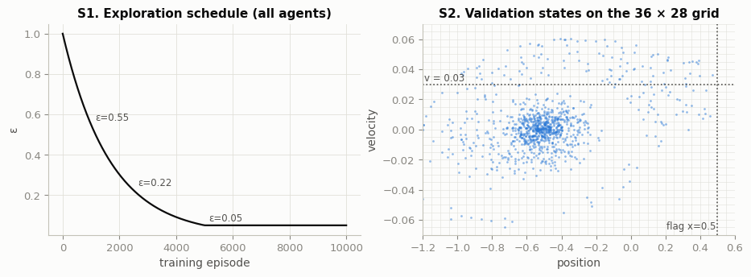

2.4 The agent — Q-learning and SARSA differ only in td_target
Both algorithms use one class and one training loop. The loop always picks the next action a′ with ε-greedy before the update (SARSA needs it for its target; Q-learning just executes it on the next step), so random number use and code path are identical. The only branch on the algorithm is the bootstrap term:
- Q-learning (off-policy): target = R + γ · max_a′ Q(s′, a′)
- SARSA (on-policy): target = R + γ · Q(s′, a′) with a′ the action actually chosen by ε-greedy
If the episode terminated (flag reached) the target is just R. Truncation is not terminal: at step 200 both algorithms still bootstrap from s′ (SARSA uses the a′ it selected at s′, even though it is never executed). a in the update is the action selected by the agent, because the executed action is hidden from it.
In [35]:
class TabularTDAgent:
"""Tabular one-step TD control agent; algorithm='q_learning' (off-policy) or 'sarsa'
(on-policy)."""

def __init__(
self,
algorithm: str,
state_shape: tuple,
n_actions: int,
alpha: float,
gamma: float,
rng,
):
"""Create a zero-initialised Q-table of shape state_shape + (n_actions,)."""
if algorithm not in ("q_learning", "sarsa"): # only the two required algorithms
raise ValueError(algorithm) # reject unknown algorithms
self.algorithm = algorithm # selects the TD target
self.Q = np.zeros(tuple(state_shape) + (n_actions,)) # Q-table, all zeros
self.n_actions = n_actions # 3 for MountainCar
self.alpha = alpha # learning rate
self.gamma = gamma # discount factor
self.rng = rng # agent's own random generator

def greedy_action(self, s: tuple, rng=None) -> int:
"""argmax_a Q(s, a), breaking ties uniformly at random (all-zero rows are common
early on)."""
q = self.Q[s] # the 3 action values of state s
best = np.flatnonzero(q == q.max()) # all maximising actions
if len(best) == 1: # usual case: a unique maximum
return int(best[0]) # the unique best action
return int((rng or self.rng).choice(best)) # random tie-break

def select_action(self, s: tuple, epsilon: float) -> int:
"""ε-greedy: a random action with probability ε, otherwise the greedy action."""
if self.rng.random() < epsilon: # explore
return int(self.rng.integers(self.n_actions)) # uniformly random action
return self.greedy_action(s) # exploit

def td_target(self, r: float, s_next: tuple, a_next, terminated: bool) -> float:
"""THE ONLY ALGORITHM-SPECIFIC LINE: the bootstrap term of the one-step TD
target."""
if terminated: # flag reached: no bootstrap
return r # terminal: target is the reward only
if self.algorithm == "q_learning": # off-policy: value of the greedy action
bootstrap = self.Q[s_next].max() # max over next actions (greedy)
else: # on-policy: value of the action chosen
bootstrap = self.Q[s_next + (a_next,)] # value of the chosen next action
return r + self.gamma * bootstrap # one-step TD target

def update(
self, s: tuple, a: int, r: float, s_next: tuple, a_next, terminated: bool
) -> float:
"""Q(s,a) <- Q(s,a) + α [target - Q(s,a)]; returns the TD error."""
idx = s + (a,) # index of the updated entry
# target minus current estimate
td_error = self.td_target(r, s_next, a_next, terminated) - self.Q[idx]
self.Q[idx] += self.alpha * td_error # move the estimate towards the target
return td_error # returned for logging

def avg_max_q(self, vi: np.ndarray, vj: np.ndarray) -> float:
"""Average over the validation states of max_a Q(s, a) (memory agents use last
action = 'no push')."""
# (N, 3) action values
q = self.Q[vi, vj] if self.Q.ndim == 3 else self.Q[vi, vj, NO_PUSH]
return float(q.max(axis=1).mean()) # average over validation states

2.5 Training loop (shared by all agents)
In [37]:
@dataclass
class RunResult:
"""Everything produced by one training run."""

label: str # e.g. "Q-learning | sticky"
algorithm: str # 'q_learning' or 'sarsa'
env_kind: str # 'original' or 'modified'
seed: int # random seed of the run
state_mode: str # 'obs' (required) or 'memory' (extra experiment)
agent: TabularTDAgent # trained agent (holds the Q-table)
visits: np.ndarray # number of updates per discrete state
log: pd.DataFrame # one row per training episode
seconds: float # wall-clock training time

def trailing_mean(x, w: int = 100) -> np.ndarray:
"""Mean over the previous w episodes (fewer at the start); NaNs are ignored."""
# pandas rolling mean
return pd.Series(x).rolling(w, min_periods=1).mean().to_numpy()

def train_agent(
algorithm: str,
env_kind: str,
cfg: ExperimentConfig = CFG,
seed: int = SEED,
state_mode: str = "obs",
verbose: bool = True,
log_every=None,
) -> RunResult:
"""Train one tabular agent for cfg.n_episodes episodes and return its Q-table plus
per-episode logs."""
# human-readable run name
label = f"{ALGO_LABEL[algorithm]} | {ENV_LABEL[env_kind]}" + (
" | memory" if state_mode == "memory" else ""
)
log_every = log_every or cfg.log_every # progress-line frequency
env = make_env(env_kind) # fresh environment for this run
encode = make_state_encoder(state_mode) # observation -> discrete state
agent = TabularTDAgent(
algorithm,
state_shape(state_mode),
3,
cfg.alpha,
cfg.gamma,
# agent generator derived from the seed
np.random.default_rng([seed, 1]),
)
eps_values = epsilon_schedule(cfg) # identical schedule for every agent
n = cfg.n_episodes # number of training episodes
# logs
rec = {
k: np.zeros(n)
for k in ("reward", "length", "pushes", "epsilon", "avg_max_q", "mean_abs_td")
}
success = np.zeros(n, dtype=bool) # flag reached (terminated)
gentle = np.zeros(n, dtype=bool) # gentle-arrival criterion met
arrival_v = np.full(n, np.nan) # velocity when the flag was reached
visits = np.zeros(agent.Q.shape[:-1], dtype=np.int64) # update counts per state
vi, vj = VAL_IDX # fixed validation states
t0 = time.perf_counter() # start the stopwatch
if verbose: # optional start stamp + column legend
lab_stamp(f"train {label} | seed {seed} | {n} ep")
# legend for the progress columns (two short lines so they never wrap)
print(" R100 / succ / gentle / push = means over the previous 100 episodes")
print(" maxQ = average of max_a Q(s,a) over the fixed validation states")
for ep in range(n): # training episodes
eps = eps_values[ep] # ε for this episode
# seed only the first reset (Gym convention)
obs, _ = env.reset(seed=seed if ep == 0 else None)
s = encode(obs, NO_PUSH) # initial discrete state
a = agent.select_action(s, eps) # first action
ep_reward, steps, pushes, abs_td = 0.0, 0, 0, 0.0 # per-episode accumulators
while True: # steps within the episode
# act (the env may execute a different action)
obs, r, terminated, truncated, _ = env.step(a)
ep_reward += r # undiscounted episode reward
steps += 1 # count steps
pushes += int(a != NO_PUSH) # pushes *selected* by the agent
s_next = encode(obs, a) # next discrete state
# a' chosen BEFORE the update
a_next = None if terminated else agent.select_action(s_next, eps)
# TD update (only target differs)
abs_td += abs(agent.update(s, a, r, s_next, a_next, terminated))
visits[s] += 1 # count the update of state s
if terminated or truncated: # episode over
break # leave the step loop
s, a = s_next, a_next # SARSA-style hand-over for both algorithms
# store per-episode results
rec["reward"][ep], rec["length"][ep], rec["pushes"][ep] = (
ep_reward,
steps,
pushes,
)
# epsilon used and mean |TD error| per step
rec["epsilon"][ep], rec["mean_abs_td"][ep] = eps, abs_td / steps
# value estimate on the fixed validation set
rec["avg_max_q"][ep] = agent.avg_max_q(vi, vj)
success[ep] = terminated # reached the flag
# bonus criterion, also tracked in the original env
gentle[ep] = (
terminated
and not truncated
and obs[0] >= GOAL_POSITION
and obs[1] <= GENTLE_SPEED
)
# arrival speed (only if arrived)
arrival_v[ep] = obs[1] if terminated else np.nan
if verbose and (ep + 1) % log_every == 0: # periodic progress line
w = slice(max(0, ep - 99), ep + 1) # previous 100 episodes
# one progress line
print(
f"{clock()} ep {ep + 1:>5}/{n} eps {eps:.3f} "
f"R100 {rec['reward'][w].mean():7.1f} succ {success[w].mean():.2f} "
f"gentle {gentle[w].mean():.2f} push {rec['pushes'][w].mean():5.1f} "
f"maxQ {rec['avg_max_q'][ep]:6.1f}"
)
seconds = time.perf_counter() - t0 # training time
log = pd.DataFrame(rec) # per-episode log table
# add the boolean columns
log["success"], log["gentle"], log["arrival_velocity"] = success, gentle, arrival_v
log.index.name = "episode" # name the index
# unique file name per run
tag = f"{algorithm}_{env_kind}_{state_mode}_seed{seed}_ep{n}"
log.to_csv(os.path.join(OUT_DIR, f"log_{tag}.csv")) # full per-episode log on disk
if verbose: # optional end stamp
print(f"{clock()} done in {seconds:.1f} s -> {OUT_DIR}/log_{tag}.csv")
# everything the analysis needs
return RunResult(
label, algorithm, env_kind, seed, state_mode, agent, visits, log, seconds
)

3. Training

3.1 Part (b) — Q-learning on the original and the modified environment
One progress line is printed every 100 episodes: time, episode, ε, then R100 / succ / gentle / push (means over the previous 100 episodes) and maxQ (average max_a Q on the fixed validation states). The complete per-episode log of every run is written to outputs/log_*.csv.
In [39]:
RUNS = {} # (algorithm, env_kind) -> RunResult
for env_kind in ("original", "modified"): # same seed, config and episode count
# Q-learning run
RUNS[("q_learning", env_kind)] = train_agent("q_learning", env_kind)
[lab-stamp] 2026-11-04 22:44:09 | host=ip-10-3-20-152.ap-south-1.compute.internal | user=s2025ag05066 | train Q-learning | original | seed 109 | 10000 ep
R100 / succ / gentle / push = means over the previous 100 episodes
maxQ = average of max_a Q(s,a) over the fixed validation states
22:44:10 ep 100/10000 eps 0.942 R100 -200.0 succ 0.00 gentle 0.00 push 133.0 maxQ -5.7
22:44:12 ep 200/10000 eps 0.888 R100 -200.0 succ 0.00 gentle 0.00 push 135.5 maxQ -8.0
22:44:13 ep 300/10000 eps 0.836 R100 -200.0 succ 0.00 gentle 0.00 push 137.3 maxQ -9.8
22:44:14 ep 400/10000 eps 0.787 R100 -200.0 succ 0.00 gentle 0.00 push 140.3 maxQ -11.1
22:44:16 ep 500/10000 eps 0.742 R100 -200.0 succ 0.00 gentle 0.00 push 140.3 maxQ -12.7
22:44:17 ep 600/10000 eps 0.698 R100 -200.0 succ 0.00 gentle 0.00 push 140.9 maxQ -13.7
22:44:18 ep 700/10000 eps 0.658 R100 -200.0 succ 0.00 gentle 0.00 push 142.1 maxQ -14.9
22:44:20 ep 800/10000 eps 0.620 R100 -200.0 succ 0.00 gentle 0.00 push 142.3 maxQ -16.3
22:44:21 ep 900/10000 eps 0.584 R100 -200.0 succ 0.00 gentle 0.00 push 143.5 maxQ -17.0
22:44:22 ep 1000/10000 eps 0.550 R100 -200.0 succ 0.00 gentle 0.00 push 143.4 maxQ -17.9
22:44:24 ep 1100/10000 eps 0.518 R100 -200.0 succ 0.00 gentle 0.00 push 141.8 maxQ -19.1
22:44:25 ep 1200/10000 eps 0.488 R100 -200.0 succ 0.00 gentle 0.00 push 143.7 maxQ -20.0
22:44:27 ep 1300/10000 eps 0.459 R100 -200.0 succ 0.00 gentle 0.00 push 143.5 maxQ -21.0
22:44:29 ep 1400/10000 eps 0.432 R100 -200.0 succ 0.00 gentle 0.00 push 145.1 maxQ -21.5
22:44:30 ep 1500/10000 eps 0.407 R100 -200.0 succ 0.00 gentle 0.00 push 144.1 maxQ -22.2
22:44:31 ep 1600/10000 eps 0.384 R100 -200.0 succ 0.00 gentle 0.00 push 144.7 maxQ -22.9
22:44:33 ep 1700/10000 eps 0.361 R100 -199.8 succ 0.02 gentle 0.02 push 145.8 maxQ -23.6
22:44:35 ep 1800/10000 eps 0.340 R100 -200.0 succ 0.00 gentle 0.00 push 146.2 maxQ -24.3
22:44:37 ep 1900/10000 eps 0.321 R100 -200.0 succ 0.00 gentle 0.00 push 145.9 maxQ -25.0
22:44:38 ep 2000/10000 eps 0.302 R100 -199.6 succ 0.04 gentle 0.04 push 146.3 maxQ -25.4
22:44:40 ep 2100/10000 eps 0.284 R100 -198.6 succ 0.07 gentle 0.06 push 146.0 maxQ -26.2
22:44:41 ep 2200/10000 eps 0.268 R100 -196.8 succ 0.15 gentle 0.15 push 145.2 maxQ -26.9
22:44:43 ep 2300/10000 eps 0.252 R100 -197.3 succ 0.11 gentle 0.11 push 144.0 maxQ -27.4
22:44:44 ep 2400/10000 eps 0.238 R100 -199.6 succ 0.02 gentle 0.02 push 146.5 maxQ -28.1
22:44:45 ep 2500/10000 eps 0.224 R100 -197.4 succ 0.08 gentle 0.08 push 146.1 maxQ -28.5
22:44:47 ep 2600/10000 eps 0.211 R100 -198.2 succ 0.10 gentle 0.09 push 148.2 maxQ -29.1
22:44:48 ep 2700/10000 eps 0.198 R100 -197.2 succ 0.10 gentle 0.09 push 147.0 maxQ -29.6
22:44:49 ep 2800/10000 eps 0.187 R100 -198.8 succ 0.13 gentle 0.11 push 146.1 maxQ -30.2
22:44:51 ep 2900/10000 eps 0.176 R100 -196.0 succ 0.22 gentle 0.19 push 143.4 maxQ -30.6
22:44:52 ep 3000/10000 eps 0.166 R100 -190.8 succ 0.41 gentle 0.39 push 143.3 maxQ -31.1
22:44:53 ep 3100/10000 eps 0.156 R100 -193.2 succ 0.24 gentle 0.21 push 144.2 maxQ -31.5
22:44:55 ep 3200/10000 eps 0.147 R100 -198.8 succ 0.12 gentle 0.11 push 148.0 maxQ -32.1
22:44:56 ep 3300/10000 eps 0.139 R100 -193.8 succ 0.41 gentle 0.26 push 146.4 maxQ -32.4
22:44:57 ep 3400/10000 eps 0.130 R100 -179.8 succ 0.76 gentle 0.46 push 137.3 maxQ -32.8
22:44:58 ep 3500/10000 eps 0.123 R100 -188.8 succ 0.40 gentle 0.32 push 142.4 maxQ -33.5
22:45:00 ep 3600/10000 eps 0.116 R100 -186.9 succ 0.54 gentle 0.37 push 141.8 maxQ -33.8
22:45:01 ep 3700/10000 eps 0.109 R100 -192.1 succ 0.36 gentle 0.24 push 146.2 maxQ -34.2
22:45:02 ep 3800/10000 eps 0.103 R100 -195.7 succ 0.19 gentle 0.16 push 148.2 maxQ -34.6
22:45:03 ep 3900/10000 eps 0.097 R100 -197.4 succ 0.09 gentle 0.08 push 151.2 maxQ -35.0
22:45:05 ep 4000/10000 eps 0.091 R100 -198.2 succ 0.06 gentle 0.06 push 147.3 maxQ -35.5
22:45:06 ep 4100/10000 eps 0.086 R100 -194.8 succ 0.27 gentle 0.23 push 144.8 maxQ -36.1
22:45:07 ep 4200/10000 eps 0.081 R100 -183.3 succ 0.62 gentle 0.57 push 138.5 maxQ -36.4
22:45:08 ep 4300/10000 eps 0.076 R100 -187.9 succ 0.48 gentle 0.38 push 142.6 maxQ -36.8
22:45:10 ep 4400/10000 eps 0.072 R100 -193.9 succ 0.24 gentle 0.14 push 145.8 maxQ -37.2
22:45:11 ep 4500/10000 eps 0.068 R100 -196.5 succ 0.38 gentle 0.09 push 148.6 maxQ -37.6
22:45:12 ep 4600/10000 eps 0.064 R100 -182.2 succ 0.74 gentle 0.01 push 142.2 maxQ -37.9
22:45:13 ep 4700/10000 eps 0.060 R100 -181.1 succ 0.55 gentle 0.08 push 139.6 maxQ -38.4
22:45:15 ep 4800/10000 eps 0.056 R100 -188.4 succ 0.38 gentle 0.22 push 143.4 maxQ -39.0
22:45:16 ep 4900/10000 eps 0.053 R100 -181.6 succ 0.84 gentle 0.31 push 140.9 maxQ -39.3
22:45:17 ep 5000/10000 eps 0.050 R100 -173.1 succ 0.82 gentle 0.37 push 135.6 maxQ -39.6
22:45:18 ep 5100/10000 eps 0.050 R100 -178.0 succ 0.72 gentle 0.39 push 137.2 maxQ -39.9
22:45:19 ep 5200/10000 eps 0.050 R100 -171.8 succ 0.86 gentle 0.61 push 134.7 maxQ -40.3
22:45:20 ep 5300/10000 eps 0.050 R100 -170.7 succ 0.77 gentle 0.64 push 131.8 maxQ -40.6
22:45:21 ep 5400/10000 eps 0.050 R100 -167.7 succ 0.72 gentle 0.62 push 130.9 maxQ -41.0
22:45:23 ep 5500/10000 eps 0.050 R100 -193.5 succ 0.25 gentle 0.12 push 148.5 maxQ -41.5
22:45:24 ep 5600/10000 eps 0.050 R100 -181.2 succ 0.52 gentle 0.40 push 142.4 maxQ -41.8
22:45:25 ep 5700/10000 eps 0.050 R100 -176.8 succ 0.77 gentle 0.15 push 139.2 maxQ -42.2
22:45:26 ep 5800/10000 eps 0.050 R100 -175.7 succ 0.76 gentle 0.08 push 136.0 maxQ -42.4
22:45:27 ep 5900/10000 eps 0.050 R100 -176.4 succ 0.89 gentle 0.38 push 137.9 maxQ -42.5
22:45:28 ep 6000/10000 eps 0.050 R100 -175.1 succ 0.97 gentle 0.06 push 140.9 maxQ -42.7
22:45:29 ep 6100/10000 eps 0.050 R100 -161.1 succ 0.90 gentle 0.35 push 128.1 maxQ -43.0
22:45:30 ep 6200/10000 eps 0.050 R100 -164.0 succ 0.80 gentle 0.52 push 128.9 maxQ -43.4
22:45:31 ep 6300/10000 eps 0.050 R100 -163.6 succ 0.79 gentle 0.68 push 130.3 maxQ -43.7
22:45:32 ep 6400/10000 eps 0.050 R100 -167.4 succ 0.97 gentle 0.26 push 133.3 maxQ -43.8
22:45:34 ep 6500/10000 eps 0.050 R100 -180.0 succ 0.66 gentle 0.11 push 142.9 maxQ -44.1
22:45:35 ep 6600/10000 eps 0.050 R100 -175.6 succ 0.82 gentle 0.05 push 139.4 maxQ -44.4
22:45:36 ep 6700/10000 eps 0.050 R100 -168.6 succ 0.83 gentle 0.04 push 137.8 maxQ -44.7
22:45:37 ep 6800/10000 eps 0.050 R100 -174.2 succ 0.86 gentle 0.02 push 140.8 maxQ -45.1
22:45:38 ep 6900/10000 eps 0.050 R100 -174.8 succ 0.80 gentle 0.05 push 143.1 maxQ -45.1
22:45:39 ep 7000/10000 eps 0.050 R100 -174.0 succ 0.87 gentle 0.18 push 138.4 maxQ -45.3
22:45:40 ep 7100/10000 eps 0.050 R100 -182.2 succ 0.62 gentle 0.19 push 141.3 maxQ -45.7
22:45:42 ep 7200/10000 eps 0.050 R100 -174.2 succ 0.86 gentle 0.37 push 137.6 maxQ -45.9
22:45:43 ep 7300/10000 eps 0.050 R100 -170.5 succ 0.88 gentle 0.41 push 135.2 maxQ -46.2
22:45:44 ep 7400/10000 eps 0.050 R100 -164.2 succ 0.95 gentle 0.12 push 134.1 maxQ -46.4
22:45:45 ep 7500/10000 eps 0.050 R100 -153.4 succ 0.98 gentle 0.46 push 124.7 maxQ -46.6
22:45:46 ep 7600/10000 eps 0.050 R100 -151.9 succ 0.96 gentle 0.48 push 122.2 maxQ -46.8
22:45:47 ep 7700/10000 eps 0.050 R100 -143.3 succ 1.00 gentle 0.80 push 116.4 maxQ -46.8
22:45:48 ep 7800/10000 eps 0.050 R100 -156.6 succ 0.95 gentle 0.65 push 122.8 maxQ -47.0
22:45:49 ep 7900/10000 eps 0.050 R100 -148.8 succ 0.99 gentle 0.66 push 119.0 maxQ -47.3
22:45:50 ep 8000/10000 eps 0.050 R100 -147.8 succ 0.99 gentle 0.49 push 119.1 maxQ -47.5
22:45:51 ep 8100/10000 eps 0.050 R100 -150.1 succ 1.00 gentle 0.32 push 120.3 maxQ -47.7
22:45:52 ep 8200/10000 eps 0.050 R100 -153.0 succ 0.98 gentle 0.39 push 123.5 maxQ -47.9
22:45:53 ep 8300/10000 eps 0.050 R100 -151.7 succ 0.95 gentle 0.51 push 123.9 maxQ -48.2
22:45:54 ep 8400/10000 eps 0.050 R100 -151.0 succ 0.93 gentle 0.38 push 124.2 maxQ -48.2
22:45:55 ep 8500/10000 eps 0.050 R100 -157.3 succ 0.97 gentle 0.25 push 129.1 maxQ -48.3
22:45:56 ep 8600/10000 eps 0.050 R100 -165.2 succ 0.90 gentle 0.09 push 134.6 maxQ -48.4
22:45:57 ep 8700/10000 eps 0.050 R100 -156.1 succ 0.91 gentle 0.16 push 129.3 maxQ -48.7
22:45:58 ep 8800/10000 eps 0.050 R100 -167.9 succ 0.95 gentle 0.02 push 140.4 maxQ -48.8
22:45:59 ep 8900/10000 eps 0.050 R100 -171.1 succ 0.93 gentle 0.00 push 141.5 maxQ -49.0
22:46:00 ep 9000/10000 eps 0.050 R100 -160.9 succ 0.89 gentle 0.04 push 131.6 maxQ -49.2
22:46:01 ep 9100/10000 eps 0.050 R100 -158.2 succ 0.94 gentle 0.12 push 126.9 maxQ -49.3
22:46:02 ep 9200/10000 eps 0.050 R100 -160.2 succ 0.88 gentle 0.45 push 128.0 maxQ -49.5
22:46:03 ep 9300/10000 eps 0.050 R100 -162.3 succ 0.94 gentle 0.23 push 130.1 maxQ -49.6
22:46:04 ep 9400/10000 eps 0.050 R100 -158.1 succ 0.87 gentle 0.24 push 128.8 maxQ -49.6
22:46:05 ep 9500/10000 eps 0.050 R100 -156.2 succ 0.91 gentle 0.24 push 130.7 maxQ -49.9
22:46:06 ep 9600/10000 eps 0.050 R100 -153.8 succ 0.94 gentle 0.23 push 127.8 maxQ -49.9
22:46:07 ep 9700/10000 eps 0.050 R100 -158.5 succ 0.90 gentle 0.22 push 130.4 maxQ -50.1
22:46:08 ep 9800/10000 eps 0.050 R100 -154.3 succ 0.91 gentle 0.37 push 125.4 maxQ -50.2
22:46:09 ep 9900/10000 eps 0.050 R100 -150.1 succ 1.00 gentle 0.77 push 121.4 maxQ -50.4
22:46:10 ep 10000/10000 eps 0.050 R100 -140.2 succ 0.99 gentle 0.76 push 118.9 maxQ -50.5
22:46:10 done in 120.8 s -> outputs/log_q_learning_original_obs_seed109_ep10000.csv
[lab-stamp] 2026-11-04 22:46:10 | host=ip-10-3-20-152.ap-south-1.compute.internal | user=s2025ag05066 | train Q-learning | sticky | seed 109 | 10000 ep
R100 / succ / gentle / push = means over the previous 100 episodes
maxQ = average of max_a Q(s,a) over the fixed validation states
22:46:11 ep 100/10000 eps 0.942 R100 -239.3 succ 0.00 gentle 0.00 push 131.0 maxQ -7.7
22:46:13 ep 200/10000 eps 0.888 R100 -239.4 succ 0.00 gentle 0.00 push 131.3 maxQ -11.5
22:46:14 ep 300/10000 eps 0.836 R100 -239.2 succ 0.00 gentle 0.00 push 130.8 maxQ -14.0
22:46:16 ep 400/10000 eps 0.787 R100 -239.8 succ 0.00 gentle 0.00 push 132.6 maxQ -15.7
22:46:17 ep 500/10000 eps 0.742 R100 -239.3 succ 0.00 gentle 0.00 push 131.1 maxQ -17.7
22:46:18 ep 600/10000 eps 0.698 R100 -239.7 succ 0.00 gentle 0.00 push 132.4 maxQ -19.0
22:46:20 ep 700/10000 eps 0.658 R100 -239.0 succ 0.00 gentle 0.00 push 130.0 maxQ -20.7
22:46:21 ep 800/10000 eps 0.620 R100 -239.6 succ 0.00 gentle 0.00 push 131.9 maxQ -22.0
22:46:23 ep 900/10000 eps 0.584 R100 -239.1 succ 0.00 gentle 0.00 push 130.4 maxQ -23.2
22:46:24 ep 1000/10000 eps 0.550 R100 -238.9 succ 0.00 gentle 0.00 push 129.6 maxQ -24.1
22:46:26 ep 1100/10000 eps 0.518 R100 -238.9 succ 0.00 gentle 0.00 push 129.7 maxQ -25.3
22:46:27 ep 1200/10000 eps 0.488 R100 -239.7 succ 0.00 gentle 0.00 push 132.2 maxQ -26.5
22:46:29 ep 1300/10000 eps 0.459 R100 -239.5 succ 0.00 gentle 0.00 push 131.7 maxQ -27.4
22:46:30 ep 1400/10000 eps 0.432 R100 -238.8 succ 0.00 gentle 0.00 push 129.3 maxQ -28.4
22:46:32 ep 1500/10000 eps 0.407 R100 -239.1 succ 0.00 gentle 0.00 push 130.2 maxQ -29.3
22:46:33 ep 1600/10000 eps 0.384 R100 -238.5 succ 0.01 gentle 0.01 push 129.2 maxQ -30.4
22:46:34 ep 1700/10000 eps 0.361 R100 -238.9 succ 0.00 gentle 0.00 push 129.5 maxQ -31.1
22:46:36 ep 1800/10000 eps 0.340 R100 -238.4 succ 0.01 gentle 0.01 push 129.6 maxQ -31.9
22:46:37 ep 1900/10000 eps 0.321 R100 -238.4 succ 0.01 gentle 0.01 push 129.5 maxQ -32.5
22:46:39 ep 2000/10000 eps 0.302 R100 -238.8 succ 0.00 gentle 0.00 push 129.3 maxQ -33.2
22:46:40 ep 2100/10000 eps 0.284 R100 -238.5 succ 0.01 gentle 0.01 push 129.3 maxQ -34.1
22:46:42 ep 2200/10000 eps 0.268 R100 -238.0 succ 0.02 gentle 0.02 push 130.2 maxQ -34.9
22:46:43 ep 2300/10000 eps 0.252 R100 -238.6 succ 0.00 gentle 0.00 push 128.6 maxQ -35.3
22:46:45 ep 2400/10000 eps 0.238 R100 -238.2 succ 0.02 gentle 0.02 push 130.0 maxQ -36.1
22:46:46 ep 2500/10000 eps 0.224 R100 -237.7 succ 0.04 gentle 0.03 push 129.5 maxQ -36.9
22:46:48 ep 2600/10000 eps 0.211 R100 -239.1 succ 0.00 gentle 0.00 push 130.3 maxQ -37.7
22:46:49 ep 2700/10000 eps 0.198 R100 -238.3 succ 0.01 gentle 0.01 push 129.5 maxQ -38.2
22:46:51 ep 2800/10000 eps 0.187 R100 -235.5 succ 0.06 gentle 0.06 push 128.3 maxQ -38.7
22:46:52 ep 2900/10000 eps 0.176 R100 -236.9 succ 0.06 gentle 0.05 push 130.8 maxQ -39.2
22:46:54 ep 3000/10000 eps 0.166 R100 -234.6 succ 0.09 gentle 0.09 push 128.7 maxQ -39.7
22:46:55 ep 3100/10000 eps 0.156 R100 -237.2 succ 0.03 gentle 0.03 push 128.2 maxQ -40.2
22:46:57 ep 3200/10000 eps 0.147 R100 -238.9 succ 0.01 gentle 0.01 push 131.0 maxQ -40.8
22:46:58 ep 3300/10000 eps 0.139 R100 -237.6 succ 0.04 gentle 0.03 push 129.4 maxQ -41.4
22:47:00 ep 3400/10000 eps 0.130 R100 -238.7 succ 0.02 gentle 0.02 push 131.5 maxQ -42.0
22:47:01 ep 3500/10000 eps 0.123 R100 -235.9 succ 0.07 gentle 0.06 push 128.1 maxQ -42.6
22:47:03 ep 3600/10000 eps 0.116 R100 -232.1 succ 0.13 gentle 0.12 push 127.0 maxQ -43.1
22:47:04 ep 3700/10000 eps 0.109 R100 -235.7 succ 0.05 gentle 0.05 push 127.9 maxQ -43.7
22:47:06 ep 3800/10000 eps 0.103 R100 -232.6 succ 0.12 gentle 0.12 push 127.2 maxQ -44.5
22:47:07 ep 3900/10000 eps 0.097 R100 -223.3 succ 0.34 gentle 0.29 push 125.2 maxQ -44.8
22:47:09 ep 4000/10000 eps 0.091 R100 -226.2 succ 0.24 gentle 0.24 push 127.1 maxQ -45.2
22:47:10 ep 4100/10000 eps 0.086 R100 -217.8 succ 0.41 gentle 0.39 push 124.0 maxQ -45.7
22:47:12 ep 4200/10000 eps 0.081 R100 -228.6 succ 0.23 gentle 0.22 push 129.6 maxQ -46.2
22:47:14 ep 4300/10000 eps 0.076 R100 -236.1 succ 0.06 gentle 0.05 push 127.3 maxQ -46.8
22:47:15 ep 4400/10000 eps 0.072 R100 -226.8 succ 0.32 gentle 0.28 push 128.8 maxQ -47.3
22:47:17 ep 4500/10000 eps 0.068 R100 -218.0 succ 0.40 gentle 0.39 push 125.7 maxQ -47.4
22:47:19 ep 4600/10000 eps 0.064 R100 -218.4 succ 0.36 gentle 0.35 push 125.0 maxQ -47.9
22:47:20 ep 4700/10000 eps 0.060 R100 -232.0 succ 0.14 gentle 0.13 push 126.0 maxQ -48.4
22:47:22 ep 4800/10000 eps 0.056 R100 -227.3 succ 0.22 gentle 0.20 push 124.9 maxQ -48.9
22:47:23 ep 4900/10000 eps 0.053 R100 -215.0 succ 0.46 gentle 0.45 push 124.2 maxQ -49.3
22:47:25 ep 5000/10000 eps 0.050 R100 -220.9 succ 0.31 gentle 0.29 push 123.7 maxQ -49.6
22:47:26 ep 5100/10000 eps 0.050 R100 -213.3 succ 0.52 gentle 0.48 push 122.0 maxQ -49.8
22:47:28 ep 5200/10000 eps 0.050 R100 -219.3 succ 0.33 gentle 0.30 push 122.3 maxQ -50.3
22:47:29 ep 5300/10000 eps 0.050 R100 -215.7 succ 0.44 gentle 0.41 push 122.4 maxQ -50.7
22:47:31 ep 5400/10000 eps 0.050 R100 -199.7 succ 0.69 gentle 0.68 push 119.2 maxQ -51.2
22:47:32 ep 5500/10000 eps 0.050 R100 -189.1 succ 0.76 gentle 0.75 push 114.5 maxQ -51.4
22:47:33 ep 5600/10000 eps 0.050 R100 -190.9 succ 0.66 gentle 0.66 push 115.8 maxQ -51.6
22:47:35 ep 5700/10000 eps 0.050 R100 -206.7 succ 0.49 gentle 0.48 push 119.0 maxQ -52.1
22:47:36 ep 5800/10000 eps 0.050 R100 -206.0 succ 0.67 gentle 0.62 push 124.3 maxQ -52.4
22:47:38 ep 5900/10000 eps 0.050 R100 -192.6 succ 0.80 gentle 0.74 push 118.4 maxQ -52.6
22:47:39 ep 6000/10000 eps 0.050 R100 -189.7 succ 0.73 gentle 0.70 push 117.1 maxQ -52.9
22:47:40 ep 6100/10000 eps 0.050 R100 -204.7 succ 0.56 gentle 0.55 push 119.0 maxQ -53.1
22:47:42 ep 6200/10000 eps 0.050 R100 -207.2 succ 0.52 gentle 0.50 push 121.0 maxQ -53.4
22:47:43 ep 6300/10000 eps 0.050 R100 -200.6 succ 0.65 gentle 0.64 push 118.3 maxQ -53.9
22:47:44 ep 6400/10000 eps 0.050 R100 -195.0 succ 0.74 gentle 0.72 push 116.1 maxQ -54.1
22:47:46 ep 6500/10000 eps 0.050 R100 -200.8 succ 0.69 gentle 0.68 push 117.7 maxQ -54.4
22:47:47 ep 6600/10000 eps 0.050 R100 -208.4 succ 0.46 gentle 0.45 push 116.9 maxQ -54.9
22:47:49 ep 6700/10000 eps 0.050 R100 -200.3 succ 0.68 gentle 0.67 push 115.1 maxQ -55.2
22:47:50 ep 6800/10000 eps 0.050 R100 -190.0 succ 0.80 gentle 0.77 push 111.7 maxQ -55.2
22:47:51 ep 6900/10000 eps 0.050 R100 -186.7 succ 0.80 gentle 0.79 push 109.6 maxQ -55.2
22:47:53 ep 7000/10000 eps 0.050 R100 -193.5 succ 0.72 gentle 0.71 push 111.1 maxQ -55.4
22:47:54 ep 7100/10000 eps 0.050 R100 -200.2 succ 0.57 gentle 0.57 push 115.2 maxQ -55.8
22:47:55 ep 7200/10000 eps 0.050 R100 -201.9 succ 0.54 gentle 0.54 push 111.7 maxQ -55.9
22:47:57 ep 7300/10000 eps 0.050 R100 -190.5 succ 0.67 gentle 0.67 push 109.7 maxQ -55.9
22:47:58 ep 7400/10000 eps 0.050 R100 -202.0 succ 0.58 gentle 0.58 push 115.3 maxQ -56.5
22:48:00 ep 7500/10000 eps 0.050 R100 -212.6 succ 0.43 gentle 0.42 push 114.6 maxQ -56.8
22:48:01 ep 7600/10000 eps 0.050 R100 -213.2 succ 0.42 gentle 0.40 push 112.0 maxQ -57.2
22:48:03 ep 7700/10000 eps 0.050 R100 -212.3 succ 0.45 gentle 0.44 push 114.1 maxQ -57.2
22:48:04 ep 7800/10000 eps 0.050 R100 -206.4 succ 0.60 gentle 0.58 push 115.6 maxQ -57.3
22:48:05 ep 7900/10000 eps 0.050 R100 -214.3 succ 0.45 gentle 0.44 push 117.6 maxQ -57.5
22:48:07 ep 8000/10000 eps 0.050 R100 -201.5 succ 0.61 gentle 0.61 push 114.3 maxQ -57.7
22:48:08 ep 8100/10000 eps 0.050 R100 -190.2 succ 0.75 gentle 0.75 push 115.1 maxQ -57.9
22:48:09 ep 8200/10000 eps 0.050 R100 -198.4 succ 0.59 gentle 0.59 push 116.1 maxQ -58.2
22:48:11 ep 8300/10000 eps 0.050 R100 -215.0 succ 0.34 gentle 0.34 push 121.4 maxQ -58.6
22:48:12 ep 8400/10000 eps 0.050 R100 -230.0 succ 0.15 gentle 0.11 push 118.2 maxQ -59.0
22:48:14 ep 8500/10000 eps 0.050 R100 -215.7 succ 0.43 gentle 0.40 push 116.2 maxQ -59.2
22:48:15 ep 8600/10000 eps 0.050 R100 -204.8 succ 0.57 gentle 0.54 push 114.6 maxQ -59.3
22:48:17 ep 8700/10000 eps 0.050 R100 -193.4 succ 0.80 gentle 0.77 push 113.8 maxQ -59.3
22:48:18 ep 8800/10000 eps 0.050 R100 -186.7 succ 0.82 gentle 0.77 push 110.4 maxQ -59.4
22:48:19 ep 8900/10000 eps 0.050 R100 -194.5 succ 0.64 gentle 0.62 push 107.0 maxQ -59.8
22:48:21 ep 9000/10000 eps 0.050 R100 -202.1 succ 0.54 gentle 0.53 push 110.4 maxQ -60.0
22:48:22 ep 9100/10000 eps 0.050 R100 -190.2 succ 0.71 gentle 0.71 push 110.4 maxQ -60.2
22:48:23 ep 9200/10000 eps 0.050 R100 -192.3 succ 0.73 gentle 0.70 push 111.7 maxQ -60.6
22:48:25 ep 9300/10000 eps 0.050 R100 -194.7 succ 0.78 gentle 0.75 push 115.0 maxQ -60.7
22:48:26 ep 9400/10000 eps 0.050 R100 -191.5 succ 0.77 gentle 0.75 push 110.0 maxQ -60.9
22:48:27 ep 9500/10000 eps 0.050 R100 -171.6 succ 0.84 gentle 0.83 push 104.0 maxQ -60.7
22:48:29 ep 9600/10000 eps 0.050 R100 -167.6 succ 0.91 gentle 0.90 push 101.7 maxQ -60.6
22:48:30 ep 9700/10000 eps 0.050 R100 -173.8 succ 0.86 gentle 0.85 push 103.7 maxQ -60.5
22:48:31 ep 9800/10000 eps 0.050 R100 -174.6 succ 0.88 gentle 0.88 push 104.0 maxQ -60.7
22:48:32 ep 9900/10000 eps 0.050 R100 -180.8 succ 0.87 gentle 0.85 push 106.9 maxQ -60.9
22:48:34 ep 10000/10000 eps 0.050 R100 -177.6 succ 0.91 gentle 0.90 push 102.0 maxQ -60.9
22:48:34 done in 143.6 s -> outputs/log_q_learning_modified_obs_seed109_ep10000.csv

3.2 Part (c) — SARSA on the original and the modified environment
In [41]:
for env_kind in ("original", "modified"): # identical conditions to part (b)
RUNS[("sarsa", env_kind)] = train_agent("sarsa", env_kind) # SARSA run
[lab-stamp] 2026-11-04 22:48:34 | host=ip-10-3-20-152.ap-south-1.compute.internal | user=s2025ag05066 | train SARSA | original | seed 109 | 10000 ep
R100 / succ / gentle / push = means over the previous 100 episodes
maxQ = average of max_a Q(s,a) over the fixed validation states
22:48:35 ep 100/10000 eps 0.942 R100 -200.0 succ 0.00 gentle 0.00 push 132.9 maxQ -9.1
22:48:36 ep 200/10000 eps 0.888 R100 -200.0 succ 0.00 gentle 0.00 push 134.6 maxQ -13.9
22:48:37 ep 300/10000 eps 0.836 R100 -200.0 succ 0.00 gentle 0.00 push 136.9 maxQ -17.0
22:48:38 ep 400/10000 eps 0.787 R100 -200.0 succ 0.00 gentle 0.00 push 140.0 maxQ -18.8
22:48:39 ep 500/10000 eps 0.742 R100 -200.0 succ 0.00 gentle 0.00 push 139.8 maxQ -20.7
22:48:40 ep 600/10000 eps 0.698 R100 -200.0 succ 0.00 gentle 0.00 push 141.2 maxQ -22.2
22:48:41 ep 700/10000 eps 0.658 R100 -200.0 succ 0.00 gentle 0.00 push 143.0 maxQ -23.2
22:48:43 ep 800/10000 eps 0.620 R100 -200.0 succ 0.00 gentle 0.00 push 142.5 maxQ -24.4
22:48:44 ep 900/10000 eps 0.584 R100 -200.0 succ 0.00 gentle 0.00 push 144.3 maxQ -25.0
22:48:45 ep 1000/10000 eps 0.550 R100 -200.0 succ 0.00 gentle 0.00 push 142.4 maxQ -25.8
22:48:46 ep 1100/10000 eps 0.518 R100 -200.0 succ 0.00 gentle 0.00 push 143.9 maxQ -26.4
22:48:47 ep 1200/10000 eps 0.488 R100 -200.0 succ 0.00 gentle 0.00 push 145.4 maxQ -27.1
22:48:49 ep 1300/10000 eps 0.459 R100 -200.0 succ 0.00 gentle 0.00 push 143.9 maxQ -27.7
22:48:50 ep 1400/10000 eps 0.432 R100 -200.0 succ 0.00 gentle 0.00 push 145.6 maxQ -28.0
22:48:51 ep 1500/10000 eps 0.407 R100 -200.0 succ 0.00 gentle 0.00 push 146.0 maxQ -28.5
22:48:52 ep 1600/10000 eps 0.384 R100 -199.6 succ 0.01 gentle 0.01 push 145.4 maxQ -29.0
22:48:53 ep 1700/10000 eps 0.361 R100 -199.3 succ 0.04 gentle 0.04 push 145.8 maxQ -29.4
22:48:55 ep 1800/10000 eps 0.340 R100 -199.7 succ 0.02 gentle 0.02 push 145.9 maxQ -29.9
22:48:56 ep 1900/10000 eps 0.321 R100 -199.7 succ 0.02 gentle 0.02 push 146.6 maxQ -30.1
22:48:57 ep 2000/10000 eps 0.302 R100 -198.1 succ 0.07 gentle 0.07 push 146.6 maxQ -30.4
22:48:58 ep 2100/10000 eps 0.284 R100 -196.7 succ 0.12 gentle 0.12 push 146.5 maxQ -30.9
22:48:59 ep 2200/10000 eps 0.268 R100 -194.6 succ 0.24 gentle 0.23 push 145.5 maxQ -31.3
22:49:00 ep 2300/10000 eps 0.252 R100 -197.6 succ 0.10 gentle 0.10 push 144.2 maxQ -31.5
22:49:02 ep 2400/10000 eps 0.238 R100 -197.4 succ 0.15 gentle 0.13 push 147.6 maxQ -31.9
22:49:03 ep 2500/10000 eps 0.224 R100 -192.0 succ 0.30 gentle 0.28 push 143.3 maxQ -32.3
22:49:04 ep 2600/10000 eps 0.211 R100 -196.8 succ 0.11 gentle 0.11 push 145.8 maxQ -32.7
22:49:05 ep 2700/10000 eps 0.198 R100 -197.2 succ 0.11 gentle 0.10 push 146.8 maxQ -33.1
22:49:06 ep 2800/10000 eps 0.187 R100 -196.4 succ 0.20 gentle 0.19 push 147.5 maxQ -33.5
22:49:07 ep 2900/10000 eps 0.176 R100 -192.2 succ 0.38 gentle 0.36 push 145.9 maxQ -33.7
22:49:08 ep 3000/10000 eps 0.166 R100 -192.9 succ 0.35 gentle 0.25 push 144.6 maxQ -34.2
22:49:10 ep 3100/10000 eps 0.156 R100 -192.4 succ 0.26 gentle 0.22 push 144.1 maxQ -34.6
22:49:11 ep 3200/10000 eps 0.147 R100 -187.8 succ 0.43 gentle 0.29 push 143.9 maxQ -35.0
22:49:12 ep 3300/10000 eps 0.139 R100 -197.6 succ 0.11 gentle 0.06 push 150.2 maxQ -35.3
22:49:13 ep 3400/10000 eps 0.130 R100 -197.1 succ 0.24 gentle 0.08 push 150.1 maxQ -35.7
22:49:14 ep 3500/10000 eps 0.123 R100 -191.8 succ 0.41 gentle 0.23 push 143.0 maxQ -36.0
22:49:15 ep 3600/10000 eps 0.116 R100 -185.0 succ 0.53 gentle 0.42 push 140.1 maxQ -36.4
22:49:16 ep 3700/10000 eps 0.109 R100 -187.5 succ 0.42 gentle 0.38 push 142.7 maxQ -37.0
22:49:17 ep 3800/10000 eps 0.103 R100 -178.9 succ 0.83 gentle 0.76 push 138.1 maxQ -37.2
22:49:19 ep 3900/10000 eps 0.097 R100 -175.8 succ 0.88 gentle 0.51 push 136.4 maxQ -37.5
22:49:20 ep 4000/10000 eps 0.091 R100 -191.5 succ 0.29 gentle 0.17 push 144.8 maxQ -37.9
22:49:21 ep 4100/10000 eps 0.086 R100 -199.0 succ 0.05 gentle 0.00 push 152.7 maxQ -38.2
22:49:22 ep 4200/10000 eps 0.081 R100 -194.6 succ 0.22 gentle 0.03 push 149.0 maxQ -38.7
22:49:23 ep 4300/10000 eps 0.076 R100 -181.8 succ 0.76 gentle 0.23 push 142.2 maxQ -39.1
22:49:24 ep 4400/10000 eps 0.072 R100 -183.5 succ 0.86 gentle 0.54 push 141.8 maxQ -39.3
22:49:25 ep 4500/10000 eps 0.068 R100 -180.5 succ 0.70 gentle 0.44 push 141.5 maxQ -39.6
22:49:26 ep 4600/10000 eps 0.064 R100 -180.9 succ 0.52 gentle 0.48 push 137.8 maxQ -39.9
22:49:27 ep 4700/10000 eps 0.060 R100 -170.5 succ 0.64 gentle 0.59 push 133.7 maxQ -40.3
22:49:29 ep 4800/10000 eps 0.056 R100 -187.5 succ 0.51 gentle 0.22 push 146.7 maxQ -40.7
22:49:30 ep 4900/10000 eps 0.053 R100 -180.6 succ 0.78 gentle 0.71 push 140.2 maxQ -40.9
22:49:31 ep 5000/10000 eps 0.050 R100 -169.3 succ 0.84 gentle 0.49 push 133.2 maxQ -41.2
22:49:32 ep 5100/10000 eps 0.050 R100 -151.4 succ 0.97 gentle 0.76 push 122.8 maxQ -41.5
22:49:33 ep 5200/10000 eps 0.050 R100 -176.5 succ 0.60 gentle 0.55 push 137.4 maxQ -41.8
22:49:34 ep 5300/10000 eps 0.050 R100 -191.2 succ 0.38 gentle 0.16 push 145.5 maxQ -42.1
22:49:35 ep 5400/10000 eps 0.050 R100 -174.1 succ 0.93 gentle 0.15 push 136.2 maxQ -42.4
22:49:36 ep 5500/10000 eps 0.050 R100 -174.9 succ 0.85 gentle 0.14 push 137.7 maxQ -42.6
22:49:37 ep 5600/10000 eps 0.050 R100 -174.4 succ 0.83 gentle 0.07 push 137.5 maxQ -42.9
22:49:38 ep 5700/10000 eps 0.050 R100 -173.3 succ 0.86 gentle 0.05 push 139.8 maxQ -43.1
22:49:39 ep 5800/10000 eps 0.050 R100 -175.6 succ 0.84 gentle 0.15 push 138.4 maxQ -43.4
22:49:40 ep 5900/10000 eps 0.050 R100 -181.2 succ 0.44 gentle 0.28 push 144.1 maxQ -43.7
22:49:41 ep 6000/10000 eps 0.050 R100 -181.1 succ 0.65 gentle 0.15 push 143.7 maxQ -44.2
22:49:43 ep 6100/10000 eps 0.050 R100 -178.8 succ 0.91 gentle 0.24 push 140.8 maxQ -44.6
22:49:44 ep 6200/10000 eps 0.050 R100 -171.1 succ 0.92 gentle 0.25 push 134.8 maxQ -44.8
22:49:45 ep 6300/10000 eps 0.050 R100 -169.1 succ 0.78 gentle 0.36 push 132.7 maxQ -45.0
22:49:46 ep 6400/10000 eps 0.050 R100 -155.5 succ 0.94 gentle 0.75 push 121.7 maxQ -45.2
22:49:46 ep 6500/10000 eps 0.050 R100 -157.7 succ 0.88 gentle 0.84 push 127.5 maxQ -45.5
22:49:48 ep 6600/10000 eps 0.050 R100 -174.9 succ 0.63 gentle 0.31 push 137.6 maxQ -45.9
22:49:49 ep 6700/10000 eps 0.050 R100 -171.9 succ 0.80 gentle 0.07 push 139.8 maxQ -46.3
22:49:50 ep 6800/10000 eps 0.050 R100 -167.0 succ 0.91 gentle 0.00 push 136.7 maxQ -46.6
22:49:51 ep 6900/10000 eps 0.050 R100 -169.4 succ 0.97 gentle 0.00 push 136.5 maxQ -46.6
22:49:52 ep 7000/10000 eps 0.050 R100 -168.4 succ 1.00 gentle 0.06 push 134.4 maxQ -46.7
22:49:53 ep 7100/10000 eps 0.050 R100 -166.3 succ 0.92 gentle 0.16 push 133.1 maxQ -47.0
22:49:54 ep 7200/10000 eps 0.050 R100 -168.0 succ 0.83 gentle 0.25 push 133.7 maxQ -47.2
22:49:55 ep 7300/10000 eps 0.050 R100 -166.4 succ 0.72 gentle 0.47 push 131.1 maxQ -47.3
22:49:56 ep 7400/10000 eps 0.050 R100 -168.3 succ 0.75 gentle 0.57 push 132.3 maxQ -47.6
22:49:57 ep 7500/10000 eps 0.050 R100 -156.9 succ 0.97 gentle 0.65 push 126.8 maxQ -47.8
22:49:58 ep 7600/10000 eps 0.050 R100 -164.4 succ 0.91 gentle 0.18 push 134.9 maxQ -48.0
22:49:59 ep 7700/10000 eps 0.050 R100 -173.6 succ 0.90 gentle 0.09 push 143.7 maxQ -48.2
22:50:00 ep 7800/10000 eps 0.050 R100 -162.0 succ 0.93 gentle 0.09 push 134.0 maxQ -48.3
22:50:01 ep 7900/10000 eps 0.050 R100 -151.1 succ 0.92 gentle 0.26 push 124.0 maxQ -48.5
22:50:02 ep 8000/10000 eps 0.050 R100 -150.7 succ 0.95 gentle 0.43 push 124.6 maxQ -48.8
22:50:03 ep 8100/10000 eps 0.050 R100 -155.8 succ 0.91 gentle 0.21 push 126.8 maxQ -48.9
22:50:04 ep 8200/10000 eps 0.050 R100 -163.9 succ 0.96 gentle 0.02 push 129.2 maxQ -49.1
22:50:05 ep 8300/10000 eps 0.050 R100 -162.5 succ 0.95 gentle 0.12 push 130.8 maxQ -49.4
22:50:06 ep 8400/10000 eps 0.050 R100 -170.2 succ 0.97 gentle 0.00 push 137.2 maxQ -49.6
22:50:07 ep 8500/10000 eps 0.050 R100 -167.7 succ 0.96 gentle 0.02 push 137.2 maxQ -49.9
22:50:08 ep 8600/10000 eps 0.050 R100 -163.1 succ 0.92 gentle 0.00 push 131.9 maxQ -50.0
22:50:09 ep 8700/10000 eps 0.050 R100 -158.5 succ 0.92 gentle 0.18 push 125.2 maxQ -50.2
22:50:10 ep 8800/10000 eps 0.050 R100 -148.8 succ 0.98 gentle 0.51 push 117.9 maxQ -50.3
22:50:11 ep 8900/10000 eps 0.050 R100 -158.7 succ 0.87 gentle 0.36 push 124.7 maxQ -50.5
22:50:11 ep 9000/10000 eps 0.050 R100 -151.5 succ 0.99 gentle 0.41 push 122.2 maxQ -50.6
22:50:12 ep 9100/10000 eps 0.050 R100 -160.1 succ 0.85 gentle 0.13 push 129.0 maxQ -51.0
22:50:13 ep 9200/10000 eps 0.050 R100 -167.8 succ 0.82 gentle 0.05 push 135.1 maxQ -51.3
22:50:15 ep 9300/10000 eps 0.050 R100 -173.6 succ 0.69 gentle 0.01 push 140.7 maxQ -51.4
22:50:16 ep 9400/10000 eps 0.050 R100 -163.7 succ 0.86 gentle 0.00 push 133.9 maxQ -51.5
22:50:17 ep 9500/10000 eps 0.050 R100 -156.3 succ 0.97 gentle 0.04 push 129.3 maxQ -51.7
22:50:17 ep 9600/10000 eps 0.050 R100 -153.3 succ 0.99 gentle 0.04 push 127.9 maxQ -51.7
22:50:18 ep 9700/10000 eps 0.050 R100 -154.7 succ 0.97 gentle 0.13 push 128.0 maxQ -51.9
22:50:19 ep 9800/10000 eps 0.050 R100 -162.1 succ 0.87 gentle 0.20 push 131.7 maxQ -52.2
22:50:20 ep 9900/10000 eps 0.050 R100 -165.5 succ 0.91 gentle 0.05 push 138.3 maxQ -52.3
22:50:21 ep 10000/10000 eps 0.050 R100 -169.3 succ 0.97 gentle 0.00 push 140.5 maxQ -52.4
22:50:22 done in 107.6 s -> outputs/log_sarsa_original_obs_seed109_ep10000.csv
[lab-stamp] 2026-11-04 22:50:22 | host=ip-10-3-20-152.ap-south-1.compute.internal | user=s2025ag05066 | train SARSA | sticky | seed 109 | 10000 ep
R100 / succ / gentle / push = means over the previous 100 episodes
maxQ = average of max_a Q(s,a) over the fixed validation states
22:50:23 ep 100/10000 eps 0.942 R100 -239.4 succ 0.00 gentle 0.00 push 131.3 maxQ -9.7
22:50:24 ep 200/10000 eps 0.888 R100 -239.4 succ 0.00 gentle 0.00 push 131.4 maxQ -16.2
22:50:25 ep 300/10000 eps 0.836 R100 -239.8 succ 0.00 gentle 0.00 push 132.8 maxQ -20.1
22:50:26 ep 400/10000 eps 0.787 R100 -240.1 succ 0.00 gentle 0.00 push 133.5 maxQ -23.3
22:50:28 ep 500/10000 eps 0.742 R100 -240.0 succ 0.00 gentle 0.00 push 133.4 maxQ -25.4
22:50:29 ep 600/10000 eps 0.698 R100 -239.8 succ 0.00 gentle 0.00 push 132.8 maxQ -27.5
22:50:30 ep 700/10000 eps 0.658 R100 -239.9 succ 0.00 gentle 0.00 push 133.0 maxQ -29.2
22:50:32 ep 800/10000 eps 0.620 R100 -239.9 succ 0.00 gentle 0.00 push 133.1 maxQ -30.6
22:50:33 ep 900/10000 eps 0.584 R100 -240.0 succ 0.00 gentle 0.00 push 133.5 maxQ -31.9
22:50:34 ep 1000/10000 eps 0.550 R100 -239.8 succ 0.00 gentle 0.00 push 132.5 maxQ -33.0
22:50:36 ep 1100/10000 eps 0.518 R100 -239.8 succ 0.00 gentle 0.00 push 132.6 maxQ -33.7
22:50:37 ep 1200/10000 eps 0.488 R100 -240.1 succ 0.00 gentle 0.00 push 133.8 maxQ -34.6
22:50:39 ep 1300/10000 eps 0.459 R100 -239.5 succ 0.00 gentle 0.00 push 131.7 maxQ -35.4
22:50:40 ep 1400/10000 eps 0.432 R100 -239.0 succ 0.00 gentle 0.00 push 130.1 maxQ -36.2
22:50:42 ep 1500/10000 eps 0.407 R100 -239.5 succ 0.00 gentle 0.00 push 131.8 maxQ -37.2
22:50:43 ep 1600/10000 eps 0.384 R100 -239.4 succ 0.00 gentle 0.00 push 131.3 maxQ -37.9
22:50:45 ep 1700/10000 eps 0.361 R100 -240.0 succ 0.00 gentle 0.00 push 133.4 maxQ -38.2
22:50:46 ep 1800/10000 eps 0.340 R100 -239.3 succ 0.01 gentle 0.01 push 132.8 maxQ -38.7
22:50:48 ep 1900/10000 eps 0.321 R100 -239.5 succ 0.03 gentle 0.02 push 134.2 maxQ -39.1
22:50:49 ep 2000/10000 eps 0.302 R100 -239.7 succ 0.00 gentle 0.00 push 132.4 maxQ -39.7
22:50:51 ep 2100/10000 eps 0.284 R100 -239.2 succ 0.01 gentle 0.01 push 132.0 maxQ -40.3
22:50:53 ep 2200/10000 eps 0.268 R100 -238.3 succ 0.02 gentle 0.02 push 130.8 maxQ -40.6
22:50:54 ep 2300/10000 eps 0.252 R100 -238.0 succ 0.03 gentle 0.03 push 131.1 maxQ -41.0
22:50:56 ep 2400/10000 eps 0.238 R100 -238.6 succ 0.02 gentle 0.02 push 132.3 maxQ -41.5
22:50:57 ep 2500/10000 eps 0.224 R100 -237.5 succ 0.05 gentle 0.05 push 134.3 maxQ -41.9
22:50:59 ep 2600/10000 eps 0.211 R100 -238.4 succ 0.04 gentle 0.04 push 133.2 maxQ -42.3
22:51:00 ep 2700/10000 eps 0.198 R100 -237.2 succ 0.04 gentle 0.04 push 130.6 maxQ -43.0
22:51:02 ep 2800/10000 eps 0.187 R100 -235.4 succ 0.07 gentle 0.07 push 129.9 maxQ -43.3
22:51:03 ep 2900/10000 eps 0.176 R100 -235.6 succ 0.08 gentle 0.07 push 130.1 maxQ -43.7
22:51:05 ep 3000/10000 eps 0.166 R100 -235.3 succ 0.08 gentle 0.08 push 129.8 maxQ -44.2
22:51:06 ep 3100/10000 eps 0.156 R100 -235.3 succ 0.07 gentle 0.07 push 131.0 maxQ -44.7
22:51:08 ep 3200/10000 eps 0.147 R100 -233.9 succ 0.11 gentle 0.11 push 128.8 maxQ -45.3
22:51:09 ep 3300/10000 eps 0.139 R100 -238.1 succ 0.03 gentle 0.03 push 132.4 maxQ -45.5
22:51:11 ep 3400/10000 eps 0.130 R100 -238.2 succ 0.03 gentle 0.03 push 131.9 maxQ -46.1
22:51:12 ep 3500/10000 eps 0.123 R100 -235.2 succ 0.07 gentle 0.06 push 128.6 maxQ -46.7
22:51:14 ep 3600/10000 eps 0.116 R100 -223.8 succ 0.38 gentle 0.32 push 130.2 maxQ -46.9
22:51:15 ep 3700/10000 eps 0.109 R100 -224.9 succ 0.33 gentle 0.30 push 130.4 maxQ -47.1
22:51:17 ep 3800/10000 eps 0.103 R100 -227.7 succ 0.19 gentle 0.19 push 124.2 maxQ -47.5
22:51:19 ep 3900/10000 eps 0.097 R100 -232.2 succ 0.13 gentle 0.13 push 129.2 maxQ -47.9
22:51:20 ep 4000/10000 eps 0.091 R100 -229.8 succ 0.18 gentle 0.17 push 130.1 maxQ -48.3
22:51:22 ep 4100/10000 eps 0.086 R100 -230.4 succ 0.16 gentle 0.15 push 127.7 maxQ -48.9
22:51:23 ep 4200/10000 eps 0.081 R100 -220.5 succ 0.32 gentle 0.30 push 121.8 maxQ -49.5
22:51:25 ep 4300/10000 eps 0.076 R100 -210.7 succ 0.55 gentle 0.54 push 123.8 maxQ -49.6
22:51:26 ep 4400/10000 eps 0.072 R100 -222.8 succ 0.30 gentle 0.29 push 123.6 maxQ -49.8
22:51:28 ep 4500/10000 eps 0.068 R100 -224.8 succ 0.26 gentle 0.24 push 126.6 maxQ -50.3
22:51:29 ep 4600/10000 eps 0.064 R100 -226.5 succ 0.20 gentle 0.20 push 126.9 maxQ -50.8
22:51:31 ep 4700/10000 eps 0.060 R100 -223.4 succ 0.30 gentle 0.27 push 126.3 maxQ -51.0
22:51:32 ep 4800/10000 eps 0.056 R100 -225.5 succ 0.23 gentle 0.23 push 123.9 maxQ -51.6
22:51:34 ep 4900/10000 eps 0.053 R100 -224.9 succ 0.23 gentle 0.22 push 125.4 maxQ -51.9
22:51:35 ep 5000/10000 eps 0.050 R100 -232.3 succ 0.18 gentle 0.14 push 129.5 maxQ -52.4
22:51:37 ep 5100/10000 eps 0.050 R100 -227.3 succ 0.24 gentle 0.24 push 128.0 maxQ -52.9
22:51:38 ep 5200/10000 eps 0.050 R100 -213.3 succ 0.57 gentle 0.55 push 121.3 maxQ -53.2
22:51:40 ep 5300/10000 eps 0.050 R100 -207.0 succ 0.59 gentle 0.58 push 119.3 maxQ -53.7
22:51:41 ep 5400/10000 eps 0.050 R100 -203.2 succ 0.68 gentle 0.63 push 121.3 maxQ -53.7
22:51:43 ep 5500/10000 eps 0.050 R100 -197.8 succ 0.68 gentle 0.65 push 118.1 maxQ -53.8
22:51:44 ep 5600/10000 eps 0.050 R100 -196.2 succ 0.69 gentle 0.69 push 118.6 maxQ -54.1
22:51:46 ep 5700/10000 eps 0.050 R100 -201.6 succ 0.60 gentle 0.59 push 121.8 maxQ -54.5
22:51:47 ep 5800/10000 eps 0.050 R100 -213.8 succ 0.44 gentle 0.42 push 122.8 maxQ -55.2
22:51:49 ep 5900/10000 eps 0.050 R100 -209.1 succ 0.52 gentle 0.50 push 121.6 maxQ -55.5
22:51:50 ep 6000/10000 eps 0.050 R100 -208.1 succ 0.55 gentle 0.55 push 122.0 maxQ -55.4
22:51:52 ep 6100/10000 eps 0.050 R100 -223.6 succ 0.32 gentle 0.32 push 121.1 maxQ -55.8
22:51:53 ep 6200/10000 eps 0.050 R100 -201.7 succ 0.64 gentle 0.59 push 117.1 maxQ -55.9
22:51:55 ep 6300/10000 eps 0.050 R100 -202.9 succ 0.67 gentle 0.55 push 120.4 maxQ -56.0
22:51:56 ep 6400/10000 eps 0.050 R100 -197.5 succ 0.71 gentle 0.63 push 120.0 maxQ -56.2
22:51:57 ep 6500/10000 eps 0.050 R100 -195.4 succ 0.70 gentle 0.65 push 113.8 maxQ -56.4
22:51:59 ep 6600/10000 eps 0.050 R100 -202.6 succ 0.54 gentle 0.54 push 111.3 maxQ -56.6
22:52:00 ep 6700/10000 eps 0.050 R100 -221.3 succ 0.27 gentle 0.26 push 119.5 maxQ -57.0
22:52:02 ep 6800/10000 eps 0.050 R100 -221.4 succ 0.31 gentle 0.30 push 118.4 maxQ -57.6
22:52:03 ep 6900/10000 eps 0.050 R100 -211.8 succ 0.52 gentle 0.46 push 120.7 maxQ -57.8
22:52:05 ep 7000/10000 eps 0.050 R100 -202.1 succ 0.69 gentle 0.62 push 119.7 maxQ -58.0
22:52:06 ep 7100/10000 eps 0.050 R100 -190.4 succ 0.84 gentle 0.82 push 112.7 maxQ -58.2
22:52:08 ep 7200/10000 eps 0.050 R100 -195.7 succ 0.65 gentle 0.63 push 111.8 maxQ -58.5
22:52:09 ep 7300/10000 eps 0.050 R100 -199.0 succ 0.60 gentle 0.56 push 112.4 maxQ -58.6
22:52:10 ep 7400/10000 eps 0.050 R100 -183.6 succ 0.79 gentle 0.79 push 111.9 maxQ -58.8
22:52:12 ep 7500/10000 eps 0.050 R100 -200.9 succ 0.63 gentle 0.60 push 117.6 maxQ -59.1
22:52:13 ep 7600/10000 eps 0.050 R100 -196.8 succ 0.78 gentle 0.76 push 113.8 maxQ -59.4
22:52:15 ep 7700/10000 eps 0.050 R100 -190.6 succ 0.79 gentle 0.77 push 107.6 maxQ -59.4
22:52:16 ep 7800/10000 eps 0.050 R100 -188.6 succ 0.81 gentle 0.80 push 108.9 maxQ -59.5
22:52:18 ep 7900/10000 eps 0.050 R100 -186.6 succ 0.75 gentle 0.74 push 105.5 maxQ -59.7
22:52:19 ep 8000/10000 eps 0.050 R100 -186.8 succ 0.75 gentle 0.74 push 111.2 maxQ -60.0
22:52:21 ep 8100/10000 eps 0.050 R100 -201.4 succ 0.61 gentle 0.61 push 112.9 maxQ -60.3
22:52:22 ep 8200/10000 eps 0.050 R100 -193.7 succ 0.71 gentle 0.68 push 110.5 maxQ -60.4
22:52:24 ep 8300/10000 eps 0.050 R100 -198.1 succ 0.62 gentle 0.62 push 113.4 maxQ -60.9
22:52:25 ep 8400/10000 eps 0.050 R100 -194.2 succ 0.63 gentle 0.62 push 115.9 maxQ -61.3
22:52:27 ep 8500/10000 eps 0.050 R100 -204.1 succ 0.61 gentle 0.58 push 115.1 maxQ -61.6
22:52:28 ep 8600/10000 eps 0.050 R100 -189.4 succ 0.90 gentle 0.86 push 113.6 maxQ -61.4
22:52:30 ep 8700/10000 eps 0.050 R100 -190.4 succ 0.83 gentle 0.78 push 107.8 maxQ -61.5
22:52:31 ep 8800/10000 eps 0.050 R100 -186.7 succ 0.81 gentle 0.76 push 102.4 maxQ -61.6
22:52:33 ep 8900/10000 eps 0.050 R100 -182.7 succ 0.80 gentle 0.76 push 105.8 maxQ -61.7
22:52:34 ep 9000/10000 eps 0.050 R100 -199.2 succ 0.59 gentle 0.56 push 108.9 maxQ -61.9
22:52:36 ep 9100/10000 eps 0.050 R100 -204.1 succ 0.55 gentle 0.52 push 111.6 maxQ -62.2
22:52:37 ep 9200/10000 eps 0.050 R100 -199.5 succ 0.70 gentle 0.65 push 108.9 maxQ -62.2
22:52:39 ep 9300/10000 eps 0.050 R100 -190.7 succ 0.73 gentle 0.69 push 107.2 maxQ -62.4
22:52:40 ep 9400/10000 eps 0.050 R100 -194.6 succ 0.67 gentle 0.63 push 104.1 maxQ -62.6
22:52:42 ep 9500/10000 eps 0.050 R100 -208.4 succ 0.50 gentle 0.50 push 113.2 maxQ -63.0
22:52:43 ep 9600/10000 eps 0.050 R100 -185.3 succ 0.78 gentle 0.75 push 108.3 maxQ -63.1
22:52:44 ep 9700/10000 eps 0.050 R100 -170.5 succ 0.93 gentle 0.92 push 104.4 maxQ -63.1
22:52:46 ep 9800/10000 eps 0.050 R100 -174.7 succ 0.90 gentle 0.87 push 107.3 maxQ -63.2
22:52:47 ep 9900/10000 eps 0.050 R100 -171.9 succ 0.91 gentle 0.91 push 105.1 maxQ -63.3
22:52:48 ep 10000/10000 eps 0.050 R100 -169.6 succ 0.94 gentle 0.90 push 102.3 maxQ -63.4
22:52:48 done in 146.7 s -> outputs/log_sarsa_modified_obs_seed109_ep10000.csv

3.3 Proof of identical experimental conditions
In [43]:
conditions = pd.DataFrame(
[
{
"agent": r.label,
"seed": r.seed,
"grid": f"{DISC.bins[0]}x{DISC.bins[1]}",
"Q-table shape": r.agent.Q.shape,
"initial Q": 0.0,
"alpha": r.agent.alpha,
"gamma": r.agent.gamma,
"episodes": len(r.log),
"eps first/last": f"{r.log['epsilon'].iloc[0]:.2f} / "
f"{r.log['epsilon'].iloc[-1]:.2f}",
"train time (s)": round(r.seconds, 1),
}
for r in RUNS.values()
]
)
display(conditions) # show the conditions table
 | agent | seed | grid | Q-table shape | initial Q | alpha | gamma | episodes | eps first/last | train time (s)
0 | Q-learning | original | 109 | 36x28 | (36, 28, 3) | 0.0 | 0.1 | 0.99 | 10000 | 1.00 / 0.05 | 120.8
1 | Q-learning | sticky | 109 | 36x28 | (36, 28, 3) | 0.0 | 0.1 | 0.99 | 10000 | 1.00 / 0.05 | 143.6
2 | SARSA | original | 109 | 36x28 | (36, 28, 3) | 0.0 | 0.1 | 0.99 | 10000 | 1.00 / 0.05 | 107.6
3 | SARSA | sticky | 109 | 36x28 | (36, 28, 3) | 0.0 | 0.1 | 0.99 | 10000 | 1.00 / 0.05 | 146.7

4. Part (d) — Performance evaluation
Four agents: Q-learning and SARSA, each on the original and the sticky (modified) environment. All curves are trailing means over the previous 100 episodes; the faint lines in D1 are raw per-episode values.
In [45]:
AGENTS = [
("q_learning", "original"),
("sarsa", "original"),
("q_learning", "modified"),
("sarsa", "modified"),
]

def curve(
ax, run: RunResult, column: str, raw: bool = False, label: str = None
) -> None:
"""Plot the 100-episode trailing mean of one log column (optionally with the raw
values faintly behind)."""
y = run.log[column].to_numpy(dtype=float) # raw per-episode values
# encoding: colour=algo, style=env
color, style = ALGO_COLOR[run.algorithm], ENV_STYLE[run.env_kind]
if raw: # raw curve only when requested
ax.plot(y, color=color, lw=0.5, alpha=0.12) # raw values, very faint
# trailing 100-episode mean
ax.plot(trailing_mean(y), color=color, ls=style, lw=1.8, label=label or run.label)

lab_stamp("part (d) - figures") # stamp the start of part (d)
[lab-stamp] 2026-11-04 22:52:49 | host=ip-10-3-20-152.ap-south-1.compute.internal | user=s2025ag05066 | part (d) - figures

4.1 Episode reward versus training episode
In [47]:
fig, axes = plt.subplots(1, 2, figsize=(12, 3.8))
# separate panels: different reward scales
for ax, env_kind in zip(axes, ("original", "modified")):
for alg in ("q_learning", "sarsa"): # both algorithms in this panel
# raw + moving average
curve(ax, RUNS[(alg, env_kind)], "reward", raw=True, label=ALGO_LABEL[alg])
# axis labels and panel title
ax.set(
xlabel="training episode",
ylabel="episode reward",
title=f"D1{'a' if env_kind == 'original' else 'b'}. Reward, "
f"{ENV_LABEL[env_kind]} environment",
)
ax.legend(loc="lower right") # legend in the empty corner
# reward definition, original env
axes[0].text(
0.01,
0.97,
"reward = −1 per step",
transform=axes[0].transAxes,
va="top",
fontsize=8.5,
color=INK_2,
)
# reward definition, sticky env
axes[1].text(
0.01,
0.97,
"reward = −1 − 0.3·push + 25·gentle",
transform=axes[1].transAxes,
va="top",
fontsize=8.5,
color=INK_2,
)
save_fig(fig, "D1_reward") # save and show
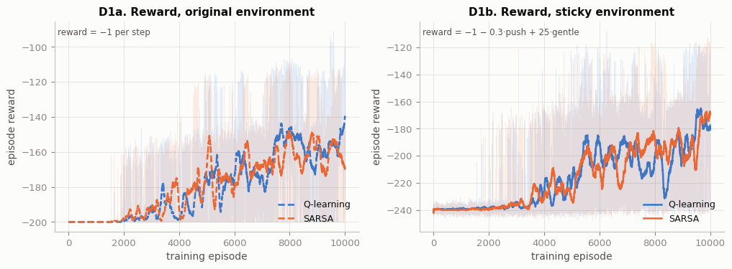
Interpretation (D1).
- Plateau first. In both environments no agent reaches the flag for roughly the first 2 000 episodes, so every episode scores the floor: −200 in the original env and about −240 in the sticky env (−200 plus 0.3 for each of the ~130 pushes an exploring agent selects). This is the classic MountainCar exploration problem.
- Original env. Learning starts once ε has dropped to ≈ 0.3–0.4 (episodes 1 600–2 000) and the optimistic zero-initialised values along the valley floor have been explored away. Both algorithms climb to about −140 … −170 by episode 10 000.
- Sticky env. The rise starts later (≈ episode 3 500) and is noisier. A wrong action can persist for several steps, and every selected push costs 0.3. The final level (≈ −170 … −180) already includes the +25 earned by gentle arrivals; without it these episodes would score ≈ −185 … −200.
- Q-learning vs SARSA. The curves overlap for most of training. The two algorithms differ more clearly in their final greedy policies (table 4.6) than in their ε-greedy training reward.

4.2 Average predicted value, max_a Q(s, a), on the fixed validation set
In [50]:
fig, axes = plt.subplots(1, 3, figsize=(15, 3.8))
# one panel per environment
for ax, env_kind in zip(axes[:2], ("original", "modified")):
for alg in ("q_learning", "sarsa"): # both algorithms
# value-estimate curve
curve(ax, RUNS[(alg, env_kind)], "avg_max_q", label=ALGO_LABEL[alg])
ax.set(
xlabel="training episode",
ylabel="mean of max_a Q(s,a)", # labels and title
title=f"D2{'a' if env_kind == 'original' else 'b'}. Value estimate, "
f"{ENV_LABEL[env_kind]} env",
)
ax.legend(loc="upper right") # legend
ax = axes[2] # gap Q-learning minus SARSA
for env_kind in ("original", "modified"): # both environments
# gap per episode
gap = (
RUNS[("q_learning", env_kind)].log["avg_max_q"]
- RUNS[("sarsa", env_kind)].log["avg_max_q"]
)
# gap curve
ax.plot(
trailing_mean(gap),
color=INK if env_kind == "modified" else INK_MUTED,
ls=ENV_STYLE[env_kind],
label=f"{ENV_LABEL[env_kind]} env",
)
ax.axhline(0, color="#c3c2b7", lw=1) # zero-gap reference
# labels and title
ax.set(
xlabel="training episode",
ylabel="Q-learning − SARSA",
title="D2c. Value gap between the algorithms",
)
ax.legend(loc="upper right") # legend
save_fig(fig, "D2_avg_max_q") # save and show
gap_table = pd.DataFrame(
{
env_kind: { # final values per environment
"Q-learning avg max Q (last 500 ep)": RUNS[("q_learning", env_kind)]
.log["avg_max_q"]
.iloc[-500:]
.mean(),
"SARSA avg max Q (last 500 ep)": RUNS[("sarsa", env_kind)]
.log["avg_max_q"]
.iloc[-500:]
.mean(),
}
for env_kind in ("original", "modified")
}
).T
# absolute gap
gap_table["gap (Q - SARSA)"] = gap_table.iloc[:, 0] - gap_table.iloc[:, 1]
# gap relative to SARSA
gap_table["relative gap"] = gap_table["gap (Q - SARSA)"] / gap_table.iloc[:, 1].abs()
display(gap_table.round(3)) # show the gap table
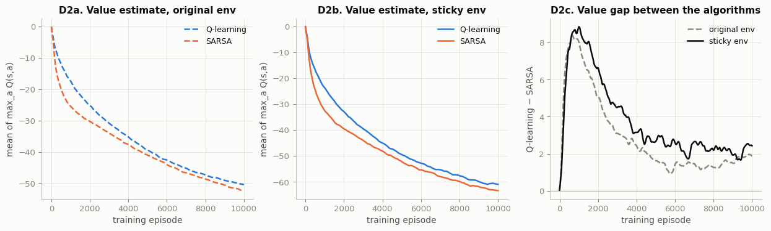
 | Q-learning avg max Q (last 500 ep) | SARSA avg max Q (last 500 ep) | gap (Q - SARSA) | relative gap
original | -50.178 | -52.061 | 1.883 | 0.036
modified | -60.712 | -63.163 | 2.451 | 0.039

Interpretation (D2).
- Optimism is learned away. All curves start at 0 and fall steadily. Every step costs at least 1, so the zero initialisation is optimistic, and training replaces it with realistic returns (≈ −50 original, ≈ −60 sticky). The curves still drift down slightly at episode 10 000, so the values are not fully converged.
- Q-learning is always above SARSA. Q-learning's target uses max_a′ Q(s′,a′): it values the greedy policy and collects the positive noise of the max (maximisation bias, Session 9). SARSA's target uses the action the ε-greedy policy actually chose, so it is charged for exploratory mistakes and is more pessimistic.
- The gap is larger with sticky actuators (D2c). It peaks at ≈ 8 around episode 1 000, while ε is still large, then settles. From about episode 1 500 the sticky-env gap stays above the original-env gap for most of training. Over the last 500 episodes it is 2.45 vs 1.88 for seed 109, and 3.0 vs 1.4 averaged over three seeds (section 5.2).
- Sticky values are lower overall. The −0.3 push penalty and slower progress cost more than the discounted +25 bonus gives back.

4.3 Success rate and gentle-arrival rate (trailing 100 episodes)
Success = the flag was reached (terminated). Gentle arrival = the bonus criterion (terminated, not truncated, v ≤ 0.03). The criterion is also evaluated for the original-environment agents, even though they were never rewarded for it.
In [53]:
# small multiples: metric x env
fig, axes = plt.subplots(2, 2, figsize=(12, 6.6), sharex=True, sharey=True)
panel = iter("abcd") # panel letters D3a..D3d
# rows: success / gentle
for row, (column, name) in enumerate(
(("success", "Success rate"), ("gentle", "Gentle-arrival rate"))
):
# columns: original / sticky
for col, env_kind in enumerate(("original", "modified")):
ax = axes[row, col] # current panel
for alg in ("q_learning", "sarsa"): # two lines per panel
# Q-learning and SARSA
curve(ax, RUNS[(alg, env_kind)], column, label=ALGO_LABEL[alg])
# fixed 0-1 range and title
ax.set(
ylim=(-0.02, 1.02),
title=f"D3{next(panel)}. {name}, {ENV_LABEL[env_kind]} env",
)
ax.legend(loc="upper left") # legend
for ax in axes[1]: # bottom row
ax.set_xlabel("training episode") # x label once
for ax in axes[:, 0]: # left column
ax.set_ylabel("rate (previous 100 episodes)") # y label once
fig.tight_layout() # avoid overlapping titles
save_fig(fig, "D3_success_gentle") # save and show
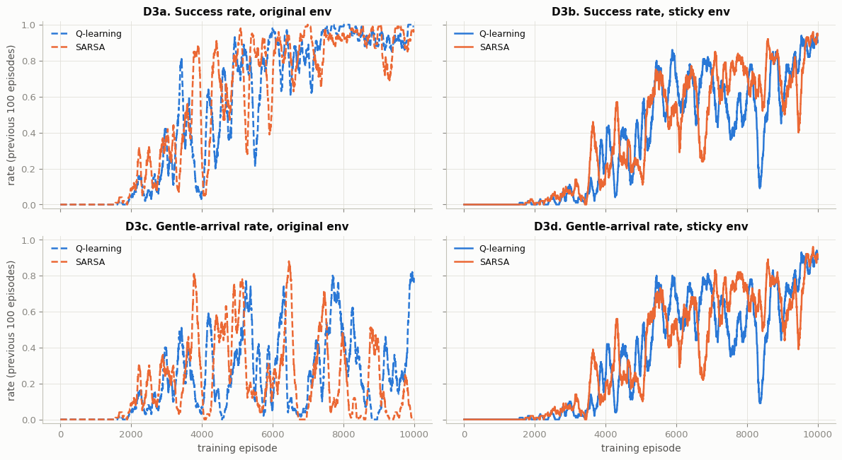
Interpretation (D3).
- Original env (left). Both algorithms go from 0 to a sustained ≈ 90 % success between episodes ≈ 2 000 and 7 000. Their gentle-arrival rate swings between 0 and 0.9 and ends near 0 for SARSA: nothing rewards a slow arrival, so arrival speed is just a side effect of whichever pumping cycle the agent locks into.
- Sticky env (right). Success rises later (≈ 20–30 % at episode 5 000 vs > 80 % in the original env) and more erratically; Q-learning even drops to ≈ 0.1 around episode 8 300 before recovering. Hidden actuator delays make the same greedy policy succeed in one episode and miss in the next.
- The bonus shapes the arrival. In the sticky env the gentle-arrival curve sits almost on top of the success curve: nearly every successful episode ends with a gentle arrival. Both algorithms finish at ≈ 0.9 or above on both metrics.

4.4 Push actions selected per episode
In [56]:
fig, axes = plt.subplots(1, 2, figsize=(12, 3.8))
for alg, env_kind in AGENTS: # all four agents
run = RUNS[(alg, env_kind)] # its run result
curve(axes[0], run, "pushes") # absolute pushes per episode
# colour = algorithm, style = environment
color, style = ALGO_COLOR[alg], ENV_STYLE[env_kind]
# share of steps with a push
axes[1].plot(
trailing_mean(run.log["pushes"] / run.log["length"]),
color=color,
ls=style,
label=run.label,
)
# left panel labels
axes[0].set(
xlabel="training episode",
ylabel="pushes selected per episode",
title="D4a. Pushes per episode",
)
# right panel labels
axes[1].set(
xlabel="training episode",
ylabel="pushes / steps",
title="D4b. Share of steps with a push",
ylim=(0, 1.02),
)
axes[1].legend(loc="lower left") # legend
save_fig(fig, "D4_pushes") # save and show
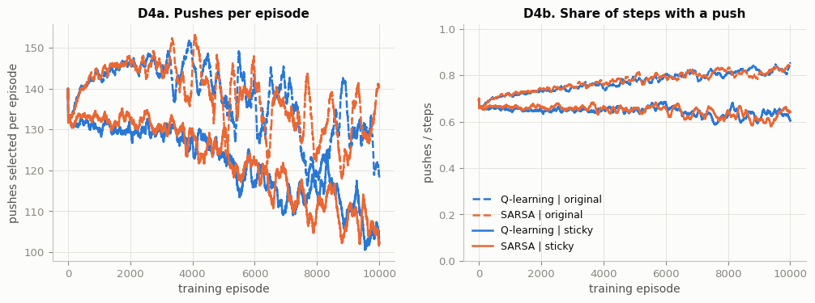
Interpretation (D4).
- Original env: more pushing. The share of steps with a push rises during training, from 0.67 (random choice) to ≈ 0.84. Pushing is free there, and the quickest way out of the valley is "bang-bang" energy pumping.
- Sticky env: less pushing. The push share falls to ≈ 0.62, and pushes per episode drop from ≈ 133 to ≈ 102. The 0.3 penalty teaches the agent to coast whenever gravity does the work.
- The reward drives this, not the algorithm. Q-learning and SARSA behave almost identically: push count depends on the reward function, not on whether learning is on- or off-policy.

4.5 Greedy policy maps
Each cell is one discretised state, coloured by argmax_a Q(s, a). Hatched cells were never updated (all-zero rows), so their "greedy action" would be meaningless. The black line is one greedy test episode (seed 50 000) in that agent's own environment.
In [59]:
def greedy_trajectory(run: RunResult, env_kind: str, seed: int) -> np.ndarray:
"""Positions/velocities visited by the greedy policy (ε = 0) in one seeded
episode."""
env = make_env(env_kind) # evaluation environment
encode = make_state_encoder(run.state_mode) # state representation of the agent
tie_rng = np.random.default_rng([seed, 3]) # deterministic tie-breaking
obs, _ = env.reset(seed=seed) # seeded start
path, last = [obs.copy()], NO_PUSH # path starts at the initial state
while True: # until the episode ends
a = run.agent.greedy_action(encode(obs, last), tie_rng) # greedy action
obs, _, te, tr, _ = env.step(a) # step the environment
path.append(obs.copy()) # record the new state
last = a # remember the selected action
if te or tr: # end of episode
return np.array(path) # array of visited states

POLICY_COLORS = ["#2a78d6", "#c3c2b7", "#e34948"] # push left / no push / push right
policy_cmap = ListedColormap(POLICY_COLORS) # 3-colour map
policy_cmap.set_bad((0, 0, 0, 0)) # unvisited cells transparent (hatch shows)
# 2 x 2 small multiples
fig, axes = plt.subplots(2, 2, figsize=(12, 8.2), sharex=True, sharey=True)
# one panel per agent
for ax, (alg, env_kind) in zip(
axes.flat,
[
("q_learning", "original"),
("sarsa", "original"),
("q_learning", "modified"),
("sarsa", "modified"),
],
):
run = RUNS[(alg, env_kind)] # its run result
greedy = run.agent.Q.argmax(axis=-1).astype(float) # greedy action per state
greedy[run.visits == 0] = np.nan # mask states never updated
ax.add_patch(
Rectangle(
(-1.2, -0.07),
1.8,
0.14,
facecolor="#fcfcfb",
edgecolor="#d6d5cf",
# hatched background = unvisited
hatch="////",
lw=0,
zorder=0,
)
)
ax.pcolormesh(
DISC.edges[0],
DISC.edges[1],
np.ma.masked_invalid(greedy.T),
cmap=policy_cmap,
vmin=-0.5,
vmax=2.5,
edgecolors="#fcfcfb",
linewidth=0.3,
zorder=1,
)
path = greedy_trajectory(run, env_kind, TEST_SEEDS[0]) # one greedy test episode
ax.plot(path[:, 0], path[:, 1], color=INK, lw=1.0, zorder=3) # trajectory line
ax.plot(path[0, 0], path[0, 1], "o", ms=5, color=INK, zorder=3) # start point
ax.axvline(GOAL_POSITION, color=INK, ls=":", lw=1, zorder=2) # flag
ax.axhline(GENTLE_SPEED, color=INK, ls=":", lw=1, zorder=2) # gentle threshold
# title with coverage statistics
ax.set_title(
f"D5. {run.label} (visited {np.isfinite(greedy).mean():.0%} of cells, "
f"'no push' in {np.mean(greedy[np.isfinite(greedy)] == 1):.0%})",
fontsize=10,
)
ax.set(xlim=(-1.2, 0.6), ylim=(-0.07, 0.07)) # observation box
ax.grid(False) # cells replace the grid
for ax in axes[1]: # bottom row
ax.set_xlabel("position") # x label
for ax in axes[:, 0]: # left column
ax.set_ylabel("velocity") # y label
# legend swatches
handles = [Patch(color=c, label=ACTION_NAMES[i]) for i, c in enumerate(POLICY_COLORS)]
handles.append(
Patch(facecolor="#fcfcfb", edgecolor="#b8b7b0", hatch="////", label="never visited")
)
# shared legend under the panels
fig.legend(handles=handles, loc="lower center", ncol=4, bbox_to_anchor=(0.5, -0.02))
fig.tight_layout(rect=(0, 0.04, 1, 1)) # leave space for the legend
save_fig(fig, "D5_policy_maps") # save and show
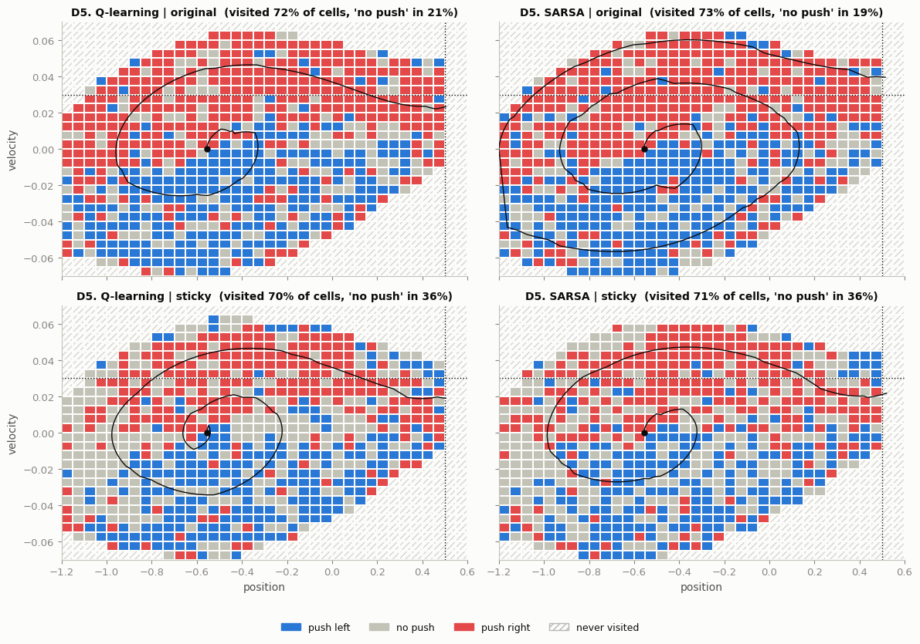
Interpretation (D5).
- Original env (top): bang-bang. Red (push right) fills most of the upper half (v > 0) and blue (push left) most of the lower half (v < 0). The agents have discovered "push in the direction of the velocity" for themselves; only ≈ 20 % of visited cells choose 'no push'.
- Sticky env (bottom): coasting. 'No push' grows to ≈ 36 % of cells, mostly where the car turns around (|v| small) and on the far-left slope, where gravity alone reverses the car.
- Sticky env: braking. Just left of the flag at high speed (x ≈ 0.4–0.5, v ≈ 0.03–0.045) there are blue "brake" cells: the agent pushes left to shed speed so it crosses x = 0.5 below 0.03.
- Greedy trajectories (black). SARSA-original crosses the flag still accelerating (v ≈ 0.04), while both sticky agents level off at v ≈ 0.02 on the final approach. Q-learning-original also arrives slowly here, but that is chance (see 4.7).
- The two algorithms. In each environment Q-learning and SARSA produce similar structure; most differences are in rarely visited cells at the edge of the visited region. About 30 % of cells are never visited (hatched): physically unreachable combinations such as high speed at the left wall.

4.6 Greedy test: 100 episodes with fixed seeds, ε = 0
Seeds 50 000 – 50 099 fix both the initial state and (in the modified env) the actuator's random stream, so all agents face exactly the same 100 test conditions. Ties in argmax are broken by a generator seeded with the episode seed.
In [62]:
def evaluate_greedy(run: RunResult, env_kind: str, seeds=TEST_SEEDS) -> pd.DataFrame:
"""Run the greedy policy (ε = 0) for one episode per seed; return one row per
episode."""
env = make_env(env_kind) # evaluation environment
encode = make_state_encoder(run.state_mode) # agent's state representation
rows = [] # one row per test episode
for sd in seeds: # 100 fixed seeds
obs, _ = env.reset(seed=sd) # fixed initial state (and actuator stream)
tie_rng = np.random.default_rng([sd, 3]) # reproducible tie-breaking
last, total, steps, pushes = NO_PUSH, 0.0, 0, 0 # per-episode accumulators
while True: # until the episode ends
a = run.agent.greedy_action(encode(obs, last), tie_rng) # ε = 0
obs, r, te, tr, _ = env.step(a) # step the environment
# update the totals
total, steps, pushes, last = (
total + r,
steps + 1,
pushes + int(a != NO_PUSH),
a,
)
if te or tr: # end of episode
break # leave the step loop
# record the episode
rows.append(
dict(
seed=sd,
reward=total,
length=steps,
pushes=pushes,
success=te,
gentle=bool(
te and not tr and obs[0] >= GOAL_POSITION and obs[1] <= GENTLE_SPEED
),
arrival_velocity=float(obs[1]) if te else np.nan,
)
)
return pd.DataFrame(rows) # one row per episode

def summarise(df: pd.DataFrame) -> dict:
"""Collapse 100 test episodes into the metrics reported in the evaluation table."""
# metrics of the evaluation table
return {
"mean reward": df["reward"].mean(),
"std reward": df["reward"].std(),
"success rate": df["success"].mean(),
"gentle-arrival rate": df["gentle"].mean(),
"mean episode length": df["length"].mean(),
"pushes / episode": df["pushes"].mean(),
"mean arrival speed": df["arrival_velocity"].mean(),
}

lab_stamp("part (d) - greedy test episodes") # stamp the greedy tests
# each agent in its own environment
EVAL = {key: evaluate_greedy(RUNS[key], key[1]) for key in AGENTS}
# one row per agent
eval_table = pd.DataFrame(
{RUNS[key].label: summarise(df) for key, df in EVAL.items()}
).T
eval_table.to_csv(os.path.join(OUT_DIR, "eval_table.csv")) # save to CSV
display(eval_table.round(3)) # show the table
[lab-stamp] 2026-11-04 22:52:56 | host=ip-10-3-20-152.ap-south-1.compute.internal | user=s2025ag05066 | part (d) - greedy test episodes
 | mean reward | std reward | success rate | gentle-arrival rate | mean episode length | pushes / episode | mean arrival speed
Q-learning | original | -139.040 | 25.186 | 0.99 | 0.63 | 139.04 | 119.66 | 0.030
SARSA | original | -171.710 | 21.016 | 1.00 | 0.00 | 171.71 | 151.47 | 0.040
Q-learning | sticky | -158.996 | 21.472 | 0.98 | 0.98 | 154.99 | 95.02 | 0.022
SARSA | sticky | -180.032 | 33.387 | 0.93 | 0.87 | 168.29 | 111.64 | 0.024

Interpretation (test table).
- All four reach the flag. Every greedy policy succeeds in ≥ 93 % of the 100 test episodes.
- Original env. Q-learning is clearly faster (139 vs 172 steps). SARSA's policy is a longer, more cautious pumping cycle that arrives at ≈ 0.04 every time, so it never earns the gentle criterion.
- Sticky env. Q-learning (seed 109) is better on every metric: success 0.98 vs 0.93, gentle arrival 0.98 vs 0.87, reward −159 vs −180, and 95 vs 112 pushes per episode. Section 5.2 shows this ranking is partly seed-dependent.
- Gentle arrival costs time. The sticky agents need ≈ 155–170 steps against 139 for the fastest original agent; braking takes time, and the +25 bonus pays for it.
- Comparing across environments. Mean reward cannot be compared between the two environments (different reward functions); success, gentle rate, length and pushes can.

4.7 Arrival-speed statistics (needed for part (e))
In [65]:
fig, axes = plt.subplots(
1, 2, figsize=(13, 4.2), gridspec_kw={"width_ratios": [1.35, 1], "wspace": 0.55}
)
for alg, env_kind in AGENTS: # training: mean arrival speed of arrivals
run = RUNS[(alg, env_kind)] # its run result
v = run.log["arrival_velocity"] # arrival speeds (NaN = no arrival)
# rolling mean over arrivals
axes[0].plot(
v.rolling(100, min_periods=20).mean(),
color=ALGO_COLOR[alg],
ls=ENV_STYLE[env_kind],
label=run.label,
)
axes[0].axhline(GENTLE_SPEED, color=INK_2, ls=":", lw=1.2) # bonus threshold
axes[0].text(
0.01,
GENTLE_SPEED,
" bonus threshold 0.03",
transform=axes[0].get_yaxis_transform(),
va="bottom",
fontsize=8.5,
color=INK_2,
) # x in axes units, y in data units
# labels and fixed x-range
axes[0].set(
xlim=(0, CFG.n_episodes),
xlabel="training episode",
ylabel="arrival velocity (episodes that arrived)",
title="D6a. Arrival speed during training",
)
# below the panel, clear of the data
axes[0].legend(loc="upper center", bbox_to_anchor=(0.5, -0.16), ncol=2)
ax = axes[1] # test: strip plot of arrival speeds
jitter = np.random.default_rng([SEED, 5]) # vertical jitter so dots do not overlap
for row, (alg, env_kind) in enumerate(AGENTS): # one row per agent
# speeds of the test arrivals
v = EVAL[(alg, env_kind)]["arrival_velocity"].dropna().to_numpy()
# jittered dots
ax.scatter(
v,
row + jitter.uniform(-0.18, 0.18, len(v)),
s=12,
color=ALGO_COLOR[alg],
alpha=0.65,
lw=0,
)
if len(v): # only if the agent arrived
# median tick
ax.plot([np.median(v)] * 2, [row - 0.3, row + 0.3], color=INK, lw=1.6)
ax.axvline(GENTLE_SPEED, color=INK_2, ls=":", lw=1.2) # bonus threshold
ax.set_yticks(range(4)) # one row per agent
ax.set_yticklabels([RUNS[k].label for k in AGENTS]) # agent names as row labels
# labels and title
ax.set(
xlabel="arrival velocity (greedy test episodes)",
title="D6b. Arrival speed in the 100 test episodes",
)
ax.grid(axis="y", visible=False) # no horizontal grid lines
save_fig(fig, "D6_arrival_speed") # save and show
speed_table = pd.DataFrame(
{
RUNS[k].label: { # summary of arrival speeds
"arrivals": int(EVAL[k]["success"].sum()),
"median arrival v": EVAL[k]["arrival_velocity"].median(),
"share of arrivals with v <= 0.03": (
EVAL[k]["arrival_velocity"].dropna() <= GENTLE_SPEED
).mean(),
}
for k in AGENTS
}
).T
display(speed_table.round(4)) # show the speed table
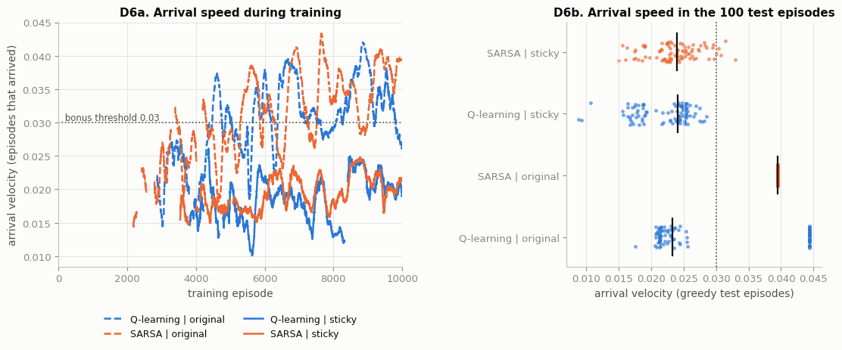
 | arrivals | median arrival v | share of arrivals with v <= 0.03
Q-learning | original | 99.0 | 0.0232 | 0.6364
SARSA | original | 100.0 | 0.0395 | 0.0000
Q-learning | sticky | 98.0 | 0.0241 | 1.0000
SARSA | sticky | 93.0 | 0.0240 | 0.9462

Interpretation (D6).
- During training (D6a) the sticky agents (solid) arrive at ≈ 0.010–0.025 almost from their first successes, below the 0.03 threshold. The original agents (dashed) drift upwards to ≈ 0.03–0.043 as they learn to pump harder, because nothing in their reward discourages a fast arrival.
- In the greedy tests (D6b) the sticky agents' arrivals cluster at 0.015–0.03 (median ≈ 0.024; 100 % of Q-learning's and 95 % of SARSA's arrivals are gentle). SARSA-original arrives at 0.0395 in every episode (one fixed cycle), and Q-learning-original is bimodal (≈ 0.021–0.026 or ≈ 0.044), so its 63 % gentle rate is luck.

5. Extra experiments (beyond the required tasks)

5.1 Cross-evaluation: robustness to the sticky actuator
The assignment title is about robust RL, so we test every greedy policy in both environments. An original-trained policy evaluated in the sticky env shows how fragile a policy is when it was never trained with actuator delays.
In [68]:
lab_stamp("extra - cross-evaluation")
cross_rows = [] # one row per agent and test env
for key in AGENTS: # the four agents
for test_env in ("original", "modified"): # every agent in both environments
s = summarise(evaluate_greedy(RUNS[key], test_env)) # 100 greedy test episodes
# record the metrics
cross_rows.append(
{
"agent (trained on)": RUNS[key].label,
"tested on": ENV_LABEL[test_env],
**{
k: s[k]
for k in (
"success rate",
"gentle-arrival rate",
"mean episode length",
"pushes / episode",
)
},
}
)
cross = pd.DataFrame(cross_rows) # cross-evaluation table
cross.to_csv(os.path.join(OUT_DIR, "cross_evaluation.csv"), index=False) # save to CSV
display(cross.round(3)) # show the table
[lab-stamp] 2026-11-04 22:53:01 | host=ip-10-3-20-152.ap-south-1.compute.internal | user=s2025ag05066 | extra - cross-evaluation
 | agent (trained on) | tested on | success rate | gentle-arrival rate | mean episode length | pushes / episode
0 | Q-learning | original | original | 0.99 | 0.63 | 139.04 | 119.66
1 | Q-learning | original | sticky | 1.00 | 0.70 | 135.19 | 116.02
2 | SARSA | original | original | 1.00 | 0.00 | 171.71 | 151.47
3 | SARSA | original | sticky | 0.88 | 0.00 | 173.56 | 150.45
4 | Q-learning | sticky | original | 1.00 | 1.00 | 152.89 | 93.26
5 | Q-learning | sticky | sticky | 0.98 | 0.98 | 154.99 | 95.02
6 | SARSA | sticky | original | 0.96 | 0.96 | 172.05 | 115.92
7 | SARSA | sticky | sticky | 0.93 | 0.87 | 168.29 | 111.64

Interpretation (cross-evaluation).
- Sticky-trained agents transfer well. In the clean environment they do at least as well as in their own: Q-learning 1.00 / 1.00 (success / gentle) and SARSA 0.96 / 0.96, and they keep arriving gently even where it is no longer rewarded.
- Clean-trained agents are less robust. SARSA-original drops from 1.00 to 0.88 success once its actions start sticking: its precise pumping rhythm is broken by the delays. Q-learning-original happens to cope (0.99 → 1.00).
- Gentle arrival has to be trained. Neither original agent learns it reliably (SARSA 0.00; Q-learning 0.63–0.70 only by chance).
- Conclusion. Training under the perturbation is what produces a robust policy, which is the point of the assignment's title.

5.2 Robustness across random seeds
One seed can be lucky. We repeat all four trainings with two more seeds (1109, 2109): same config, only the seed changes. The table reports mean ± standard deviation of the greedy-test metrics over the 3 seeds; the figure shows the mean success-rate curve with a min–max band.
In [71]:
EXTRA_SEEDS = (1109, 2109) # two additional seeds
# reuse the seed-109 runs
SEED_RUNS = {(alg, env_kind, SEED): RUNS[(alg, env_kind)] for alg, env_kind in AGENTS}
lab_stamp("extra - multi-seed training") # stamp the multi-seed runs
for sd in EXTRA_SEEDS: # each extra seed
for alg, env_kind in AGENTS: # each agent
# quiet run (log still saved to CSV)
r = train_agent(alg, env_kind, seed=sd, verbose=False)
SEED_RUNS[(alg, env_kind, sd)] = r # store the run
# one line per run
print(
f"{clock()} {r.label:<21} seed {sd} {r.seconds:5.1f} s "
f"last-500 success {r.log['success'].iloc[-500:].mean():.2f}"
)
ALL_SEEDS = (SEED,) + EXTRA_SEEDS # all three seeds
seed_rows = [] # evaluation rows
for (alg, env_kind, sd), r in SEED_RUNS.items(): # every (agent, seed) pair
s = summarise(evaluate_greedy(r, env_kind)) # greedy test
# metrics and final value estimate
seed_rows.append(
{
"agent": r.label,
"seed": sd,
**s,
"final avg max Q": r.log["avg_max_q"].iloc[-500:].mean(),
}
)
seed_df = pd.DataFrame(seed_rows) # table of all runs
seed_df.to_csv(os.path.join(OUT_DIR, "multi_seed_eval.csv"), index=False) # save to CSV
# metrics to aggregate
metrics = [
"success rate",
"gentle-arrival rate",
"mean reward",
"mean episode length",
"pushes / episode",
"final avg max Q",
]
# mean and std over seeds
agg = seed_df.groupby("agent", sort=False)[metrics].agg(["mean", "std"])
# format as mean +/- std
agg_fmt = pd.DataFrame(
{
m: agg[m]["mean"].map("{:.3f}".format)
+ " ± "
+ agg[m]["std"].map("{:.3f}".format)
for m in metrics
}
)
display(agg_fmt) # show the summary

fig, axes = plt.subplots(1, 2, figsize=(12, 3.8), sharey=True) # two panels
for ax, env_kind in zip(axes, ("original", "modified")): # one per environment
for alg in ("q_learning", "sarsa"): # both algorithms
curves = np.array(
[
trailing_mean(
SEED_RUNS[(alg, env_kind, sd)].log["success"].astype(float)
)
for sd in ALL_SEEDS
]
) # (3 seeds, episodes)
x = np.arange(curves.shape[1]) # episode axis
# min-max band over seeds
ax.fill_between(
x, curves.min(0), curves.max(0), color=ALGO_COLOR[alg], alpha=0.15, lw=0
)
# mean curve
ax.plot(
x,
curves.mean(0),
color=ALGO_COLOR[alg],
ls=ENV_STYLE[env_kind],
label=f"{ALGO_LABEL[alg]} (mean of 3 seeds)",
)
# labels and title
ax.set(
xlabel="training episode",
ylabel="success rate (MA100)",
ylim=(-0.02, 1.02),
title=f"E1{'a' if env_kind == 'original' else 'b'}. Success rate across seeds, "
f"{ENV_LABEL[env_kind]} env",
)
ax.legend(loc="upper left") # legend
save_fig(fig, "E1_multi_seed") # save and show
[lab-stamp] 2026-11-04 22:53:10 | host=ip-10-3-20-152.ap-south-1.compute.internal | user=s2025ag05066 | extra - multi-seed training
22:55:09 Q-learning | original seed 1109 119.6 s last-500 success 0.94
22:57:04 SARSA | original seed 1109 114.1 s last-500 success 0.99
22:59:45 Q-learning | sticky seed 1109 161.0 s last-500 success 0.82
23:02:11 SARSA | sticky seed 1109 145.7 s last-500 success 0.73
23:04:14 Q-learning | original seed 2109 122.8 s last-500 success 0.93
23:06:04 SARSA | original seed 2109 110.4 s last-500 success 0.93
23:08:30 Q-learning | sticky seed 2109 146.2 s last-500 success 0.52
23:10:46 SARSA | sticky seed 2109 135.1 s last-500 success 0.67
 | success rate | gentle-arrival rate | mean reward | mean episode length | pushes / episode | final avg max Q
agent
Q-learning | original | 0.993 ± 0.006 | 0.223 ± 0.353 | -146.067 ± 7.782 | 146.067 ± 7.782 | 121.740 ± 5.305 | -50.467 ± 0.262
SARSA | original | 0.970 ± 0.052 | 0.043 ± 0.075 | -168.063 ± 3.733 | 168.063 ± 3.733 | 137.203 ± 19.195 | -51.874 ± 0.201
Q-learning | sticky | 0.930 ± 0.056 | 0.917 ± 0.057 | -167.410 ± 10.455 | 161.337 ± 8.682 | 96.633 ± 1.936 | -60.240 ± 0.457
SARSA | sticky | 0.960 ± 0.030 | 0.933 ± 0.055 | -178.520 ± 4.817 | 168.733 ± 5.010 | 110.400 ± 1.327 | -63.237 ± 0.064

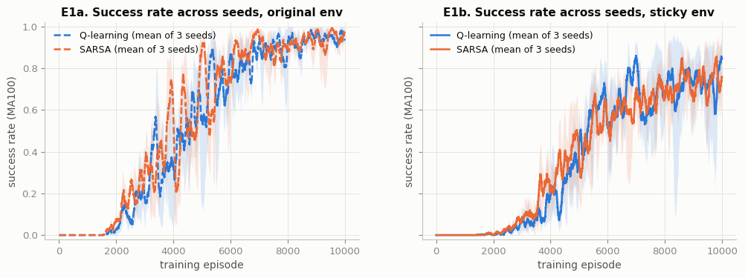
Interpretation (3 seeds).
- Original env. Greedy success is 0.91–1.00 on every seed (mean 0.99 for Q-learning, 0.97 for SARSA). Gentle arrival varies enormously between seeds (Q-learning 0.22 ± 0.35), which confirms that without the bonus arrival speed is an accident of the learned cycle.
- Sticky env. On average Q-learning has the higher return (−167 vs −179) and shorter episodes (161 vs 169 steps), on 2 of the 3 seeds, and selects fewer pushes on every seed (97 vs 110 on average). SARSA has slightly higher and more consistent success (0.96 ± 0.03 vs 0.93 ± 0.06). Seed 109 alone suggested Q-learning wins on every metric, which shows why several seeds are needed.
- The value gap is larger with sticky actuators on every seed. Q-learning − SARSA in final average max Q is 2.45 / 3.06 / 3.48 (sticky) against 1.88 / 1.12 / 1.21 (original) for seeds 109 / 1109 / 2109, i.e. ≈ 3.0 vs ≈ 1.4 on average. This is the strongest evidence for question (e)-1.
- Learning curves (E1). They overlap within the min–max bands; the sticky env is clearly slower to learn and has wider bands.

5.3 Implemented improvement: an agent that remembers its own last selected action
The modified environment is non-Markovian because a_prev is hidden (discussed in part (e)). The agent cannot see a_prev, but it does know which action it selected on the previous step. That action equals a_prev whenever the previous switch was not blocked: ≈ 80 % of steps even under a uniformly random policy (V3 audit: 1 − 12 037 / 60 000 = 0.799), and more under a learned policy, which switches less often. We append it to the state, giving a 36 × 28 × 3 × 3 Q-table. The environment is unchanged and exposes nothing new; the extra information lives in the agent's own memory.
The table is 3× larger, so we compare two budgets (seed 109, same config otherwise):
- equal episodes: 10 000 episodes for both representations;
- equal updates per Q-entry: 30 000 episodes, which gives the memory agent about as many updates per table entry as the baseline had at 10 000. The observation-only agent is also trained for 30 000 episodes, so it gets the same extra data.
In [74]:
lab_stamp("extra - memory-augmented agents")
# 30 000 episodes, everything else identical
CFG_LONG = replace(CFG, n_episodes=3 * CFG.n_episodes)
MEM = {} # (algorithm, state mode, episodes) -> RunResult
for alg in ("q_learning", "sarsa"): # both algorithms
# baseline: already trained in section 3
MEM[(alg, "obs", CFG.n_episodes)] = RUNS[(alg, "modified")]
# the three new runs
for mode, cfg_m in (("memory", CFG), ("obs", CFG_LONG), ("memory", CFG_LONG)):
MEM[(alg, mode, cfg_m.n_episodes)] = train_agent(
alg,
"modified",
cfg=cfg_m,
seed=SEED,
state_mode=mode,
# 4 progress lines per run
log_every=cfg_m.n_episodes // 4,
)
mem_rows = [] # evaluation rows
for (alg, mode, n_ep), r in MEM.items(): # every memory-experiment run
s = summarise(evaluate_greedy(r, "modified")) # same 100 test seeds as section 4.6
mem_rows.append(
{
"algorithm": ALGO_LABEL[alg],
"state": (
"obs + last selected action" if mode == "memory" else "observation only"
),
"episodes": n_ep,
"Q entries": r.agent.Q.size,
# data per table entry
"updates per Q entry": round(r.log["length"].sum() / r.agent.Q.size),
"train success (last 1000)": r.log["success"].iloc[-1000:].mean(),
**{
m: s[m]
for m in (
"success rate",
"gentle-arrival rate",
"mean reward",
"mean episode length",
)
},
}
)
mem_table = pd.DataFrame(mem_rows) # results table
# save to CSV
mem_table.to_csv(os.path.join(OUT_DIR, "memory_agent_eval.csv"), index=False)
display(mem_table.round(3)) # show the table

fig, axes = plt.subplots(1, 2, figsize=(12, 3.8), sharey=True) # two panels
# one panel per algorithm, 30 000-episode runs
for ax, alg in zip(axes, ("q_learning", "sarsa")):
# both representations
for mode, style, name in (
("obs", ":", "observation only"),
("memory", "-", "obs + last selected action"),
):
# success rate, trailing mean
y = trailing_mean(
MEM[(alg, mode, CFG_LONG.n_episodes)].log["success"].astype(float)
)
ax.plot(y, color=ALGO_COLOR[alg], ls=style, label=name) # curve
# the standard 10 000-episode budget
ax.axvline(CFG.n_episodes, color=INK_MUTED, lw=1)
# label the budget line
ax.text(
CFG.n_episodes,
1.0,
"standard budget ",
ha="right",
va="top",
fontsize=8.5,
color=INK_2,
)
# labels and title
ax.set(
xlabel="training episode",
ylabel="success rate (MA100)",
ylim=(-0.02, 1.02),
title=f"E2{'a' if alg == 'q_learning' else 'b'}. {ALGO_LABEL[alg]}, sticky "
"env, 30 000 episodes",
)
# legend below the panel, clear of the curves
ax.legend(loc="upper center", bbox_to_anchor=(0.5, -0.18), ncol=2)
save_fig(fig, "E2_memory_agent") # save and show
[lab-stamp] 2026-11-04 23:10:59 | host=ip-10-3-20-152.ap-south-1.compute.internal | user=s2025ag05066 | extra - memory-augmented agents
[lab-stamp] 2026-11-04 23:10:59 | host=ip-10-3-20-152.ap-south-1.compute.internal | user=s2025ag05066 | train Q-learning | sticky | memory | seed 109 | 10000 ep
R100 / succ / gentle / push = means over the previous 100 episodes
maxQ = average of max_a Q(s,a) over the fixed validation states
23:11:37 ep 2500/10000 eps 0.224 R100 -240.0 succ 0.00 gentle 0.00 push 133.5 maxQ -24.7
23:12:20 ep 5000/10000 eps 0.050 R100 -240.0 succ 0.01 gentle 0.01 push 135.1 maxQ -35.0
23:12:59 ep 7500/10000 eps 0.050 R100 -240.9 succ 0.00 gentle 0.00 push 136.4 maxQ -41.6
23:13:39 ep 10000/10000 eps 0.050 R100 -239.4 succ 0.01 gentle 0.01 push 132.5 maxQ -47.2
23:13:39 done in 159.8 s -> outputs/log_q_learning_modified_memory_seed109_ep10000.csv
[lab-stamp] 2026-11-04 23:13:39 | host=ip-10-3-20-152.ap-south-1.compute.internal | user=s2025ag05066 | train Q-learning | sticky | seed 109 | 30000 ep
R100 / succ / gentle / push = means over the previous 100 episodes
maxQ = average of max_a Q(s,a) over the fixed validation states
23:15:31 ep 7500/30000 eps 0.224 R100 -232.0 succ 0.12 gentle 0.11 push 125.5 maxQ -52.7
23:17:12 ep 15000/30000 eps 0.050 R100 -188.7 succ 0.83 gentle 0.80 push 106.7 maxQ -61.6
23:18:49 ep 22500/30000 eps 0.050 R100 -202.1 succ 0.55 gentle 0.53 push 97.6 maxQ -64.5
23:20:27 ep 30000/30000 eps 0.050 R100 -190.0 succ 0.80 gentle 0.79 push 97.9 maxQ -65.8
23:20:28 done in 408.0 s -> outputs/log_q_learning_modified_obs_seed109_ep30000.csv
[lab-stamp] 2026-11-04 23:20:28 | host=ip-10-3-20-152.ap-south-1.compute.internal | user=s2025ag05066 | train Q-learning | sticky | memory | seed 109 | 30000 ep
R100 / succ / gentle / push = means over the previous 100 episodes
maxQ = average of max_a Q(s,a) over the fixed validation states
23:22:21 ep 7500/30000 eps 0.224 R100 -240.4 succ 0.00 gentle 0.00 push 134.6 maxQ -38.5
23:24:19 ep 15000/30000 eps 0.050 R100 -220.9 succ 0.40 gentle 0.37 push 131.4 maxQ -52.3
23:26:06 ep 22500/30000 eps 0.050 R100 -180.8 succ 0.89 gentle 0.80 push 116.0 maxQ -59.4
23:27:42 ep 30000/30000 eps 0.050 R100 -186.6 succ 0.75 gentle 0.75 push 108.2 maxQ -61.5
23:27:42 done in 434.5 s -> outputs/log_q_learning_modified_memory_seed109_ep30000.csv
[lab-stamp] 2026-11-04 23:27:42 | host=ip-10-3-20-152.ap-south-1.compute.internal | user=s2025ag05066 | train SARSA | sticky | memory | seed 109 | 10000 ep
R100 / succ / gentle / push = means over the previous 100 episodes
maxQ = average of max_a Q(s,a) over the fixed validation states
23:28:15 ep 2500/10000 eps 0.224 R100 -240.1 succ 0.00 gentle 0.00 push 133.6 maxQ -27.4
23:28:52 ep 5000/10000 eps 0.050 R100 -240.3 succ 0.00 gentle 0.00 push 134.4 maxQ -36.2
23:29:30 ep 7500/10000 eps 0.050 R100 -240.9 succ 0.00 gentle 0.00 push 136.4 maxQ -42.8
23:30:07 ep 10000/10000 eps 0.050 R100 -238.2 succ 0.02 gentle 0.02 push 131.0 maxQ -48.4
23:30:07 done in 144.4 s -> outputs/log_sarsa_modified_memory_seed109_ep10000.csv
[lab-stamp] 2026-11-04 23:30:07 | host=ip-10-3-20-152.ap-south-1.compute.internal | user=s2025ag05066 | train SARSA | sticky | seed 109 | 30000 ep
R100 / succ / gentle / push = means over the previous 100 episodes
maxQ = average of max_a Q(s,a) over the fixed validation states
23:31:45 ep 7500/30000 eps 0.224 R100 -219.4 succ 0.35 gentle 0.33 push 124.9 maxQ -60.5
23:33:20 ep 15000/30000 eps 0.050 R100 -176.0 succ 0.94 gentle 0.94 push 99.0 maxQ -67.7
23:34:50 ep 22500/30000 eps 0.050 R100 -154.2 succ 0.96 gentle 0.96 push 96.2 maxQ -67.5
23:36:16 ep 30000/30000 eps 0.050 R100 -184.2 succ 0.84 gentle 0.83 push 97.9 maxQ -67.9
23:36:17 done in 369.6 s -> outputs/log_sarsa_modified_obs_seed109_ep30000.csv
[lab-stamp] 2026-11-04 23:36:17 | host=ip-10-3-20-152.ap-south-1.compute.internal | user=s2025ag05066 | train SARSA | sticky | memory | seed 109 | 30000 ep
R100 / succ / gentle / push = means over the previous 100 episodes
maxQ = average of max_a Q(s,a) over the fixed validation states
23:37:55 ep 7500/30000 eps 0.224 R100 -240.6 succ 0.02 gentle 0.02 push 138.0 maxQ -43.7
23:39:40 ep 15000/30000 eps 0.050 R100 -206.3 succ 0.57 gentle 0.57 push 127.4 maxQ -55.0
23:41:17 ep 22500/30000 eps 0.050 R100 -202.1 succ 0.62 gentle 0.61 push 117.2 maxQ -61.6
23:42:51 ep 30000/30000 eps 0.050 R100 -165.5 succ 0.98 gentle 0.91 push 102.1 maxQ -64.6
23:42:52 done in 394.4 s -> outputs/log_sarsa_modified_memory_seed109_ep30000.csv
 | algorithm | state | episodes | Q entries | updates per Q entry | train success (last 1000) | success rate | gentle-arrival rate | mean reward | mean episode length
0 | Q-learning | observation only | 10000 | 3024 | 624 | 0.826 | 0.98 | 0.98 | -158.996 | 154.99
1 | Q-learning | obs + last selected action | 10000 | 9072 | 220 | 0.024 | 0.01 | 0.01 | -238.941 | 199.72
2 | Q-learning | observation only | 30000 | 3024 | 1802 | 0.454 | 0.75 | 0.72 | -190.349 | 179.48
3 | Q-learning | obs + last selected action | 30000 | 9072 | 618 | 0.873 | 0.94 | 0.92 | -176.566 | 168.03
4 | SARSA | observation only | 10000 | 3024 | 624 | 0.761 | 0.93 | 0.87 | -180.032 | 168.29
5 | SARSA | obs + last selected action | 10000 | 9072 | 220 | 0.057 | 0.02 | 0.02 | -241.011 | 199.40
6 | SARSA | observation only | 30000 | 3024 | 1765 | 0.781 | 0.59 | 0.55 | -195.202 | 179.60
7 | SARSA | obs + last selected action | 30000 | 9072 | 620 | 0.906 | 0.99 | 0.97 | -155.383 | 151.31

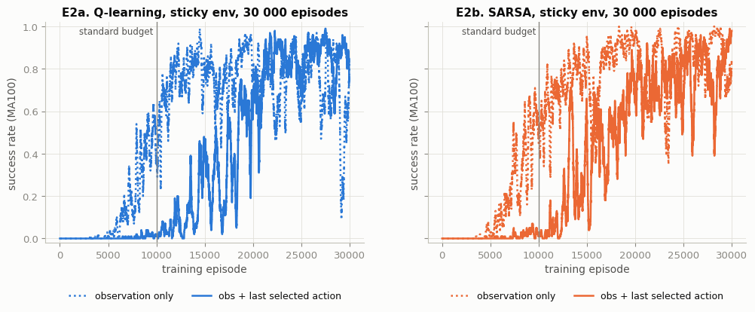
Interpretation (memory-augmented agent).
- Equal episodes (10 000): it fails. The memory agents almost never reach the flag (1–2 %). With 3× as many table entries, each entry gets only a third of the updates (≈ 220 vs ≈ 620, column "updates per Q entry"), and the optimistic zero values are still being explored away when training stops.
- Equal updates per entry (30 000 episodes): it works. The memory agents reach 94 % (Q-learning) and 99 % (SARSA) success, almost all gentle.
- More data does not help the baseline. The observation-only agents trained for the same 30 000 episodes get worse than at 10 000 (75 % and 59 %), and their training curves keep oscillating (E2). Extra data does not fix missing state information.
- Conclusion. Remembering its own last action gives the agent useful Markov information, but in a table it costs 3× the data. Generalising across the extra dimension, with tile coding or a linear/neural approximator (Lectures 11–12), would keep the benefit without that cost. This is a single seed, so the size of the effect is indicative only.

6. Part (e) — Discussion

(e)-1 Does the sticky actuator increase the difference between the value estimates of Q-learning and SARSA?
Yes: moderately, but consistently. In D2a and D2b Q-learning's average max_a Q(s,a) on the fixed validation set lies above SARSA's in both environments. In D2c the gap is larger in the sticky env for most of training after episode ≈ 1 500. Over the last 500 episodes it is 2.45 (sticky) vs 1.88 (original) for seed 109, and it is larger in the sticky env on every one of the three seeds (≈ 3.0 vs ≈ 1.4 on average, section 5.2), roughly a doubling. Two mechanisms explain it:
1. Future exploration costs more, and only SARSA prices it in. SARSA's target Q(s′, a′) uses the action the ε-greedy policy really chose next, so its values include the cost of future exploratory actions. With a sticky actuator each such action is more expensive: once executed it becomes a_prev, and every later attempt to switch back is ignored 30 % of the time, so a single random action can steer the car the wrong way for several steps. Q-learning's target max_a′ Q(s′, a′) assumes all future actions are greedy. It still sees stickiness in the transitions it samples, but it never charges itself for its own future exploration.
2. More noise, more maximisation bias. The hidden actuator adds outcome noise to every (s, a). The maximum of noisy estimates is biased upwards (Session 9, slide 39; Lecture 12 on DQN overestimation), and the noisier the estimates, the larger the bias.

(e)-2 Why is the modified environment non-Markovian with respect to the observation, and how does this affect credit assignment?
The executed action depends on a_prev, which is part of the true state but not of the observation. The Markov state is (x, v, a_prev); the agent only sees (x, v), so it is effectively solving a POMDP. Example: at observation (−0.50, 0.000) the agent selects push right. If a_prev = 2 the car is pushed right with probability 1. If a_prev = 0 (it was pumping left a moment ago) it is pushed left with probability 0.30. Same observation, same action, different next-state distributions, so P(o′ | o, a) depends on history. The convergence guarantees of tabular Q-learning and SARSA assume a Markov state, so they no longer hold. (Discretisation adds a second, smaller aliasing, but that is present in both environments.)
Effects on credit assignment:
- Credit goes to the wrong action. The update always uses the selected action a. In ≈ 30 % of attempted switches the motion really came from a_prev, so Q(s, a) is credited or blamed for what a different action did. The 0.3 penalty, by design, is charged to the selected push even when it never happened.
- Effects arrive late. A blocked switch takes effect one or more steps later. One-step TD credits the outcome to whatever action was selected at that later step, so the true cause is smeared over neighbouring steps.
- The target moves with the policy. Q(o, a) averages over the hidden a_prev values, and their distribution depends on the agent's own policy. When the policy changes, the effective dynamics change too.
Evidence: slower and noisier learning in the sticky env (D1b, D3, wider bands in E1b); observation-only agents that get worse with 3× more training (section 5.3); and the memory-augmented agent, which recovers part of the hidden state and then learns well.

(e)-3 Do the energy penalty and the gentle-arrival bonus encourage fewer pushes or a slower, more controlled arrival?
Both.
- Push-count plot (D4). The share of steps with a push falls to ≈ 0.62 in the sticky env but rises to ≈ 0.84 in the original env. In the greedy tests the sticky agents select 95 / 112 pushes per episode (Q / SARSA) against 120 / 151 for the original agents.
- Policy maps (D5). 'No push' grows from ≈ 20 % to ≈ 36 % of visited cells. Push-left brake cells appear just before the flag at v ≈ 0.03–0.045. In the original env braking there earns nothing, and the few blue cells near its flag are noise between almost equal action values.
- Arrival speed (D6, table 4.7). Sticky agents arrive at a median v ≈ 0.024, with 100 % (Q-learning) and 95 % (SARSA) of arrivals at or below 0.03. Original agents arrive at whatever speed their cycle produces: SARSA at 0.040 every time, Q-learning bimodal (≈ 0.022 or ≈ 0.044, 64 % slow by chance).
- The price is time. Sticky agents need ≈ 155–168 steps, against 139 for the fastest original agent. The discounted +25 is worth more than those extra −1 steps, so the agents trade speed for control. The penalty on its own pushes towards fewer pushes; the bonus is what makes the arrival controlled (braking cells, v ≤ 0.03).

(e)-4 Which algorithm performs better under sticky actuators? Is this consistent with theory?
It depends on the metric, and the pattern matches theory.
- Q-learning (off-policy) learns the value of the greedy policy, so its greedy test policy is the more efficient one. Averaged over 3 seeds it has higher reward (−167 vs −179) and shorter episodes (161 vs 169), on 2 of the 3 seeds, and fewer pushes on every seed (97 vs 110). On seed 109 it also has higher success (0.98 vs 0.93).
- SARSA (on-policy) learns the value of the ε-greedy behaviour it actually follows, including the extra cost that sticky actuators add to exploratory mistakes. It ends with a somewhat more conservative policy: longer episodes and more pushes, with marginally higher and more consistent success over seeds (0.96 ± 0.03 vs 0.93 ± 0.06).
This is the Cliff-Walking pattern (Sutton & Barto, Example 6.6) in a milder form: Q-learning finds the optimal but riskier route, SARSA a safer one. It is mild because in MountainCar a mistake costs a few extra steps, not −100, so SARSA's caution buys little. The sticky noise is part of the environment, so both algorithms see it in their samples; the on/off-policy difference concerns only the agent's own ε-exploration, which keeps the performance gap small. Verdict: by the main objective (expected return), Q-learning performs better here; SARSA is the slightly safer and more consistent choice.

(e)-5 One limitation of our setup and one possible improvement
Limitation. The agent's state (x, v) leaves out the actuator state a_prev, so we run tabular learning on an aliased, non-Markovian state space with a fixed budget. The value estimates have not fully converged after 10 000 episodes (D2 still drifting), learning curves oscillate (D3), and simply training longer does not help (section 5.3). A smaller limitation: the headline results use one seed; section 5.2 shows some rankings change across seeds.
Improvement, implemented in section 5.3. Let the agent remember its own last selected action and append it to the state. This information is legitimately available to the agent, and it equals the hidden a_prev on ≈ 80 % of steps even under random play. With a fair budget (equal updates per table entry, 30 000 episodes) success rose to 94 % / 99 %, against 75 % / 59 % for observation-only agents trained equally long. The natural next step is to replace the table with tile coding or a small Q-network over (x, v, last action) (Lectures 11–12). The values would then generalise across the extra dimension, removing the 3× data cost that made the tabular version fail at 10 000 episodes.

Appendix — Virtual-lab evidence
Screenshots of this notebook running in the BITS virtual lab (with visible date/time) are attached on the following pages. The [lab-stamp] lines in the outputs above record the host, user and time of each stage.
In [78]:
lab_stamp("notebook complete")
# total wall-clock time
print(
f"total run time: {(time.perf_counter() - NOTEBOOK_T0) / 60:.1f} min | outputs "
f"saved in ./{OUT_DIR}/"
)
[lab-stamp] 2026-11-04 23:43:01 | host=ip-10-3-20-152.ap-south-1.compute.internal | user=s2025ag05066 | notebook complete
total run time: 59.1 min | outputs saved in ./outputs/
Screenshot taken in the BITS virtual lab — proof.jpg (file time 2026-11-04 23:24:34)
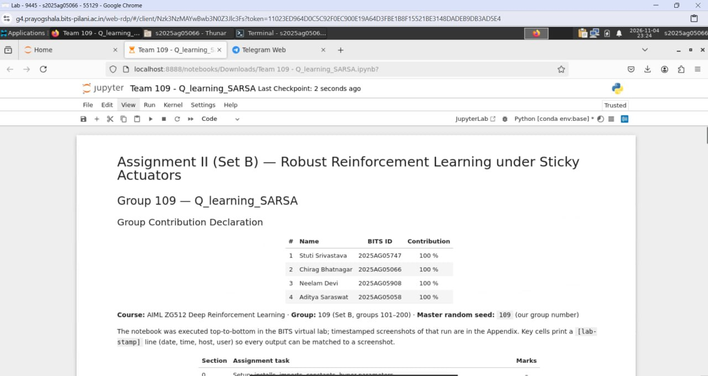
Lab screenshot 2 — run-environment report (cell In [119]): lab host, user, Rocky Linux 9.5 over xrdp/XFCE, library versions and run time.
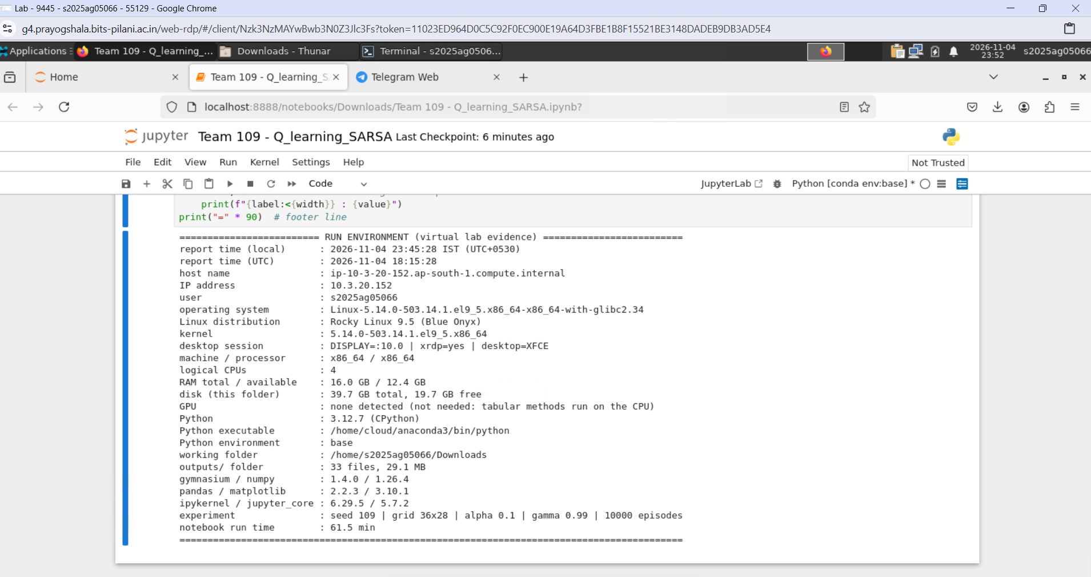
Lab screenshot 3 — part (a) verification summary (cell In [27]): all six checks True, followed by the part (a) lab-stamp.
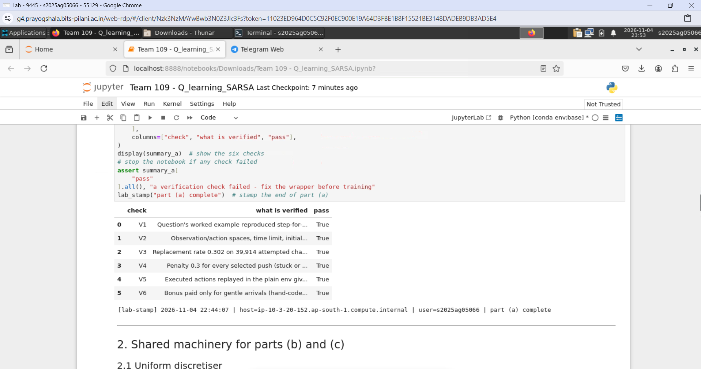
Lab screenshot 4 — training progress (cell In [39]): Q-learning on the sticky environment finishing its 10 000 episodes at 22:48:34.
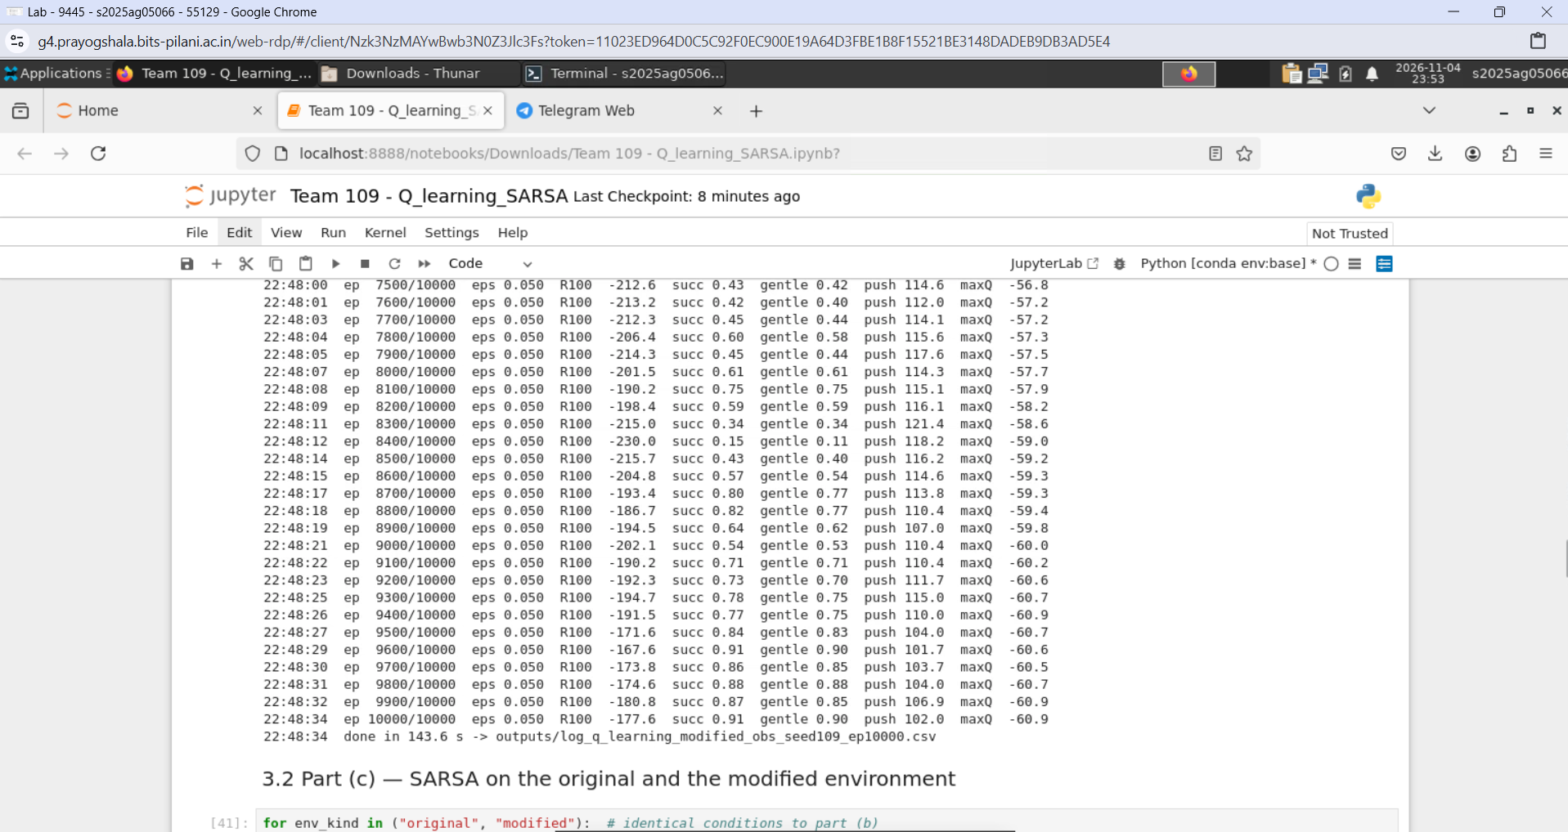
Lab screenshot 5 — end of the run (cell In [78]): 'notebook complete' lab-stamp and total run time 59.1 min.
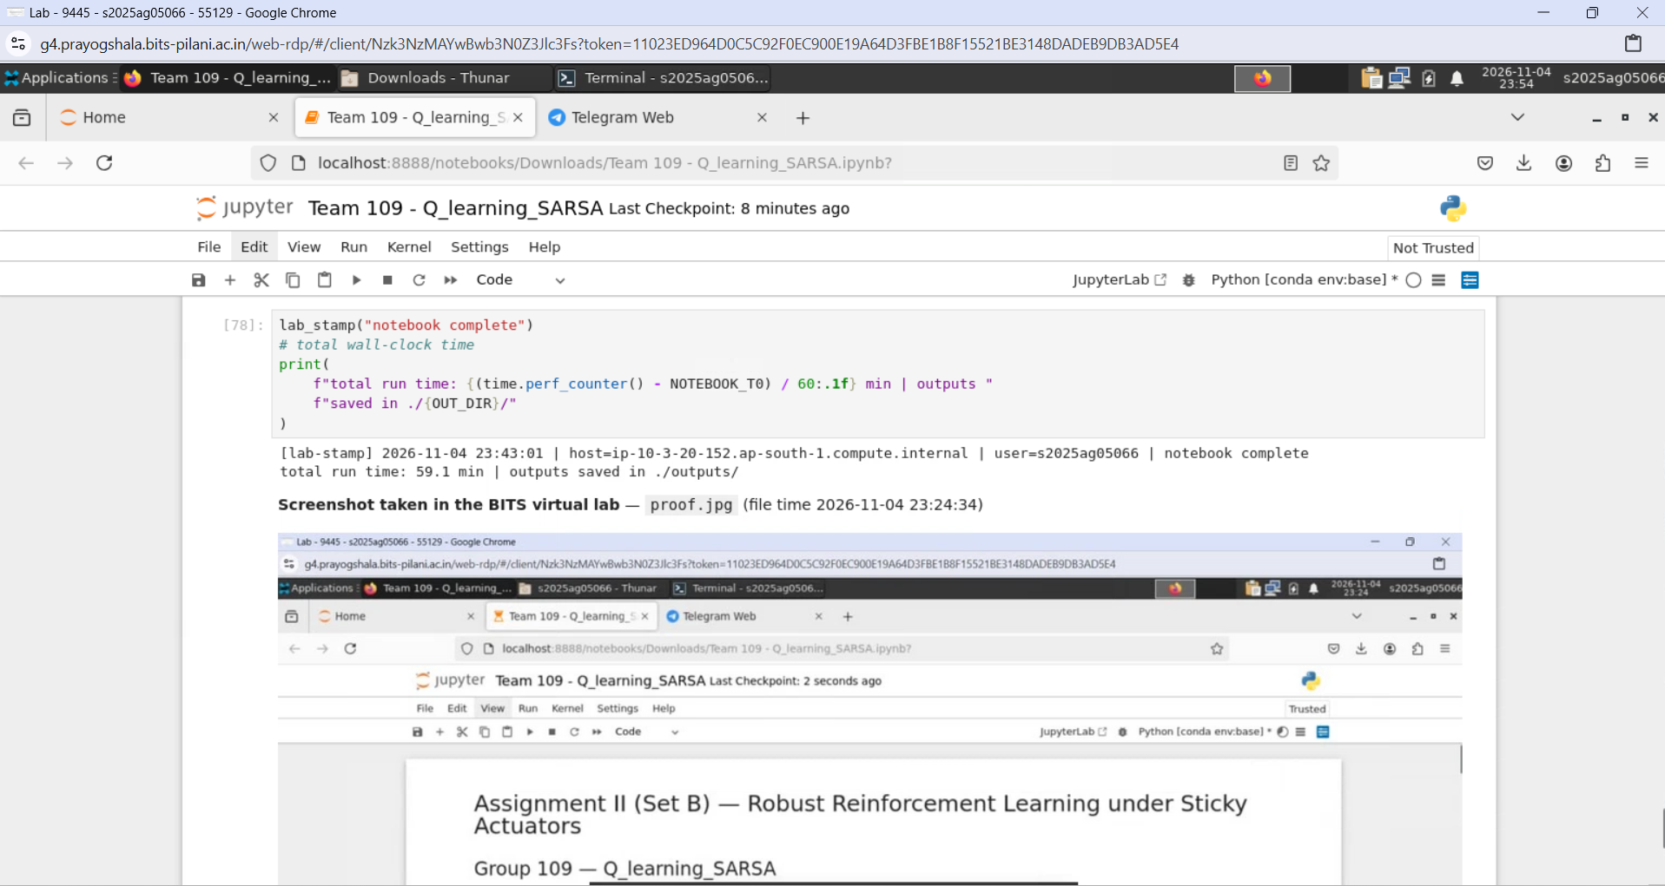
In [119]:
# ---- Run-environment report: records where, when and with what this notebook ran ----
import os # environment variables, CPU count, folder sizes
import sys # Python version, executable and platform name
import time # high-resolution timer (matches NOTEBOOK_T0 from the setup cell)
import socket # host name and IP address of the machine
import getpass # login name of the user
import platform # operating-system and processor details
import shutil # disk usage and locating optional tools
import subprocess # optional GPU query (nvidia-smi)
import datetime as dt # local and UTC timestamps
from importlib import metadata # versions of the installed packages

def safe(fn, default="n/a"):
"""Call fn() and return its result, or `default` if the machine does not allow
it."""
try:
return fn() # the requested value
except Exception: # restricted VM / missing feature: never crash the report
return default # placeholder instead of an error

def read_key_values(path, sep):
"""Read a 'KEY<sep>VALUE' text file (e.g. /proc/meminfo) into a dict."""
pairs = {} # parsed entries
with open(path) as fh: # small system text file
for line in fh: # one entry per line
if sep in line: # skip blank or malformed lines
key, value = line.split(sep, 1) # split at the first separator
pairs[key.strip()] = value.strip().strip('"') # drop quotes/spaces
return pairs

def ram_gb():
"""Return (total, available) physical memory in GB on Linux or Windows."""
if os.name == "nt": # Windows: ask the Win32 API (no extra package needed)
import ctypes # foreign-function interface of the standard library

class MemStatus(ctypes.Structure):
"""Win32 MEMORYSTATUSEX structure filled by GlobalMemoryStatusEx."""

_fields_ = [("dwLength", ctypes.c_ulong), ("dwMemoryLoad", ctypes.c_ulong)]
# the seven 64-bit counters that follow, in API order
_fields_ += [
(name, ctypes.c_ulonglong)
for name in (
"ullTotalPhys", "ullAvailPhys", "ullTotalPageFile",
"ullAvailPageFile", "ullTotalVirtual", "ullAvailVirtual",
"ullAvailExtendedVirtual",
)
]

stat = MemStatus() # empty structure
stat.dwLength = ctypes.sizeof(MemStatus) # the API requires its own size
ctypes.windll.kernel32.GlobalMemoryStatusEx(ctypes.byref(stat)) # fill it
return stat.ullTotalPhys / 1e9, stat.ullAvailPhys / 1e9 # bytes -> GB
mem = read_key_values("/proc/meminfo", ":") # Linux: "MemTotal: 16384 kB"
to_gb = lambda key: int(mem[key].split()[0]) / 1e6 # kB -> GB
return to_gb("MemTotal"), to_gb("MemAvailable") # total, available

def ip_address():
"""Primary IPv4 address of the machine (a UDP 'connect' sends no packet)."""
sock = socket.socket(socket.AF_INET, socket.SOCK_DGRAM) # UDP socket
try:
sock.connect(("10.255.255.255", 1)) # lets the OS pick the outgoing interface
return sock.getsockname()[0] # address of that interface
finally:
sock.close() # release the socket

def os_rows():
"""OS-specific identity: distribution + desktop session on Linux, domain on
Windows."""
if os.name == "nt": # Windows machine
return [
("Windows domain / computer", f"{os.environ.get('USERDOMAIN', 'n/a')} / "
f"{os.environ.get('COMPUTERNAME', 'n/a')}"),
("OS edition", safe(platform.win32_edition)), # e.g. Professional
("desktop session", os.environ.get("SESSIONNAME", "n/a")), # RDP-Tcp#N
]
release = safe(lambda: read_key_values("/etc/os-release", "="), {}) # distro info
session = ( # remote-desktop evidence: X display, xrdp flag, desktop name
f"DISPLAY={os.environ.get('DISPLAY', 'n/a')} | "
f"xrdp={'yes' if 'XRDP_SESSION' in os.environ else 'no'} | "
f"desktop={os.environ.get('XDG_CURRENT_DESKTOP', 'n/a')}"
)
return [
("Linux distribution", release.get("PRETTY_NAME", platform.platform())),
("kernel", platform.release()), # Linux kernel version
("desktop session", session),
]

def folder_size_mb(path):
"""Number of files and total size (MB) inside `path`, searched recursively."""
files = [os.path.join(r, f) for r, _, fs in os.walk(path) for f in fs] # all files
return len(files), sum(os.path.getsize(f) for f in files) / 1e6 # count, MB

def gpu_name():
"""Name of an NVIDIA GPU if nvidia-smi exists, else a note (none is needed)."""
if not shutil.which("nvidia-smi"): # no NVIDIA driver tools on this machine
return "none detected (not needed: tabular methods run on the CPU)"
out = subprocess.run( # ask the driver for the GPU model
["nvidia-smi", "--query-gpu=name", "--format=csv,noheader"],
capture_output=True, text=True, timeout=10,
)
return out.stdout.strip() or "nvidia-smi found, no GPU reported" # model name(s)

def version(pkg):
"""Installed version of a Python package, or 'not installed'."""
return safe(lambda: metadata.version(pkg), "not installed") # metadata lookup

now_local = dt.datetime.now().astimezone() # local time with the VM's time zone
now_utc = dt.datetime.now(dt.timezone.utc) # same instant in UTC
host = socket.gethostname() # machine name
total_gb, free_gb = safe(ram_gb, (float("nan"), float("nan"))) # memory in GB
disk = safe(lambda: shutil.disk_usage(os.getcwd()), None) # disk of this folder
in_venv = sys.prefix != getattr(sys, "base_prefix", sys.prefix) # venv active?
env_name = ( # which Python environment the kernel runs in
os.environ.get("CONDA_DEFAULT_ENV") # conda environment name, if any
or (os.path.basename(sys.prefix) + " (venv)" if in_venv else "system Python")
)
n_out, mb_out = safe(lambda: folder_size_mb("outputs"), (0, 0.0)) # outputs/ folder
cfg = globals().get("CFG") # experiment configuration, if this notebook defined it
t0 = globals().get("NOTEBOOK_T0") # start time recorded in the setup cell, if any
fallback_ip = safe(lambda: socket.gethostbyname(host)) # used if the UDP trick fails

rows = [ # (label, value) pairs of the report
("report time (local)", now_local.strftime("%Y-%m-%d %H:%M:%S %Z (UTC%z)")),
("report time (UTC)", now_utc.strftime("%Y-%m-%d %H:%M:%S")),
("host name", host),
("IP address", safe(ip_address, fallback_ip)),
("user", safe(getpass.getuser)),
("operating system", platform.platform()),
*os_rows(), # Linux distribution / Windows domain details
("machine / processor", f"{platform.machine()} / {platform.processor() or 'n/a'}"),
("logical CPUs", os.cpu_count()),
("RAM total / available", f"{total_gb:.1f} GB / {free_gb:.1f} GB"),
("disk (this folder)", f"{disk.total / 1e9:.1f} GB total, "
f"{disk.free / 1e9:.1f} GB free" if disk else "n/a"),
("GPU", safe(gpu_name)),
("Python", f"{platform.python_version()} ({platform.python_implementation()})"),
("Python executable", sys.executable),
("Python environment", env_name),
("working folder", os.getcwd()),
("outputs/ folder", f"{n_out} files, {mb_out:.1f} MB"),
("gymnasium / numpy", f"{version('gymnasium')} / {version('numpy')}"),
("pandas / matplotlib", f"{version('pandas')} / {version('matplotlib')}"),
("ipykernel / jupyter_core", f"{version('ipykernel')} / {version('jupyter_core')}"),
]
if cfg is not None: # add the experiment settings when run inside our notebook
rows.append(("experiment", f"seed {globals().get('SEED', 'n/a')} | grid "
f"{cfg.n_pos_bins}x{cfg.n_vel_bins} | alpha {cfg.alpha} | "
f"gamma {cfg.gamma} | {cfg.n_episodes} episodes"))
if t0 is not None: # total wall-clock time since the setup cell
rows.append(("notebook run time", f"{(time.perf_counter() - t0) / 60:.1f} min"))

width = max(len(label) for label, _ in rows) # align the colon column
print("=" * 25, "RUN ENVIRONMENT (virtual lab evidence)", "=" * 25) # header line
for label, value in rows: # one aligned line per item
print(f"{label:<{width}} : {value}")
print("=" * 90) # footer line
========================= RUN ENVIRONMENT (virtual lab evidence) =========================
report time (local) : 2026-11-04 23:45:28 IST (UTC+0530)
report time (UTC) : 2026-11-04 18:15:28
host name : ip-10-3-20-152.ap-south-1.compute.internal
IP address : 10.3.20.152
user : s2025ag05066
operating system : Linux-5.14.0-503.14.1.el9_5.x86_64-x86_64-with-glibc2.34
Linux distribution : Rocky Linux 9.5 (Blue Onyx)
kernel : 5.14.0-503.14.1.el9_5.x86_64
desktop session : DISPLAY=:10.0 | xrdp=yes | desktop=XFCE
machine / processor : x86_64 / x86_64
logical CPUs : 4
RAM total / available : 16.0 GB / 12.4 GB
disk (this folder) : 39.7 GB total, 19.7 GB free
GPU : none detected (not needed: tabular methods run on the CPU)
Python : 3.12.7 (CPython)
Python executable : /home/cloud/anaconda3/bin/python
Python environment : base
working folder : /home/s2025ag05066/Downloads
outputs/ folder : 33 files, 29.1 MB
gymnasium / numpy : 1.4.0 / 1.26.4
pandas / matplotlib : 2.2.3 / 3.10.1
ipykernel / jupyter_core : 6.29.5 / 5.7.2
experiment : seed 109 | grid 36x28 | alpha 0.1 | gamma 0.99 | 10000 episodes
notebook run time : 61.5 min
==========================================================================================

